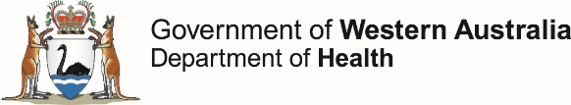

**OzFoodNet Enteric Disease Surveillance Report 4th Quarter 2019**

This report describes enteric disease surveillance and investigations carried out during the fourth quarter of 2019 (4Q19) by OzFoodNet WA in conjunction with other Western Australian Department of Health agencies and local governments.

Some of the increase in notifications is likely to be due to the introduction of polymerase chain reaction (PCR) testing of faecal specimens which has greater sensitivity than culture techniques.

**Enhancing foodborne disease surveillance across Australia**

**Appendix 1** Enteric diseases by public health region:

[https://ww2.health.wa.gov.au/~/media/Files/Corporate/general%20documents/Infectious diseases/Word/OzFoodNet/WA-OzFoodnet-appendix1-2019-Q4](https://ww2.health.wa.gov.au/~/media/Files/Corporate/general%20documents/Infectious%20diseases/Word/OzFoodNet/WA-OzFoodnet-appendix1-2019-Q4)

**Change in enteric disease notifications (%)\***

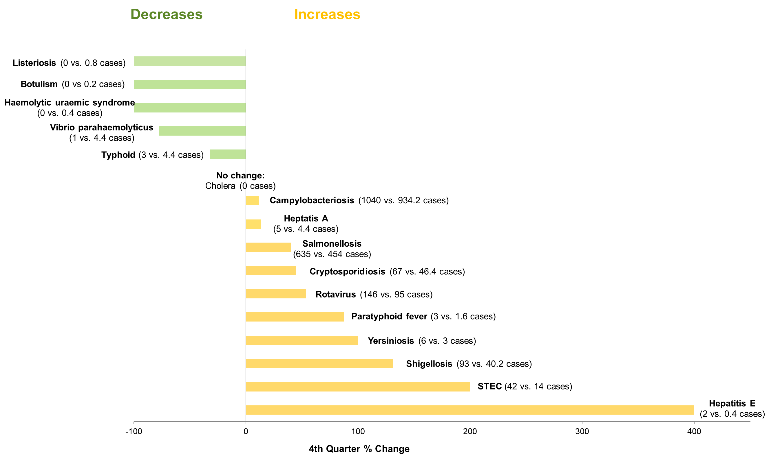

*Percentage change in the number of notifications in the current quarter compared to the historical 5-year mean for the same quarter. Positive values indicate an increase when compared to the historical 5-year mean of the same quarter. Negative values indicate a decrease when compared to the historical 5-year mean of the same quarter. Percentage change should be interpreted with caution when the number of cases is small.

**Most common enteric disease notifications in Quarter 4 2019**

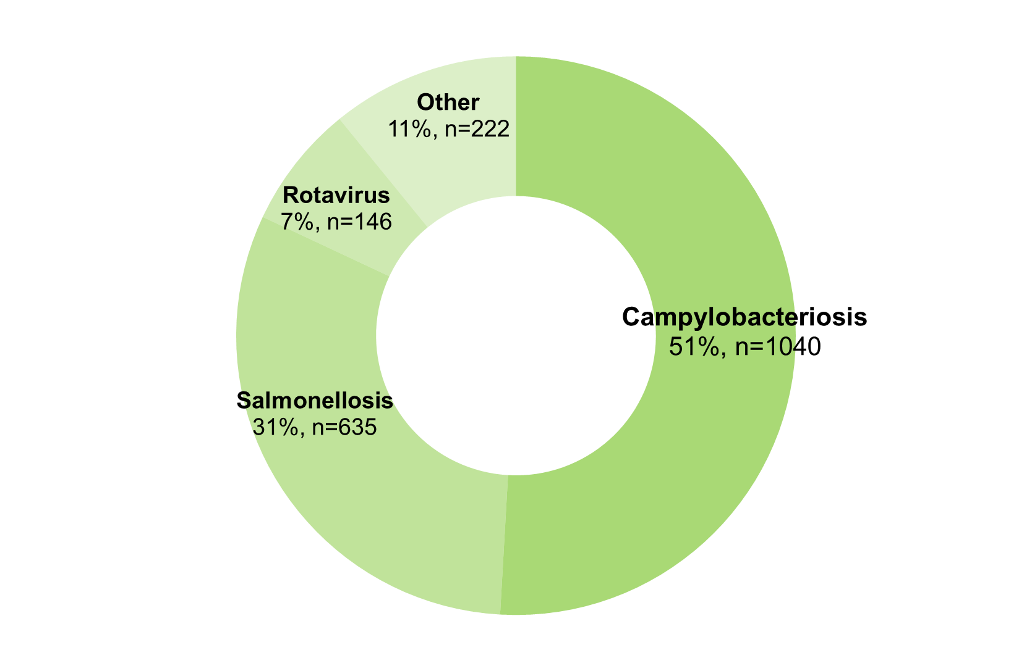

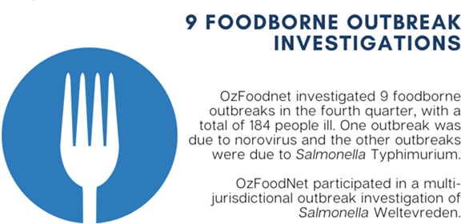**Outbreaks in Quarter 4 2019**

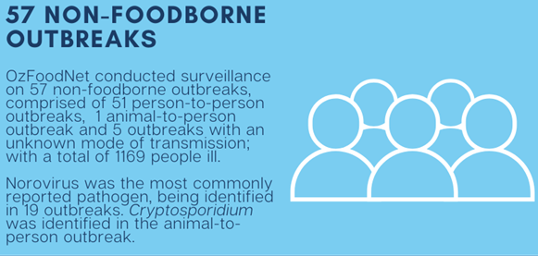

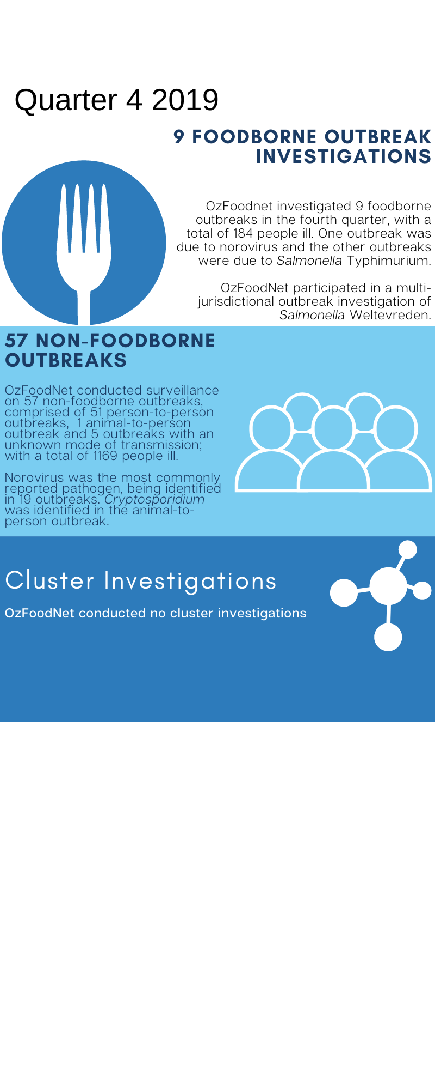

**Appendix 2** Details of foodborne outbreaks investigated in Quarter 4, 2019:

[https://ww2.health.wa.gov.au/~/media/Files/Corporate/general%20documents/Infectious diseases/Word/OzFoodNet/WA-OzFoodnet-appendix2-2019-Q4](https://ww2.health.wa.gov.au/~/media/Files/Corporate/general%20documents/Infectious%20diseases/Word/OzFoodNet/WA-OzFoodnet-appendix2-2019-Q4)

**Key trends from Quarter 4 2019**

***Salmonella* Typhimurium (STM) MLVA 03-17-09-12-523**

STM MLVA 03-17-09-12-523 has been under investigation since the type emerged in September 2016. From September 2016 to December 2019 there were 1474 cases notified, including 134 cases in 4Q19. This MLVA type was the single most common MLVA type notified in 4Q19, constituting 39% of STM notifications for the quarter. Two point source outbreaks of this MLVA type were identified in 4Q19.



Figure: Notifications of *Salmonella* Typhimurium MLVA 03-17-09-12-523 in WA, 2016 to December 2019

Travel associated infection

Where place of acquisition was known, overseas acquisition was reported for 26% (n=338) of enteric disease notifications in the 4Q19:

* The most commonly reported country of acquisition was Indonesia (56%).

***Shigella***

As of 1 July 2018 the national *Shigella* case definition changed to include notifications that are PCR positive as probable cases and culture positive notifications as confirmed cases. Previously, only culture positive cases were notified. In the 4Q19 there were 46 probable and 47 confirmed cases. The inclusion of the probable cases is the predominant reason for the increase in *Shigella* compared to the five year mean. *S. flexneri* 2B was the most commonly notified *Shigella* type in the 4Q19 (n=18). There has been a sustained increase in this *Shigella* type since April 2017 in Aboriginal communities in WA, NT and SA.

**Shiga toxin producing *E. coli* (STEC)**

Twenty eight of the 42 notifications were culture positive, the most common serotypes were O157:H7 (n=8), O128:H2 (n=3) and O26:H11 (n=3). No point source outbreaks were identified in 4Q19. Some of the increase is likely due to PCR testing by one private laboratory since the fourth quarter of 2018.