Foodborne disease surveillance and outbreak investigations in Western Australia 2017 annual report



**Enhancing foodborne disease surveillance across Australia**



OzFoodNet, Communicable Disease Control Directorate

**Acknowledgments**

Acknowledgement is given to the following people for their assistance with the activities described in this report: the staff from PathWest Laboratory Medicine WA; Mr John Coles and other staff from the Food Unit of the Department of Health, Western Australia; Public Health Nurses from the metropolitan and regional Population Health Units; and Local Government Environmental Health Officers.

**Contributors/Editors**

Barry Combs, Niki Foster, Nevada Pingault

Communicable Disease Control Directorate

Department of Health, Western Australia

PO Box 8172

Perth Business Centre

Western Australia 6849

Email: [OzfoodnetWA@health.wa.gov.au](mailto:OzfoodnetWA@health.wa.gov.au)

Telephone: (08) 9388 4999

Facsimile: (08) 9388 4877

Web:

OzFoodNet WA Health [www.public.health.wa.gov.au/3/605/2/ozfoodnet_enteric_infections_reports.pm](http://www.public.health.wa.gov.au/3/605/2/ozfoodnet_enteric_infections_reports.pm)

OzFoodNet Department of Health and Ageing

[www.ozfoodnet.gov.au/](http://www.ozfoodnet.gov.au/)

**Disclaimer**:

Every endeavour has been made to ensure that the information provided in this document was accurate at the time of writing. However, infectious disease notification data are continuously updated and subject to change.

PUBLISHED BY

This publication has been produced by the **Department of Health, Western Australia**.

# Executive summary

This report is a summary of enteric disease surveillance activities and outbreak investigations in Western Australia (WA) in 2017.

Enteric disease causes a large burden of illness in the WA community. In WA, there are 16 enteric infections that are notifiable to the Department of Health. The Department of Health through OzFoodNet (OFN) and other agencies conducts surveillance and investigates outbreaks so that targeted interventions can be used to help prevent further transmission.

In 2017, there were 7234 notifications of enteric disease in WA, which was a rate of 267 per 100 000 population, which was 39% higher than the mean rate for the previous five years. The age group with the highest enteric disease rate was 0-4 years with 732 cases per 100 000 population. The rate of enteric disease in Aboriginal people was 2.2 fold higher than non-Aboriginal people. Of the notified enteric infections with a known place of acquisition, 80% reported acquiring their infection in WA, 19% reported overseas travel and 1% reported interstate travel. Of enteric notifications reporting overseas travel, 53% had travelled to Indonesia.

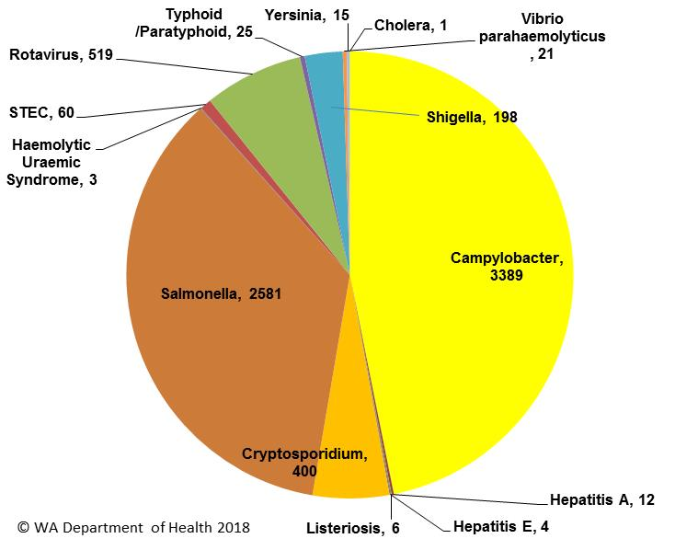

Figure A: Number of WA enteric disease notifications for 2017 by disease

Campylobacteriosiswas the most commonly notified enteric disease in 2017 (n=3389) followed by salmonellosis (n=2581) (Figure A), which had rates 22% and 66% higher than the previous five years, respectively. Cryptosporidiosis (n=400) and rotavirus infection (n=519) also had higher rates compared to the previous five years.

**Foodborne and probable foodborne outbreaks**

In 2017, there were 42 outbreaks of foodborne or probable foodborne disease investigated in WA that caused at least 459 cases of illness (Figure B). Of these 42 outbreaks, 35 were caused by *Salmonella* Typhimurium, three outbreaks were caused by norovirus, one outbreak each was caused by *Salmonella* Muenchen and *Salmonella* Paratyphi B bv Java, and two were of unknown aetiology.

Of the 42 outbreaks, there were 30 outbreaks where a food was implicated. Raw or undercooked egg dishes were the most commonly implicated food (n=18, 60%). The consumption of raw or runny eggs is not recommended and consumers risk being infected with a gastrointestinal disease if they do so as the evidence in this report, in part, is demonstrating.

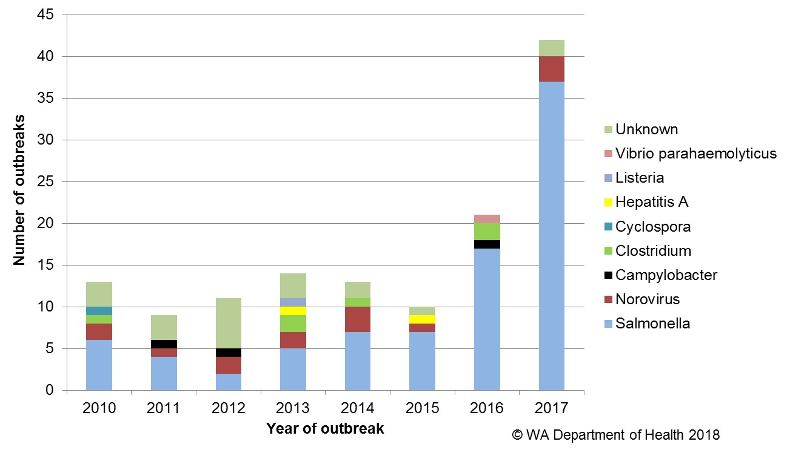

Figure B: Foodborne outbreaks investigated in WA by causative pathogen

**Non foodborne enteric disease outbreaks**

Non-foodborne enteric disease outbreaks and outbreaks with unknown mode of transmission are a major cause of illness, especially in institutions such as residential care facilities (RCFs). There were 173 non-foodborne outbreaks reported in 2017 which resulted in 3418 ill people, 64 hospitalisations and 10 associated deaths. Most of these outbreaks were in RCFs and due to person-to-person transmission.

**Table of contents**

Executive summary 3

1. Introduction 7

2. Data sources and methods 9

2.1. Data sources…………………………………………………………………………. 9

2.2. Data collection by Aboriginality…………………………………………….………...10

2.3. Regional boundaries………………………………………………………….…….…10

2.4. Calculation of rates………………………………………………………………….. .10

2.5. Definitions……………………………………………………………………………. .10

3. Site activities including prevention measures during the year ...11

3.1. Surveillance and investigation…………………………………………………….. 11

3.2. Activities on enhancing laboratory and epidemiological surveillance………… 12

3.3. Activities to assist enteric disease policy development………………………… 12

3.4. Strengthening skills and capacity for enteric disease surveillance and investigation ………………………………………………………………………………………….13

3.5. Conference meetings and presentations………………………………………… 13

4. Incidence of specific enteric diseases 14

4.1. Campylobacteriosis 14

4.2. Salmonellosis 17

4.3. Rotavirus infection 21

4.4. Cryptosporidiosis 23

4.5. Shigellosis infection 25

4.6. Hepatitis A 28

4.7. Shiga toxin-producing *E. coli* 29

4.8. Typhoid and paratyphoid fever 29

4.9. Listeriosis 30

4.10. *Vibrio parahaemolyticus* infection 30

4.11. *Yersinia* infection 31

4.12. Haemolytic Uraemic Syndrome (HUS) 31

4.13. Hepatitis E 31

4.14. Cholera 31

4.15. Botulism 31

5. Gastrointestinal disease outbreaks and investigations 32

5.1. Foodborne and probable foodborne outbreaks 32

5.2. Outbreaks due to non-foodborne transmission or with an unknown mode of transmission 36

5.3. Cluster investigations 38

6. References 43

Appendix 1: Number of notifications, notification rate and ratio of current to historical mean by pathogen/condition, 2012 to 2017, WA 49

List of tables

Table 1 Number and proportion of the top 10 *Salmonella* serotypes notified in WA, 2017, with comparison to the 5-year average 20

Table 2 The 10 most common *S*. Typhimurium MLVA types reported in 2017 21

Table 3 Foodborne and probable foodborne outbreaks, 2017 34

Table 4 Outbreaks due to non-foodborne transmission or unknown mode of transmission in WA by setting and agent, 2017 38

Table 5 Cluster investigations in WA by month investigation started, setting and agent, 2017 42

List of figures

Figure 1 Number of notifications of campylobacteriosis by year and month of onset, WA, 2012 to 2017. 15

Figure 2 Age-specific notification rates for campylobacteriosis by sex, WA, 2017 16

Figure 3 Campylobacteriosis notification rates by Aboriginality, WA, 2012 to 2017. 16

Figure 4 Campylobacteriosis notification rates by region and Aboriginality, WA, 2017. 17

Figure 5 Number of notifications of salmonellosis by year and month of onset, WA, 2012 to 2017. 18

Figure 6 Age-specific notification rates for salmonellosis by sex, WA, 2017. 18

Figure 7 Salmonellosis notification rates by region and Aboriginality, WA, 2017 19

Figure 8 Salmonellosis notifications by place of acquisition, by year of onset, 2012 to 2017 21

Figure 9 Number of notifications of rotavirus infection by year and month of onset, WA, 2012 to 2017 22

Figure 10 Age-specific notification rates for rotavirus by sex, WA, 2017 22

Figure 11 Rotavirus notification rates by region and Aboriginality, WA, 2017 23

Figure 12 Number of notifications of cryptosporidiosis by year and month of onset, WA, 2012 to 2017 24

Figure 13 Age-specific notification rates for cryptosporidiosis by sex, WA, 2017 25

Figure 14 Cryptosporidiosis notification rates by region and Aboriginality, WA, 2017 25

Figure 15 Number of notifications of shigellosis by year and month of onset, WA, 2012 to 2017 26

Figure 16 Age-specific notification rates for shigellosis by sex, WA, 2017 26

Figure 17 Shigellosis notification rates by region and Aboriginality, WA, 2017 27

Figure 18 The three most common *Shigella* types notified in 2017 28

Figure 19 Place of acquisition for hepatitis A notifications, 2012 to 2017. 29

Figure 20 Notifications of listeriosis showing non-pregnancy related infections and deaths, and materno-foetal infections and deaths, WA, 2012 to 2017. 30

Figure 21 Number of gastroenteritis outbreaks designated as non-foodborne transmission (animal-to-person, person-to-person, suspected waterborne, unknown) in 2017 37

Figure 22 Notifications of *Salmonella* Typhimurium PFGE 0001 in WA 40

Figure 23 Notifications of *Salmonella* Typhimurium MLVA 03-17-09-12-523 in WA 41

# Introduction

It has been estimated that there are 5.4 million cases of foodborne illness in Australia each year and that the cost of this illness is $1.2 billion per year1. This is likely to be an underestimate of the true cost of enteric illness in Australia as not all enteric infections are caused by foodborne transmission. Other modes of transmission such as person-to-person, animal-to-person and waterborne transmission are also very important in enteric infection. Most enteric infections are preventable through interventions at the level of primary production, institution infection control, and food handling and hand hygiene at food businesses and in households.

This report describes Western Australian enteric disease surveillance and investigations carried out in 2017 by OzFoodNet WA (OFN) and other Western Australian Department of Health agencies. Most of the data presented in this report is derived from enteric disease notifications from doctors and laboratories received by the Department of Health, WA (WA Health) and are likely to underestimate the true incidence of disease. This data nevertheless remains the most important information on incidence of these infections for surveillance purposes in Western Australia (WA). In addition, norovirus, which is not notifiable, is the cause of a large burden of illness in RCFs and also in the general community.

OFN is part of the Communicable Disease Control Directorate (CDCD) of WA Health. OFN in WA is also part of a National OzFoodNet network funded by the Commonwealth Department of Health2. The mission of OzFoodNet is to enhance surveillance of foodborne illness in Australia and to conduct applied research into associated risk factors. The OFN site based in Perth is responsible for the whole of WA, which has a total population of approximately 2.6 million. Collaboration between States and Territories is facilitated by circulation of fortnightly jurisdictional enteric surveillance reports, monthly teleconferences, tri-annual face-to-face meetings and through the informal network. This network also includes communication and consultation with Food Standards Australia New Zealand, the Commonwealth Department of Health, the National Centre for Epidemiology and Population Health, the Communicable Diseases Network of Australia and the Public Health Laboratory Network.

The primary objectives of OzFoodNet nationally are to:

* estimate the incidence and cost of foodborne illness in Australia,
* investigate the epidemiology of foodborne diseases, by enhancing surveillance and conducting special studies on foodborne pathogens,
* collaborate nationally to coordinate investigations into foodborne disease outbreaks, particularly those that cross State, Territory and country borders,
* train people to investigate foodborne illness.

On a local level, OFN conducts surveillance of enteric infections to identify clusters and outbreaks of specific diseases and conducts epidemiological investigations to help determine the cause of outbreaks. OFN also conducts research into the risk factors for sporadic cases of enteric diseases and develops policies and guidelines related to enteric disease surveillance, investigation and control. OFN regularly liaises with staff from the Population Health Units (PHUs), the Food Unit (FU) in the Environmental Health Directorate of WA Health (EHD); and the Environmental, Diagnostic and Molecular Epidemiology laboratories at PathWest Laboratory Medicine WA (PathWest).

CDCD maintains and coordinates the WA notifiable disease surveillance system and provides specialist clinical, public health and epidemiological training and advice to PHUs. The WA notifiable diseases surveillance system relies on the mandatory reporting by doctors and laboratories for the surveillance of 16 notifiable enteric diseases and syndromes.

PHUs are responsible for public health activities, including communicable disease control, in their WA administrative health regions. There are 8 PHUs in WA: Metro, Kimberley, Pilbara, Midwest, Wheatbelt, Goldfields, South West, and Great Southern. The PHUs monitor RCF gastroenteritis outbreaks and provide infection control advice. The PHUs also conduct follow up of single cases of important enteric diseases including typhoid, paratyphoid, hepatitis A and E, cholera and *Shigella dysenteriae*. OFN will also assist with the investigation of these enteric diseases if there is a cluster and/or they are locally acquired, and will investigate RCF outbreaks if the outbreak is due to probable foodborne transmission.

The FU liaises with Local Government (LG) Environmental Health Officers (EHOs) during the investigation of food businesses, and coordinates food business investigations when multiple LGs are involved.

The Environmental, Diagnostic and Molecular Epidemiology laboratories at PathWest provide public health laboratory services for the surveillance and investigation of enteric disease.

# Data sources and methods

## **Data sources**

Data on WA cases of notifiable enteric diseases were obtained from the WA notifiable infectious disease database (WANIDD). The notifications contained in WANIDD are received from medical practitioners and pathology laboratories under the provisions of the Public Health Act 2016 and subsequent amendments, and are retained in WANIDD if WA (for diseases not nationally notifiable)3 or national case definitions are met4.

Notifiable enteric diseases included in this report are campylobacteriosis, salmonellosis, rotavirus infection, cryptosporidiosis, shigellosis, hepatitis A infection, listeriosis, typhoid fever, shiga toxin-producing *E. coli* (STEC) infection, *Vibrio parahaemolyticus* infection, yersiniosis, hepatitis E infection, paratyphoid fever, cholera, haemolytic uraemic syndrome (HUS) and botulism. In April 2018, data for these diseases were extracted from WANIDD by optimal date of onset (ODOO) for the time period 01/01/2012 to 31/12/2017, and exported to Microsoft® Excel 2010. The ODOO is a composite of the ‘true’ date of onset provided by the notifying doctor or obtained during case follow-up, the date of specimen collection for laboratory notified cases, and when neither of these dates is available, the date of notification by the doctor or laboratory, or the date of receipt of notification, whichever is earliest.

Notification data extracted for this report may have been revised since the time of extraction. Subsequent minor changes to the data would not substantially affect the overall trends and patterns.

Information on *Salmonella* serotypes and *Shigella* species was obtained from PathWest, the reference laboratory for WA. Other specialised diagnostic data were obtained from the Microbiological Diagnostic Unit, University of Melbourne; the Australian *Salmonella* Reference Laboratory, Institute of Medical and Veterinary Science (Adelaide) and Queensland Health Forensic and Scientific Services. Pulsed field gel electrophoresis (PFGE) typing and multi-locus variable number tandem repeat analysis (MLVA) were carried out at PathWest.

Information on RCF outbreaks was collected by PHU staff who forward collated epidemiological and laboratory data to OFN.

## **Data collection by Aboriginality**

For the purposes of this report, the term ‘Aboriginal’ is used in preference to ‘Aboriginal and Torres Strait Islander’ to recognise that Aboriginal people are the original inhabitants of WA.

In WA, there is considerable mobility of Aboriginal people, both within WA and across the Northern Territory and South Australia borders, which means that some Aboriginal people will be patients of more than one health service. Due to the small size of the Aboriginal population in WA (3.0% of the total population in 2017) and the large number of cases reported in Aboriginal people, inaccuracies in the population estimates of Aboriginal people can have a disproportionate impact on calculated rates. In the preparation of this report, these factors are acknowledged as limitations.

## **Regional boundaries**

Notification data are broken down by regions that are based on PHU boundaries, reflecting WA Health administrative regions: Metropolitan Perth (METRO), South West (STHW), Great Southern (GSTH), Goldfields (GOLD), Central/Wheatbelt (CENT), Midwest (MIDW), Pilbara (PILB) and Kimberley (KIMB). PHU contact numbers and details are outlined at the website location in reference 5.

## **Calculation of rates**

WA’s estimated resident population figures used for calculation of rates were obtained from Rates Calculator version 9.5.5 (WA Health, Government of Western Australia). The Rates Calculator provides population estimates by age, sex, Aboriginality, year and area of residence, and is based on population figures derived from the 2011 census. The estimated population for WA in 2017 was 2 713 975 persons. Rates calculated for this report have not been adjusted for age.

## **Definitions**

**Foodborne outbreak** is an incident where two or more persons experience a similar illness after consuming a common food or meal and epidemiological analyses and/or microbiological evidence (including food and/or environmental) implicates the meal or food as the source of illness.

**Probable foodborne outbreak** is an incident where two or more persons experience a similar illness after consuming a common food or meal and a specific meal or food is suspected, but another mode of transmission cannot be ruled out.

**Person-to-person outbreak** is an incident where two or more persons experience a similar illness after exposure to an infected person.

**Unknown outbreak transmission** is an incident where two or more persons experience a similar illness but the mode of transmission is unable to be determined.

An implicated dish in a *Salmonella* outbreak is described as an **egg dish** if

* *Salmonella* is isolated from eggs (from the implicated premises) or the implicated dish containing eggs (microbiological evidence) OR
* There is analytical evidence that a dish containing eggs was associated with illness OR
* In the absence of microbiological or analytical evidence, an implicated dish is described as an egg dish if it contains raw or undercooked eggs and most cases report eating the dish in the absence of other high risk foods eaten in common.

# Site activities including prevention measures during the year

During 2017 the following activities and prevention measures were conducted by OFN.

## **Surveillance and investigation**

* Ongoing surveillance of infectious enteric disease in WA.
* Investigation of 42 local foodborne or probable foodborne outbreaks, seven *Salmonella* clusters and two *Shigella* clusters.
* Investigation of six *Listeria* *monocytogenes* cases.
* Surveillance of four paratyphoid and 21 typhoid cases.
* Investigation of *S.* Enteritidis cases with unknown travel history and interviews of nine locally acquired cases with a hypothesis generating questionnaire to identify risk factors for the cause of illness.
* Investigation of 132 person-to-person gastroenteritis outbreaks, including 85 which occurred in RCFs, 32 in child care centres and four in hospitals.
* Investigation of 37 gastroenteritis outbreaks with unknown mode of transmission including 21 occurring at RCFs and eight associated with childcare centres.
* Response to media enquiries following an article about cryptosporidiosis associated with waterparks published in Communicable Diseases Intelligence Volume 41 Issue 2, June 2017.
* Providing assistance to PHUs with distribution of shigellosis information in response to an increase in regional areas and neighbouring jurisdictions.

## **Activities on enhancing laboratory and epidemiological surveillance**

* Participation in ongoing quarterly meetings with PathWest and FU staff.
* Participation in six monthly meeting with EHD and CDCD (including OFN) from WA Health, and the Department of Primary Industries and Regional Development to discuss zoonotic diseases in WA.
* Provision of enteric disease data, interpretation and advice upon request to LG EHOs, laboratory and PHU staff.
* Participation in monthly national OzFoodNet teleconferences.
* Monitoring of culture-independent nucleic acid amplification diagnostic testing in private laboratories and impact on notification rates.
  + Including maintaining enhanced data set for STEC notifications due to the increase in notifications from laboratories conducting polymerase chain reaction (PCR) based tests.
* Addition of illness and exposure data for WA *Listeria monocytogenes* and hepatitis A cases to national enhanced data sets.
* Continued participation in a collaborative project between OFN, FU, PathWest and Murdoch University on molecular typing of locally acquired *Campylobacter* cases.
* Provision of information on diarrhoea-only outbreaks of unknown aetiology to PathWest for use in development and validation of a new viral PCR panel.
* Participation in cryptosporidiosis project with Murdoch University on the molecular typing of *Cryptosporidium* isolates from public swimming pools and human cases.
* Development of a guide and forms for PHUs for monitoring, surveillance and reporting of gastroenteritis outbreaks in schools, childcare facilities and other settings in WA.

## **Activities to assist enteric disease policy development**

* OFN epidemiologists were members of OzFoodNet and other national working groups on:
  + Outbreak register
  + Foodborne disease tool kit
  + STEC enhanced surveillance
  + Culture-independent diagnostic testing
  + Hepatitis SoNG
  + Antimicrobial resistance in *Salmonella* isolates from egg laying environments.
* Contribution of data and text for the discussion paper on the Western Australian Review of the *Food Act 2008*.
* Participation in a joint meeting with FU, OFN and Assistant Director General of Public and Aboriginal Health to discuss the *Salmonella* Typhimurium epidemic in WA.
* Participation in the Foodborne Illness Reduction Strategy Across-Government Advisory Group.
* Joint authors in publications:
  + Ng-Hublin JSY, Combs BG, Reid SC, Ryan UA, Differences in the occurrence and epidemiology of cryptosporidiosis in Aboriginal and non-Aboriginal people in Western Australia (2002−2012). [Infect Genet Evol](http://www.sciencedirect.com/science/journal/15671348) 2017;  [53](http://www.sciencedirect.com/science/journal/15671348/53/supp/C): 100-106.
  + Moffatt CRM, Musto J, Pingault N, Combs B, Miller M, Stafford R, Gregory J, Polkinghorne BG, Kirk MD. Recovery of *Salmonella* enterica from Australian layer and processing environments following outbreaks linked to eggs. Foodborne Pathog Dis. 2017; 14(8): 478-482.

## **Strengthening skills and capacity for enteric disease surveillance and investigation**

* Together with the FU, conducted foodborne outbreak investigation training for EHOs and public health nurses in metropolitan Perth in November and December.
* Lectured and conducted an outbreak scenario workshop on foodborne pathogens to Masters level students at University of Western Australia in September.

## **Conference meetings and presentations**

* Attended the national OzFoodNet face-to-face meetings in Brisbane in March and Canberra in December.
* Organised and hosted the OzFoodNet National Face-to-Face Meeting in Perth in July, including presentation of a talk on “*Salmonella* Typhimurium increase in WA”.
* In June attended the Communicable Diseases Control Conference in Melbourne and gave oral and poster presentations on the large *Salmonella* Typhimurium increase in WA.
* In Perth in September, presentation of a talk on “Epidemic *Salmonella* Typhimurium in WA” at the 71st Annual State Environmental Health Conference.

# Incidence of specific enteric diseases

In 2017, there were 7234 notifications of enteric disease in WA, which was a rate of 266 per 100 000 population. This rate was 39% higher than the mean rate for the previous five years of 191 per 100 000 population. The overall rate was heavily influenced by *Campylobacter* and *Salmonella* infections which comprised 47% and 36% of notifications, respectively. The age group with the highest enteric disease rate was 0-4 years with 732 cases per 100 000 population, which is 2.7 times the overall rate for WA. In 2017, Aboriginal people had a rate of 534 cases per 100 000 population which was 2.2 fold higher than for non-Aboriginal people (242 cases per 100 000 population). The age group with the highest rate among Aboriginal people was 0-4 years with a rate of 2841 cases per 100 000 population, compared to a 0-4 year age group rate for non-Aboriginal people of 601 cases per 100 000 population. The region with the highest rate was the KIMB region with 642 cases per 100 000 population. The GOLD and MIDW regions had the next highest rates (357 cases per 100 000 population and 311 cases per 100 000 population, respectively). The KIMB region had the highest rates for Aboriginal people (945 per 100 000 population) and non-Aboriginal people (381 per 100 000 population). Of the people notified with enteric infections with a known place of acquisition, 80% reported acquiring their infection in WA, 19% reported overseas travel and 1% reported interstate travel. Most (53%) people with enteric notifications who reported overseas travel had travelled to Indonesia.

# Campylobacteriosis

Campylobacteriosis was the most commonly notified enteric infection in 2017 with 3389 notifications and a rate of 125 per 100 000 population. This notification rate was similar to the 2016 rate (126 per 100 000 population), and 22% higher than the previous five year average (Appendix 1 and Figure 1). In 2017, notifications decreased from February to June and then increased, peaking in October. In 2017, the campylobacteriosis notification rate for males was higher than for females (136 and 114 per 100 000 population, respectively). The highest rates were in the older age groups 65 to 79 years (range 162 to 236 cases per 100 000 population), followed by the 0-4 years age group (163 per 100 000 population) (Figure 2). The lowest rates were in the age groups 10-14 years (84 per 100 000 population) and 40-44 years (86 per 100 000 population).

For the last six years the notification rate for non-Aboriginal people has been consistently higher than Aboriginal people and for 2017, the rate for non-Aboriginal people was 93% higher (117 and 61 per 100 000 population, respectively) (Figure 3). The 2017 notification rate for campylobacteriosis was highest in the GSTH region (157 cases per 100 000 population). The region with the lowest rate was the PILB (66 per 100 000 population) (Figure 4). Of those campylobacteriosis cases with known place of acquisition, most (77%) people acquired their illness in WA with 21% of people acquiring their illness overseas. Indonesia was the most common (56%) country of acquisition.

At least some of the increase in campylobacteriosis notifications is likely to be due to the use of PCR testing of faecal specimens by one large private pathology laboratory since 2014, and other private laboratories since 2016, which has greater sensitivity than culture techniques.

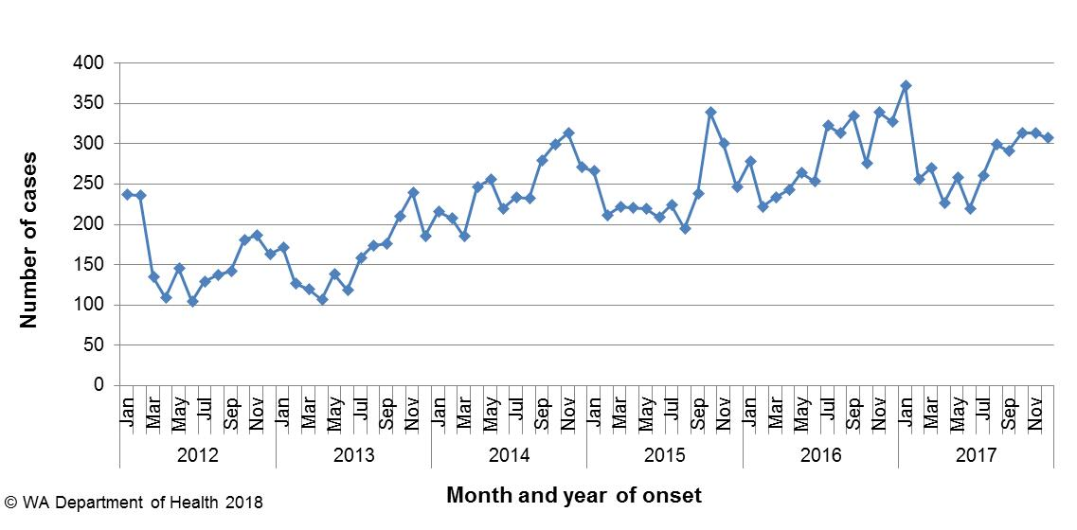

Figure 1 Number of notifications of campylobacteriosis by year and month of onset, WA, 2012 to 2017.

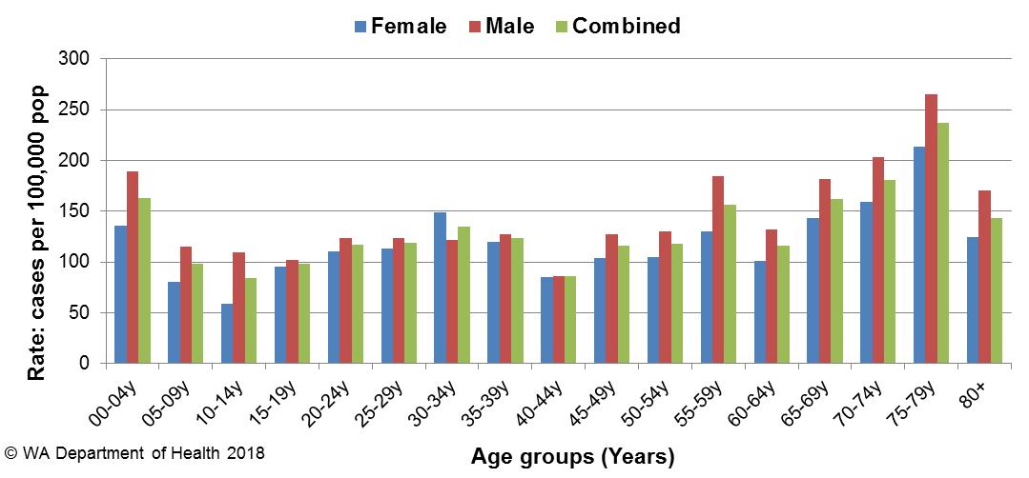

Figure 2 Age-specific notification rates for campylobacteriosis by sex, WA, 2017

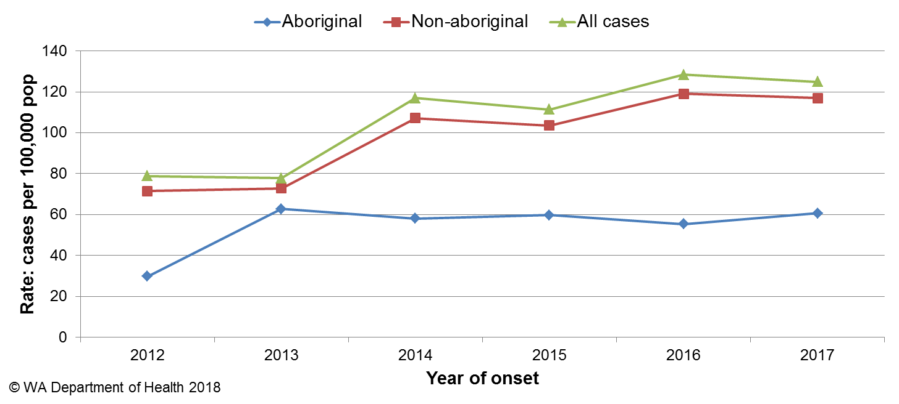

Figure 3 Campylobacteriosis notification rates by Aboriginality, WA, 2012 to 2017.

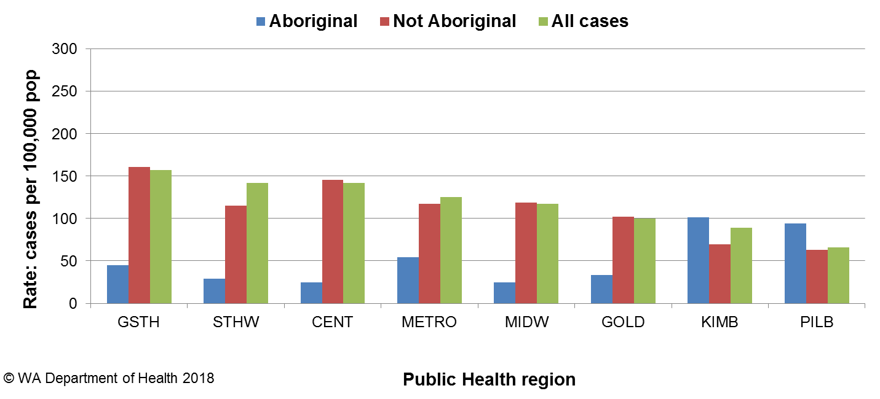

Figure 4 Campylobacteriosis notification rates by region and Aboriginality, WA, 2017.

# Salmonellosis

Salmonellosis, which is an infection due to *Salmonella,* was the second most commonly notified enteric infection in WA in 2017, with 2581 cases (Appendix 1). The salmonellosis notification rate for 2017 was 95 cases per 100 000 population which is the highest salmonellosis rate ever reported in WA and the second highest rate for 2017 among Australian jurisdictions ([NNDSS data](http://www9.health.gov.au/cda/source/rpt_4_sel.cfm)). The WA rate was also 66% higher than the previous five year average (57 cases per 100 000 population). The number of salmonellosis notifications peaked in January through to March and in each of these months, the number of notifications was higher than any previous months recorded in WA (Figure 5).

The notification rate for females was 10% higher than for males (100 and 91 per 100 000 population, respectively). As in previous years, the 0-4 year age group had the highest notification rate (302 per 100 000 population) (Figure 6). The age group 30-34 years, had the next highest notification rates (110 per 100 000 population).

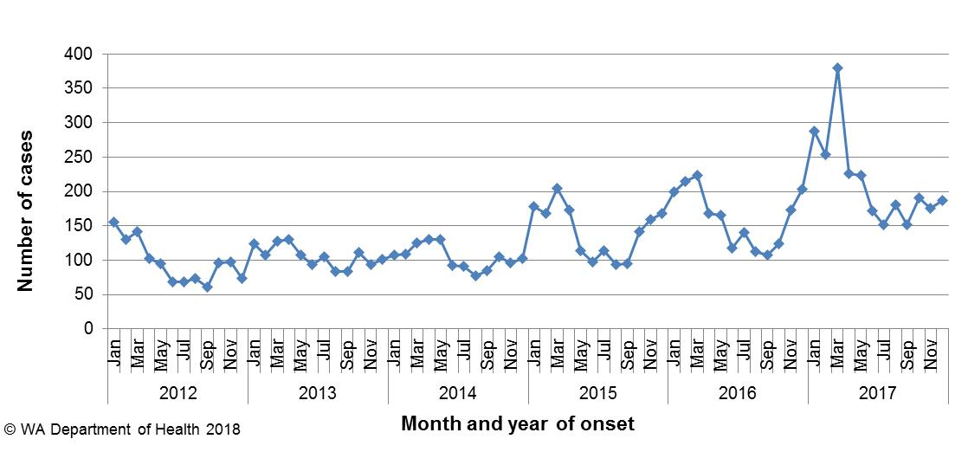

Figure 5 Number of notifications of salmonellosis by year and month of onset, WA, 2012 to 2017.

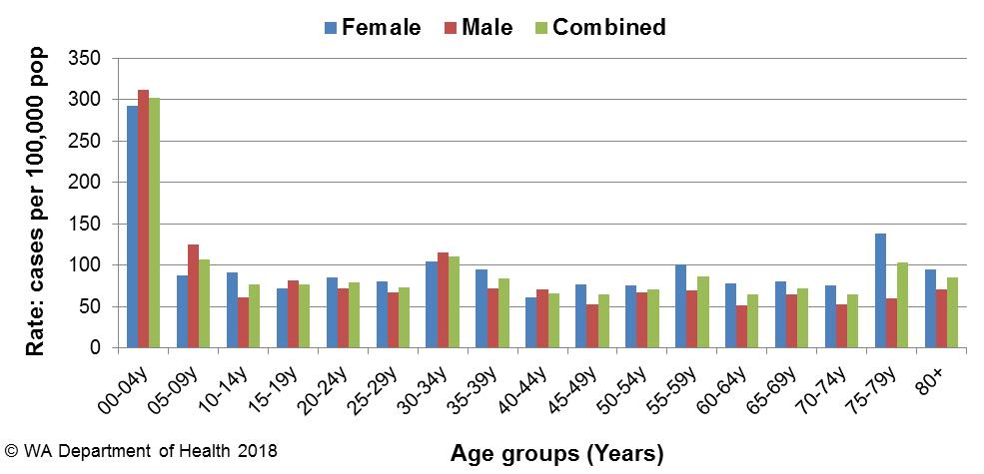

Figure 6 Age-specific notification rates for salmonellosis by sex, WA, 2017.

The overall salmonellosis notification rate for Aboriginal people was 150 cases per 100 000 population, which was 1.68 times the notification rate for non-Aboriginal people at 90 cases per 100 000 population.

The KIMB region had the highest notification rate in 2017 (255 per 100 000 population) which was 4.2 times the rate for the GSTH region, which had the lowest notification rate at 60 cases per 100 000 population. In the KIMB region, rates were higher for both Aboriginal and non-Aboriginal people when compared with other regions, with the exception of the PILB region which had the highest notification rate for Aboriginal people (Figure 7). These notifications in the PILB region included a variety of serotypes and did not cluster in time or location. Of those salmonellosis cases with known place of acquisition (2054/2581, 80%), most (80%) people acquired their illness in WA with 19% of people acquiring their illness overseas (Figure 8). Indonesia was the most common (58%) country of acquisition.

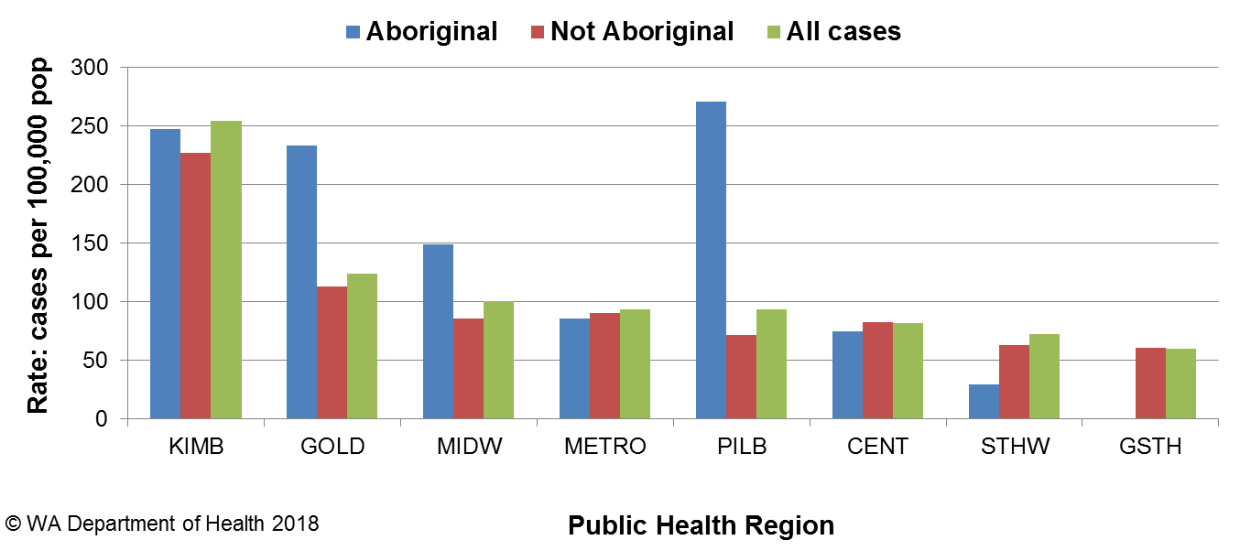

Figure 7 Salmonellosis notification rates by region and Aboriginality, WA, 2017

The most commonly notified *Salmonella* serotype in WA in 2017 was *S.* Typhimurium (STM), with 1440 notifications (Table 1), which was 2.93 fold higher than the mean of the previous five years. STM is further typed using MLVA and there were 216 MLVA types identified in 2017. Of these, the top 10 types contributed 67% (n= 967) of the total STM notifications and the most common MLVA type (03-17-09-12-523) contributed 42% of all STM notifications (Table 2). MLVA type 03-17-09-12-523 was also the *Salmonella* type that caused 16 of the 37 *Salmonella* outbreaks investigated in 2017. The next most common MLVA types were 03-17-10-12-523 (n=104) and 03-12-11-10-523 (n=53), which caused one and four outbreaks, respectively.

The second most commonly notified serotype was *S*. Enteritidis with 175 notifications which was 24% below the mean of the previous five years (Table 1). In 2017, 91% (160/175) of cases with *S*. Enteritidis infection travelled overseas during their incubation period and of these cases, 78% (n=124) had travelled to Indonesia. There were nine (5%) cases of *S*. Enteritidis that appeared to be locally acquired, but interviews of cases did not identify a common source.

Besides *S.* Typhimurium, the number of notifications of *S.* Singapore, *S.* Stanley and *Salmonella* species were also more than double the averages of the previous five years (Table 1). The number of *S.* Singapore notifications was highest from February to June, peaking in March 2017, and mostly affected residents in the metropolitan area. Details of this cluster investigation were provided in the [OzFoodNet 2017 second quarter report](http://ww2.health.wa.gov.au/Articles/F_I/Infectious-disease-data/Enteric-infection-reports-and-publications-OzFoodNet). No hypothesis for the cause of illness could be established. *S.* Stanley was investigated in October when the number of notifications peaked at 10 for the month. Follow-up of cases identified that most had travelled to Southeast Asia. The increase in *Salmonella* species (where a species was not identified) was likely to be due to the introduction of PCR testing by some WA laboratories. Some specimens are PCR-positive for *Salmonella* but culture-negative. A culture-positive result is required for the serotype to be determined.

Table 1 Number and proportion of the top 10 *Salmonella* serotypes notified in WA, 2017, with comparison to the 5-year average



*Percentage of total *Salmonella* cases notified in 2017.

‡Ratio of the number of reported cases in 2017 compared to the five year mean of 2012-2016.

Table 2 The 10 most common *S*. Typhimurium MLVA types reported in 2017



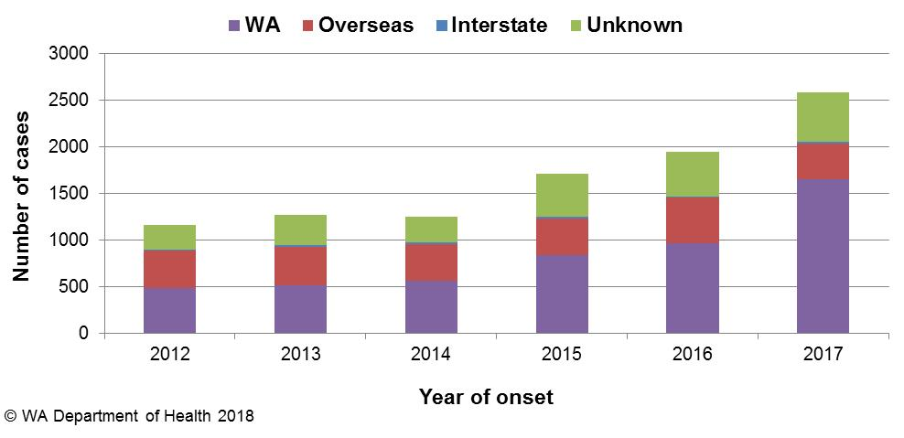

Figure 8 Salmonellosis notifications by place of acquisition, by year of onset, 2012 to 2017

# Rotavirus infection

There were 519 cases of rotavirus infection in WA in 2017 (19.1 per 100 000 population), making rotavirus the third most commonly notified enteric infection. The notification rate in 2017 was 28% higher than the previous five year average of 14.9 cases per 100 000 population (Appendix 1). Historically, rotavirus notifications typically peak in the winter months (Figure 9) which was also the peak period in 2017.

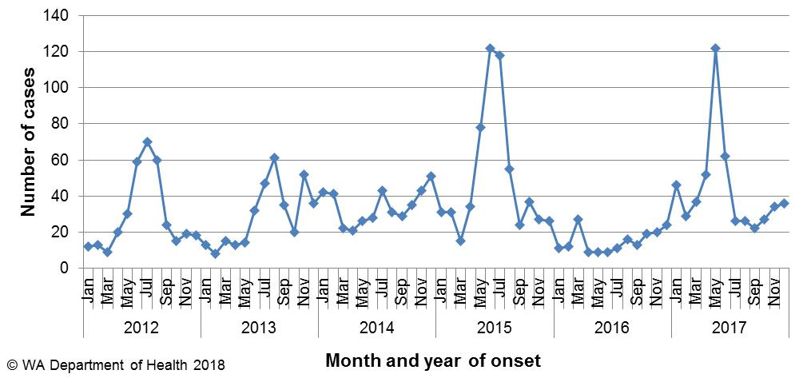

Figure 9 Number of notifications of rotavirus infection by year and month of onset, WA, 2012 to 2017

As in previous years, the age group with the highest rotavirus notification rate in 2017 was the 0-4 years group (160 cases per 100 000 population), followed by the 5-9 year age group (24 cases per 100 000 population) (Figure 10), the age cohorts for which vaccination was available. The overall notification rate was similar for females and males (20 and 19 per 100 000 population, respectively).

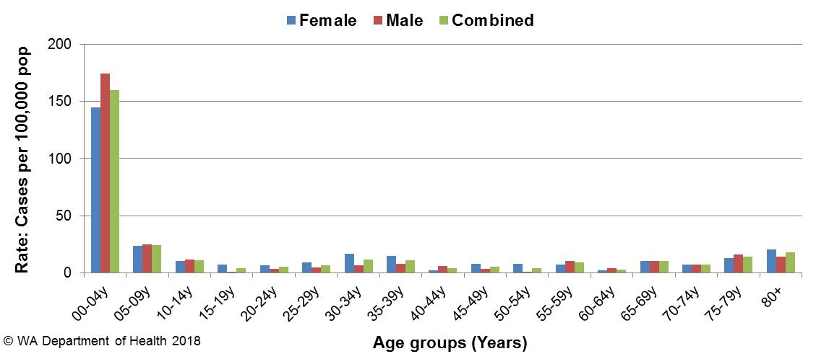

Figure 10 Age-specific notification rates for rotavirus by sex, WA, 2017

The regions with the highest rotavirus notification rates in 2017 were the KIMB, GOLD and MIDW regions (169, 52 and 50 cases per 100 000 population, respectively) (Figure 11). Overall, notification rates were 8.7 times higher for Aboriginal than for non-Aboriginal people (126 and 15 per 100 000 population, respectively). Of those rotavirus cases with known place of acquisition, most (95%) people acquired their illness in WA with 4% of people acquiring their illness overseas. There were two person-to-person outbreaks due to rotavirus both in RCFs (Table 4).

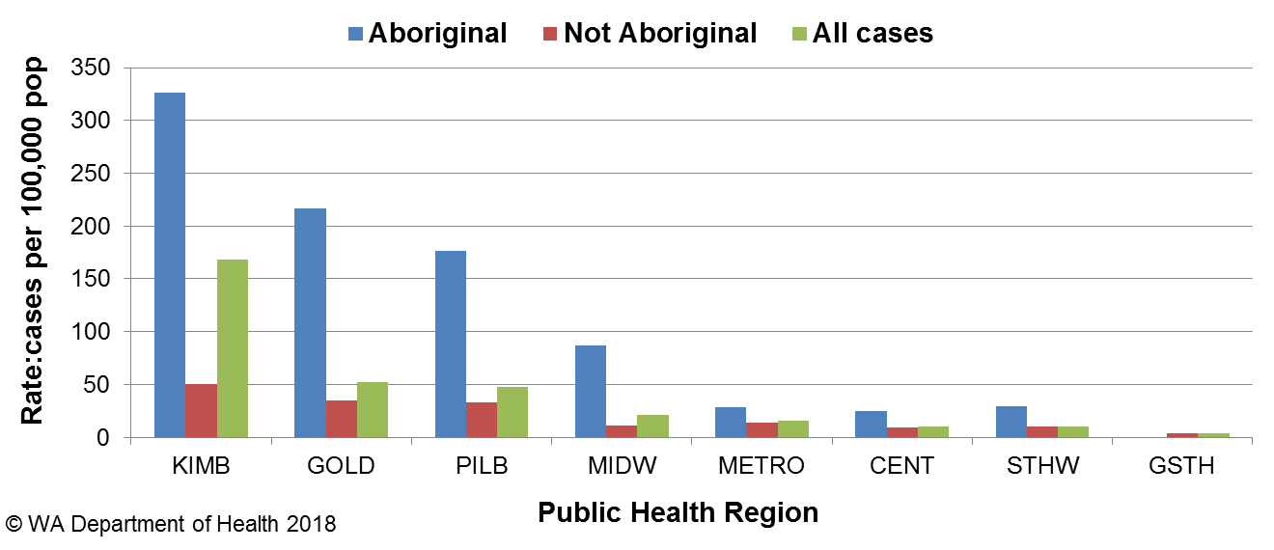

Figure 11 Rotavirus notification rates by region and Aboriginality, WA, 2017

# Cryptosporidiosis

There were 400 cryptosporidiosis cases notified in 2017, which was the fourth most common notifiable enteric disease. The notification rate (15 cases per 100 000 population) was 39% higher than the mean of the previous five years (10.6 cases per 100 000 population) (Appendix 1). In each of the years from 2012 to 2017, the number of cryptosporidiosis notifications was higher in the late summer through to autumn (Figure 12). From January to May 2017, there was a large increase in cryptosporidiosis notifications. Part of this increase was associated with three public swimming pool outbreaks due to cryptosporidiosis (See [OzFoodNet 2017 first quarter report](http://ww2.health.wa.gov.au/Articles/F_I/Infectious-disease-data/Enteric-infection-reports-and-publications-OzFoodNet)).

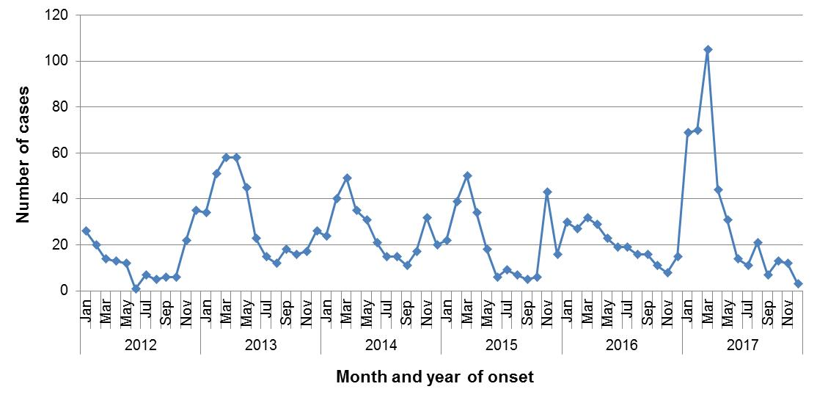

Figure 12 Number of notifications of cryptosporidiosis by year and month of onset, WA, 2012 to 2017

The cryptosporidiosis notification rate in females was 32% higher than males in 2017 (16.8 and 12.7 per 100 000 population, respectively). The 0-4 years age group had the highest notification rate (70 per 100 000 population), and accounted for 33% of all cryptosporidiosis notifications (Figure 13). The overall notification rate for the Aboriginal population was 3.1 times the rate for the non-Aboriginal population (40 and 13 cases per 100 000 population, respectively). The KIMB region had the highest notification rate (41 cases per 100 000 population), and the GSTH region had the lowest notification rate (8 cases per 100 000 population) (Figure 14). Of those cryptosporidiosis cases with known place of acquisition, most (89%) people acquired their illness in WA, with 10% of people acquiring their illness overseas.

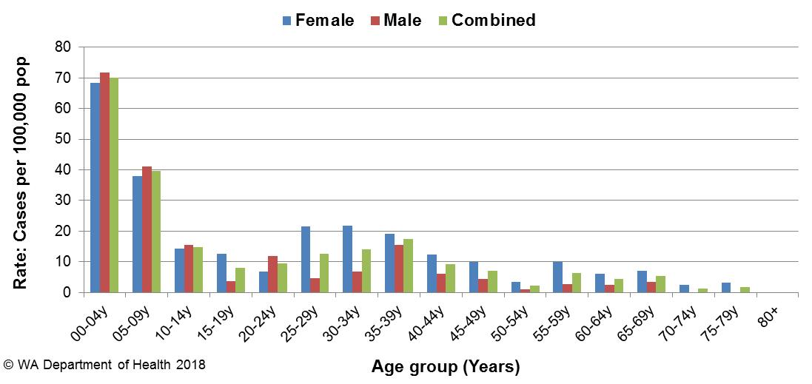

Figure 13 Age-specific notification rates for cryptosporidiosis by sex, WA, 2017

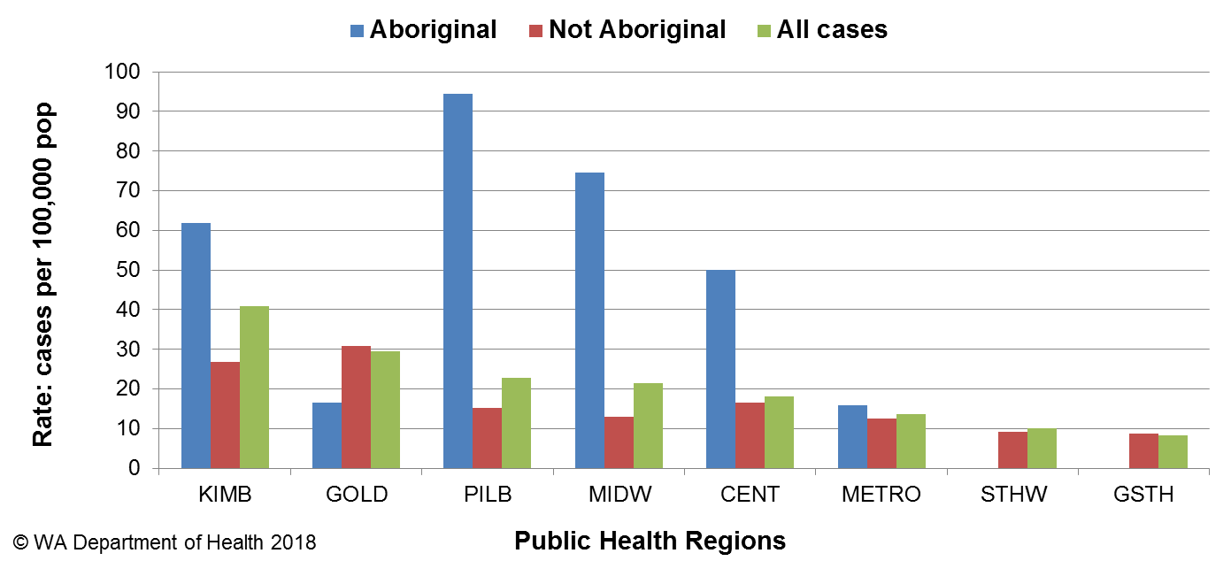

Figure 14 Cryptosporidiosis notification rates by region and Aboriginality, WA, 2017

# Shigellosis

There were 198 cases of culture-positive shigellosis notified in 2017, with a notification rate of 7.3 per 100 000 population, which is 2.5 fold higher than the previous five year average (Appendix 1). The number of notifications was highest in October 2017 (Figure 15).

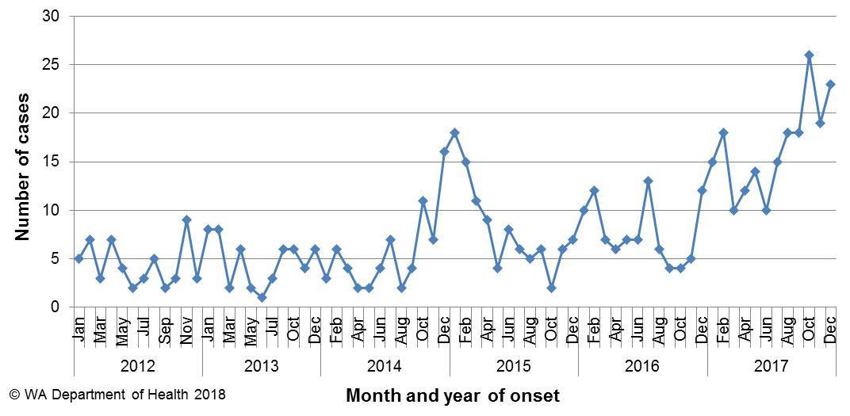

Figure 15 Number of notifications of shigellosis by year and month of onset, WA, 2012 to 2017

The shigellosis notification rate was 31% higher in females compared to males in 2017 (8.3 and 6.3 per 100 000 population, respectively). The 0-4 years age group had the highest rate of notification with 29 cases per 100 000 population (Figure 16). The population health region with the highest notification rate was the KIMB (84 cases per 100 000 population) (Figure 17).

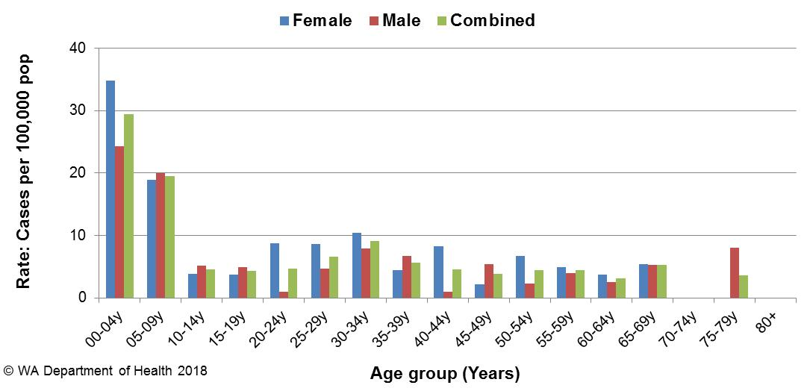

Figure 16 Age-specific notification rates for shigellosis by sex, WA, 2017

In 2017, the notification rate was 52 times higher for the Aboriginal population as compared to the non-Aboriginal population (149.3 and 2.9 per 100 000 population, respectively).

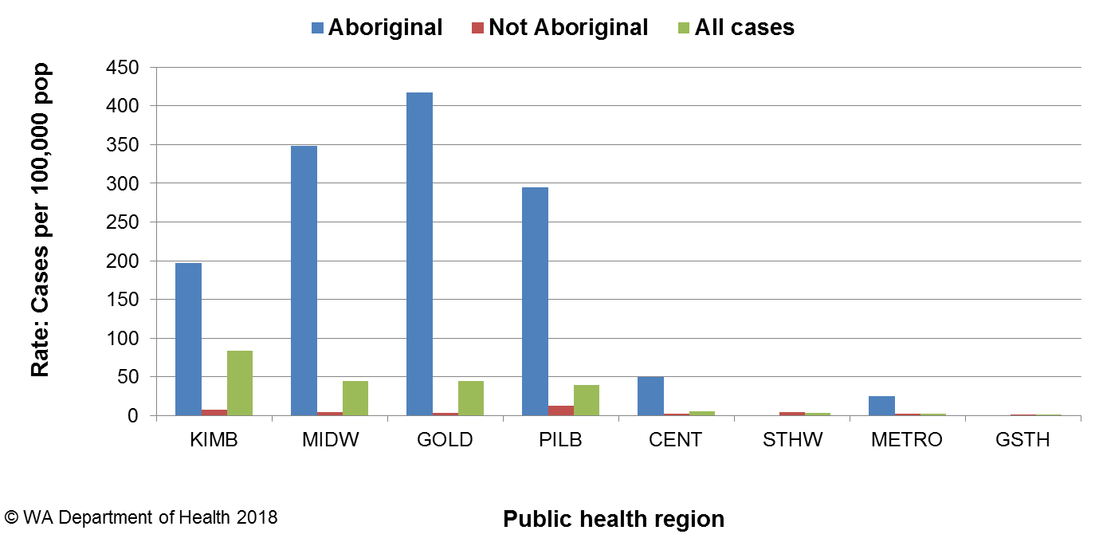

Figure 17 Shigellosis notification rates by region and Aboriginality, WA, 2017

The predominant subtypes of *Shigella* notified in 2017 were *S. flexneri* 2b (n=84) which emerged in April then peaked in October, *S. sonnei* biotype A (n=57) which peaked in January and then decreased, and *S. sonnei* biotype G (n=30) which had small numbers of notifications reported throughout the year (Figure 18). *S. flexneri* 2b notifications were 4700% higher than the five year average of two notifications. Of the notifications with known travel history, all *S. flexneri* 2b were locally acquired and 89% were in Aboriginal people. *S. sonnei* biotype A and *S. sonnei* biotype G notifications were 134% and 49% higher than the five year average, respectively. For *S. sonnei* biotype A, of those with travel history, most (98%) were locally acquired and 74% were in Aboriginal people; 62% of *S. sonnei* biotype G cases had travelled overseas and all cases were non-Aboriginal people. *S. sonnei* biotype G was twice as common among males (n=20) than females (n=10).

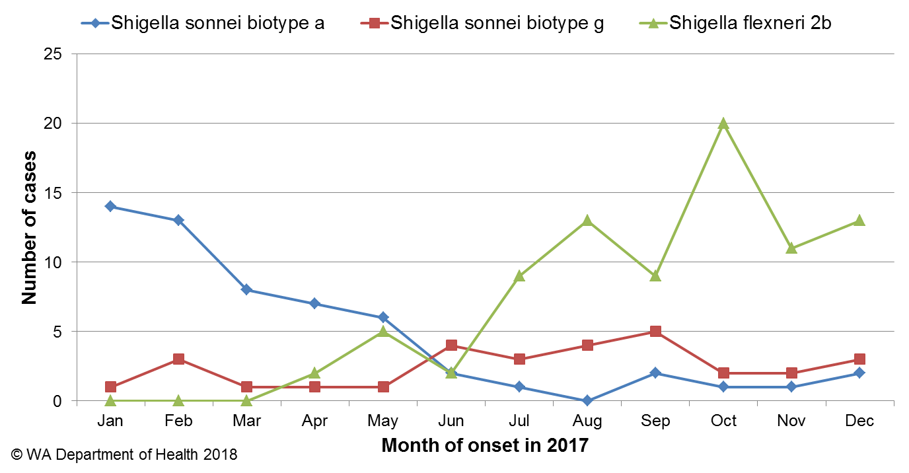

Figure 18 The three most common *Shigella* types notified in 2017

# Hepatitis A infection

There were 12 cases of hepatitis A notified in 2017 with a rate of 0.4 case per 100 000 population, which was a 38% decrease from the average rate of the previous five years (Appendix 1).

The age range for the 2017 cases was 4 to 61 years (median age 27 years), with nine (75%) male and three (25%) female notifications. Most (n=10, 83%) notifications in 2017 were acquired overseas (Figure 19) in nine different countries.

The two locally acquired cases were due to household secondary transmission and the index case had travelled to Afghanistan.

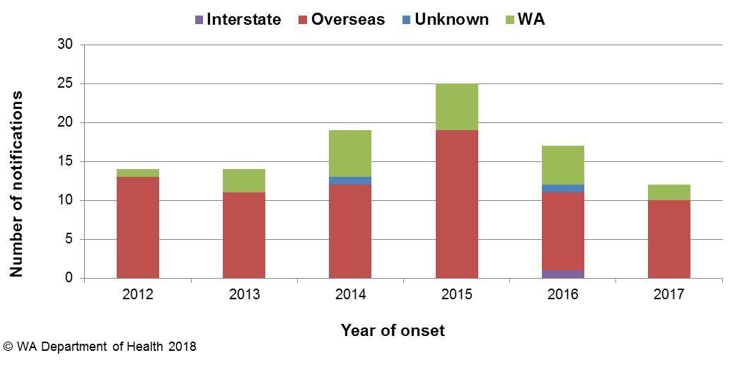

Figure 19 Place of acquisition for hepatitis A notifications, 2012 to 2017.

# Shiga toxin-producing *E. coli* infection

There were 60 cases of STEC reported in 2017 with a rate of 2.2 cases per 100 000 population which was 5.8 fold higher than the five year average. It is thought that the main reason for the large fold increase in 2017 compared to previous years is due to the introduction of PCR tests for STEC by two pathology laboratories which also notified the most number of STECs (n=59). One of these laboratories uses a PCR test on bloody diarrhoea faecal specimens and began using this method in January 2016. Another laboratory also introduced a PCR test for STEC on request in July 2016. Of the 60 cases, 57 were followed up and 50 (88%) had an acute illness prior to testing. Culture was performed on 56 specimens, 29 (52%) were culture-positive. The predominant serotype was O157 (n=11), and remaining isolates were all unique serotypes. Of the 60 cases, 28 (47%) were male and 32 (53%) were female with a median age of 47 years (range 0-91 years). Of those cases with a known travel history, 82% had acquired their infection in WA and 18% had acquired their infection overseas.

# Typhoid and paratyphoid fever

In 2017, there were 21 cases of typhoid fever (caused by *Salmonella* Typhi) notified with a rate of 0.8 cases per 100 000 population, which was 56% higher than the average rate of the previous five years (Appendix 1). All cases had recently travelled overseas prior to illness onset and countries included India (n=14), Indonesia (n=2), Pakistan (n=2), Estonia (n=1), Iraq (n=1), and Nepal (n=1). Four cases of paratyphoid fever were notified in 2017 with a rate of 0.1 cases per 100 000 population, which was 63% lower than the mean rate of the previous five years (Appendix 1). All paratyphoid fever cases were *S*. ParatyphiA, had overseas acquisition, and countries included India (n=3) and Pakistan (n=1).

# Listeriosis

There were six cases of *Listeria monocytogenes* infection notified in 2017 with a rate of 0.2 cases per 100 000 population, which is similar to the average rate of the previous five years (Appendix 1). Notifications comprised one perinatal pair and five non-pregnancy related cases (Figure 20). One non-pregnancy case did not have any immunocompromising illnesses, while the other four non-pregnancy cases reported use of immunosuppressive medications. Cases ranged in age from 0 to 88 years, with five female and one male case. Two cases died as a result of the infection.

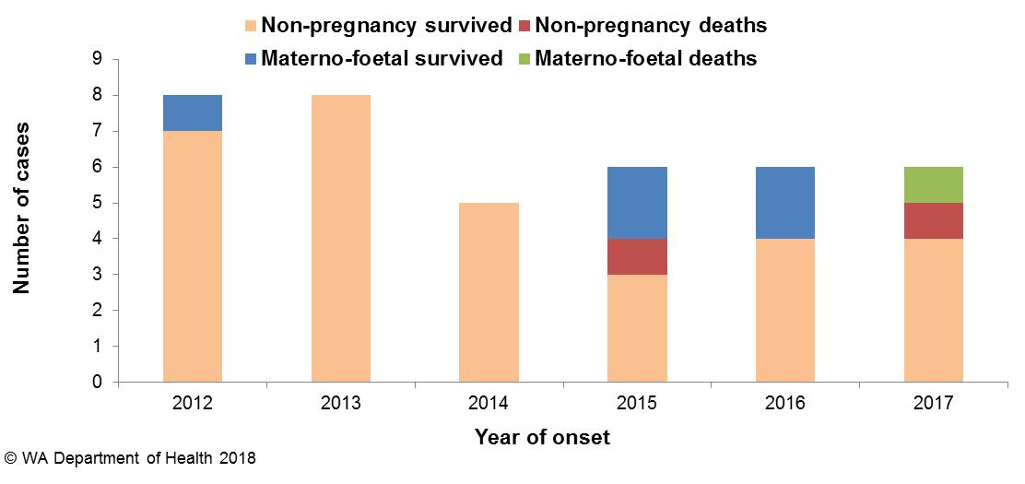

Figure 20 Notifications of listeriosis showing non-pregnancy related infections and deaths, and materno-foetal infections and deaths, WA, 2012 to 2017.

# *Vibrio parahaemolyticus* infection

There were 21 cases of *Vibrio parahaemolyticus* infection notified in 2017 with a rate of 0.8 cases per 100 000 population which was 31% higher than the mean rate of the previous five years (Appendix 1). This included 16 male and five female cases, ranging in age from 21 to 73 years. Of these cases, 13 reported travel overseas during their incubation period (to Indonesia n=6, Thailand n=2, Philippines n=1, Vietnam n=1, Malaysia n=1, Ecuador n=1, and Singapore n=1) and eight acquired their illness in Western Australia.

# *Yersinia* infection

There were 15 cases of culture-positive *Yersinia* *enterocolitica* infection notified in 2017, with a rate of 0.6 cases per 100 000 population which is similar to the mean rate of the previous five years (Appendix 1). There were nine female and six male cases with ages ranging between 0 and 88 years. Twelve cases had acquired their illness in WA, one case had acquired their illness interstate and the place of acquisition was unknown for two cases. The majority (n=13) of cases were notified by one private pathology laboratory, which uses a faecal PCR screening test with reflex culture.

# Haemolytic Uraemic Syndrome (HUS)

Three cases of HUS were notified in 2017 in children aged 14-41 years, with two female cases and one male case. Onsets were in January, March and April and there was no apparent link between cases. Two cases were negative for STEC by PCR; one had diarrhoea for one day and the other case had bloody diarrhoea. The third case had bloody diarrhoea and was PCR positive for STEC and culture positive for serotype O75:H7. No obvious risk factors were noted for the three cases.

# Hepatitis E infection

There were four cases of hepatitis E notified in 2017. All cases were male, aged 19-62 years, and had travelled to India (n=1), Bangladesh (n=1), Indonesia (n=1) and Singapore (n=1).

# Cholera

There was one notification of cholera in a 70 year old male who had travelled to Thailand. The serotype was O1 Ogawa var El Tor.

# Botulism

There were no cases of botulism notified in WA in 2017.

# Gastrointestinal disease outbreaks and investigations

# Foodborne and probable foodborne outbreaks

There were 42 foodborne or probable foodborne gastroenteritis outbreaks investigated in WA in 2017 (Table 3). This was an almost 3 fold increase in foodborne and probable foodborne outbreaks compared to the five year average (n=14.2). The 42 foodborne outbreaks caused at least 459 cases of gastroenteritis and 61 hospitalisations. Short descriptions of these outbreaks are provided in [2017 quarterly reports](http://ww2.health.wa.gov.au/Articles/F_I/Infectious-disease-data/Enteric-infection-reports-and-publications-OzFoodNet).

**Aetiology**

Of the 42 outbreaks, 35 were due to STM, with 16 outbreaks of MLVA type 03-17-09-12-523, four outbreaks of MLVA type 03-12-11-10-523, two outbreaks of MLVA type 03-26-16-12-523 and 13 outbreaks of unique MLVA types. This was a greater than 5 fold increase in STM outbreaks compared to the five year average (n=6.6). For the remaining seven outbreaks, three outbreaks were due to norovirus, one each was due to *Salmonella* Muenchen and *Salmonella* Paratyphi B bv Java, and two were of unknown aetiology.

**Food vehicles**

The investigations of the 42 outbreaks identified food vehicles for 30 outbreaks. Of these, 18 (60%) were associated with eating egg dishes. This was a greater than 4 fold increase in egg dishes compared to the five year average (n=4.2). Egg dishes included raw egg sauces, tiramisu, boiled eggs, breakfast egg dishes, burgers, chocolate mousse, chocolate soufflé, egg casserole, hollandaise sauce, cannelloni, pikelets, mousse cake, raw egg desserts, raw fresh pasta, raw muffin mix, and Vietnamese meat rolls. All 18 egg-related outbreaks were caused by STM, including MLVA types 03-17-09-12-523 (n=4), 03-12-11-10-523 (n=3), and one each of 03-25-16-12-523, 03-25-16-11-523, 03-26-16-12-523, 03-26-16-11-523, 03-17-07-12-523, 03-17-10-12-523, 03-14-09-11-523 and 03-12-10-11-523. In three outbreaks, multiple MLVA types were identified in cases. In the first, MLVA 03-20-09-12-523 was the predominant type, with one case identified with 03-17-09-12-523. In the second, MLVA 03-17-09-12-523 was the predominant type, with one case identified with 03-17-09-11-523 and one case with 03-16-09-12-523; and in the third, MLVA 03-10-16-11-496 was the predominant type, with one case identified with 03-10-15-11-496. The egg producer and production system was able to be determined in 10 of these 18 egg-related outbreaks and included multiple egg producers, and free-range and cage production systems. This information was gathered from environmental investigations. This finding should be interpreted with caution as denominator information regarding market share is unavailable, and multiple factors associated with the handling of eggs and egg-based products can contribute to whether an egg dish causes an infection.

**Epidemiological investigation and evidence**

The evidence that supported that the 42 investigations of enteric outbreaks were due to foodborne or probable foodborne transmission was obtained using only analytical studies for five outbreaks, analytical studies and microbiology for one outbreak, microbiology and descriptive case studies (DCSs) for three outbreaks, and only DCS for 33 outbreaks. The analytical studies involved interviewing those people who were at the meal using a questionnaire on all foods/drinks available. These studies can be used to find a statistical association between a food eaten and illness, and in 2017 an association was found in six outbreaks. Microbiological evidence refers to the implicated food being positive for the same pathogen as the cases. For the outbreaks investigated as a DCS, there was strong circumstantial evidence to support probable foodborne transmission, such as independently visiting a common food business (36 outbreaks).

**Food preparation settings**

The setting where food was prepared for the 42 foodborne outbreaks in 2017 included 18 restaurants (caused by *S*. Typhimurium n=16 and norovirus n=2), nine private residences (caused by *S*. Typhimurium n=8 and *S.* Paratyphi B bv Java), two commercial caterers (including two outbreaks of unknown aetiology associated with the same commercial caterer, and one outbreak caused by *S.* Typhimurium), two take-away venues (one each caused by norovirus and *S.* Typhimurium), two childcare centres (both caused by *S.* Typhimurium), two bakeries (both caused by *S.* Typhimurium), two mine sites (both caused by *S.* Typhimurium), and one outbreak each in an aged care facility (*S.* Typhimurium), a cruise ship (*S.* Typhimurium), a hospital (*S.* Typhimurium) and a place of worship (*S.* Muenchen).

**Table 3 Foodborne and probable foodborne outbreaks, 2017**

|  |  |  |  |  |  |  |  |  |  |  |
| --- | --- | --- | --- | --- | --- | --- | --- | --- | --- | --- |
| **Mode of transmission** | **Outbreak code** | **Month of outbreak1** | **Where food prepared** | **Where food eaten** | **Agent responsible2** | **Number ill** | **Hospitalised** | **Died** | **Evidence3** | **Responsible vehicles** |
| probable foodborne | 042-2017-001 | Feb | restaurant | restaurant | Salmonella Typhimurium MLVA 03-17-09-12-523 | 5 | 1 | 0 | D | Chinese food |
| probable foodborne | 042-2017-002 | Feb | restaurant | restaurant | Salmonella Typhimurium MLVA 03-25-16-12-523 | 6 | 1 | 0 | D | egg dish: Breakfast egg dishes |
| probable foodborne | 042-2017-004 | Feb | commercial caterer | other | Salmonella Typhimurium MLVA 03-17-09-12-523 | 22 | 1 | 0 | D | unknown |
| probable foodborne | 042-2017-005 | Feb | take-away | private residence | Salmonella Typhimurium MLVA 03-17-09-12-523 x20; 03-17-09-11-523 x1; 03-16-09-12-523 x1 | 24 | 10 | 0 | D | nasi lemak |
| foodborne | 042-2017-006 | Feb | restaurant | restaurant | Salmonella Typhimurium MLVA 05-14-14-11-490 | 6 | 1 | 0 | D | Unknown |
| foodborne | 042-2017-007 | Feb | restaurant | restaurant | Salmonella Typhimurium MLVA 03-26-16-11-523 | 3 | 0 | 0 | M | egg dish: hollandaise sauce |
| probable foodborne | 042-2017-008 | Feb | cruise/airline | cruise/airline | Salmonella Typhimurium MLVA 03-17-09-12-523 | 16 | 0 | 0 | D | unknown |
| foodborne | 042-2017-009 | Mar | restaurant | restaurant | Salmonella Typhimurium MLVA 03-17-09-12-523 | 42 | 1 | 0 | AM | fried rice, honey chicken |
| foodborne | 042-2017-010 | Mar | private residence | private residence | Salmonella Para B bv Java | 15 | 2 | 0 | A | chicken curry |
| foodborne | 042-2017-011 | Mar | other | other | Salmonella Typhimurium MLVA 03-20-09-12-523 x21, MLVA 03-17-09-12-523 x1 | 62 | 5 | 0 | A | egg dish: boiled eggs |
| probable foodborne | 042-2017-012 | Mar | private residence | private residence | Salmonella Typhimurium MLVA 03-17-09-12-523 | 5 | 3 | 0 | D | arancini |
| probable foodborne | 042-2017-015 | Mar | other | other | Salmonella Typhimurium MLVA 03-17-09-12-523 | 9 | 0 | 0 | D | Unknown |
| probable foodborne | 042-2017-013 | Apr | restaurant | restaurant | Salmonella Typhimurium MLVA 03-17-09-12-523 | 7 | 2 | 0 | D | egg dish: raw egg mayonnaise/aioli |
| probable foodborne | 042-2017-017 | May | restaurant | restaurant | Salmonella Typhimurium MLVA 03-13-11-10-523 | 4 | 0 | 0 | D | Unknown |
| foodborne | 042-2017-018 | May | private residence | private residence | Salmonella Typhimurium MLVA 03-12-11-10-523 | 7 | 0 | 0 | M | egg dish: raw egg chocolate mousse cake |
| foodborne | 042-2017-019 | May | child care | child care | Salmonella Typhimurium MLVA 03-25-16-11-523 | 29 | 2 | 0 | D | egg dish: egg casserole |
| probable foodborne | 042-2017-020 | May | private residence | private residence | Salmonella Typhimurium MLVA 03-17-09-12-523 | 5 | 4 | 0 | D | egg dish: raw egg fresh pasta |
| foodborne | 042-2017-021 | Jun | restaurant | other | Salmonella Typhimurium MLVA 03-17-09-12-523 | 13 | 3 | 0 | D | egg dish: Vietnamese meat roll |
| probable foodborne | 042-2017-022 | Jul | bakery | private residence | Salmonella Typhimurium MLVA 03-17-09-13-523 | 5 | 1 | 0 | D | bakery cakes |
| foodborne | 042-2017-023 | Jul | private residence | private residence | Salmonella Typhimurium MLVA 03-17-10-12-523 | 3 | 3 | 0 | M | egg dish: Raw muffin mix |
| probable foodborne | 07/17/MDJ | Jul | take-away | restaurant | Norovirus | 11 | 2 | 0 | A | donut |
| probable foodborne | 042-2017-024 | Aug | other | community | Salmonella Muenchen | 5 | 1 | 0 | D | unknown |
| probable foodborne | 042-2017-025 | Aug | child care | child care | Salmonella Typhimurium MLVA 03-14-09-11-523 | 15 | 1 | 0 | D | egg dish: pikelets |
| probable foodborne | 042-2017-026 | Aug | aged care | aged care | Salmonella Typhimurium MLVA 03-17-09-12-523 | 10 | 4 | 1 | D | unknown |
| foodborne | 042-2017-027 | Aug | bakery | private residence | Salmonella Typhimurium MLVA 03-12-11-10-523 | 3 | 1 | 0 | D | custard filled cake |
| probable foodborne | 042-2017-028 | Aug | private residence | private residence | Salmonella Typhimurium MLVA 03-17-09-12-523 | 5 | 0 | 0 | D | Chickens |
| probable foodborne | 042-2017-029 | Sep | hospital | aged care | Salmonella Typhimurium MLVA 03-25-17-11-523 | 3 | 3 | 1 | D | unknown |
| probable foodborne | 042-2017-030 | Sep | restaurant | restaurant | Salmonella Typhimurium MLVA 03-17-09-12-523 | 4 | 1 | 0 | D | unknown |
| probable foodborne | 042-2017-031 | Sep | restaurant | restaurant | Salmonella Typhimurium MLVA 03-26-16-12-523 | 2 | 0 | 0 | D | unknown |
| probable foodborne | 042-2017-032 | Sep | restaurant | restaurant | Salmonella Typhimurium MLVA 03-17-09-12-523 | 3 | 0 | 0 | D | egg dish: Burgers |
| foodborne | 042-2017-033 | Sep | restaurant | restaurant | Salmonella Typhimurium MLVA 03-12-11-10-523 | 4 | 1 | 0 | D | egg dish: chocolate soufflé |
| probable foodborne | 042-2017-035 | Oct | private residence | private residence | Salmonella Typhimurium MLVA 03-10-16-11-496 x3, 03-10-15-11-496 x1 | 4 | 1 | 0 | D | egg dish: chocolate mousse |
| probable foodborne | 042-2017-036 | Nov | restaurant | restaurant | Salmonella Typhimurium MLVA 03-26-16-12-523 | 10 | 1 | 0 | D | egg dish: Breakfast egg dishes |
| probable foodborne | 042-2017-037 | Nov | private residence | private residence | Salmonella Typhimurium MLVA 03-12-10-11-523 | 9 | 0 | 0 | D | egg dish: meat cannelloni |
| probable foodborne | 042-2017-038 | Nov | restaurant | restaurant | Salmonella Typhimurium MLVA 03-12-11-10-523 | 8 | 1 | 0 | D | egg dish: raw egg desserts |
| foodborne | 11/17/UCW | Nov | commercial caterer | commercial caterer | Unknown | 13 | 0 | 0 | A | Multiple foods |
| foodborne | 11/17/WWR | Nov | commercial caterer | commercial caterer | Unknown | 17 | 0 | 0 | A | Butter chicken |
| probable foodborne | 12/17/LCR | Nov | restaurant | restaurant | Norovirus | 6 | 0 | 0 | D | Unknown |
| probable foodborne | 042-2017-039 | Dec | private residence | picnic | Salmonella Typhimurium MLVA 03-17-09-12-523 | 7 | 0 | 0 | D | unknown |
| probable foodborne | 042-2017-040 | Dec | restaurant | restaurant | Salmonella Typhimurium MLVA 03-17-07-12-523 | 15 | 4 | 0 | D | Egg dish: Vietnamese rolls containing raw egg mayonnaise |
| probable foodborne | 042-2017-041 | Dec | restaurant | restaurant | Salmonella Typhimurium MLVA 03-17-09-12-523 x 4, 03-17-09-11-523 x1 | 8 | 0 | 0 | D | egg dish: arancini with raw egg mayo or tiramisu |
| probable foodborne | 12/17/L00 | Dec | restaurant | restaurant | Norovirus | 9 | 0 | 0 | D | Charcuterie board |

**1**Month of outbreak is the month the outbreak was first report or investigated, whichever is earliest

2PT = phage type, PFGE=pulsed field gel electrophoresis

3 D = descriptive, M= microbiological, A=Analytical

# Outbreaks due to non-foodborne transmission or with an unknown mode of transmission

In 2017, there were 173 outbreaks of gastroenteritis investigated that were not classified as foodborne disease outbreaks (Table 4). These outbreaks included 132 outbreaks associated with person-to-person transmission, 37 outbreaks where the mode of transmission was unclear or unknown, one outbreak due to animal-to-person transmission and three outbreaks due to probable waterborne transmission (Figure 21).

**Probable person-to-person outbreaks**

Of the 132 probable person-to-person (PTP) transmission outbreaks, 85 (64%) occurred in RCFs, 32 (24%) in child care centres, nine in schools (7%), four (3%) in hospitals, and one (1%) each at an accommodation refuge and in a private residence (Table 4). The causative agent for 63 (48%) of the outbreaks was confirmed as norovirus, two (2%) outbreaks were due to rotavirus and one (1%) outbreak each was due to astrovirus and hepatitis A virus. In the remaining 52 (35%) outbreaks the causative agent was unknown, either because a pathogen was not identified during testing, specimens were not collected, or viral testing was not requested. A total of 3023 people were affected by these outbreaks, with 52 hospitalisations and 9 deaths.

The number of PTP outbreaks in 2017 was similar to the average of the previous five years (n=128).

**Outbreaks with unknown mode of transmission**

In the 37 outbreaks where the likely mode of transmission was unclear or unknown, 21 (57%) occurred in aged care facilities, eight were reported in child care facilities, four were reported in hospitals, two were associated with restaurants and one outbreak each was associated with a mine site and a private residence (Table 4).

There were 24 outbreaks where all cases had diarrhoea and the proportion of cases with vomiting ranged from 0-14%. These symptoms are not typical of norovirus outbreaks and therefore the outbreaks were described as unknown rather than person-to-person. Most of the outbreaks (13/24) had specimens tested which were negative for common bacterial and viral pathogens (including norovirus). No specimens were tested for eight outbreaks.

There were another four outbreaks which were characterised with 20-33% vomiting and 78-91% diarrhoea and all were in RCFs. This percentage of vomiting was somewhat low for norovirus infection, and specimens were tested and were negative for routine pathogens and viruses (e.g. norovirus, rotavirus and adenovirus).

There were two outbreaks with *Salmonella* diagnosed. One of these outbreaks, in a hospital, had only two cases, with both diagnosed, but the mode of transmission was unclear. The other *Salmonella* outbreak, in a childcare centre, had one child diagnosed but the symptoms of other ill children were not consistent with *Salmonella* illness.

There were seven other outbreaks where there was insufficient information to determine the mode of transmission.

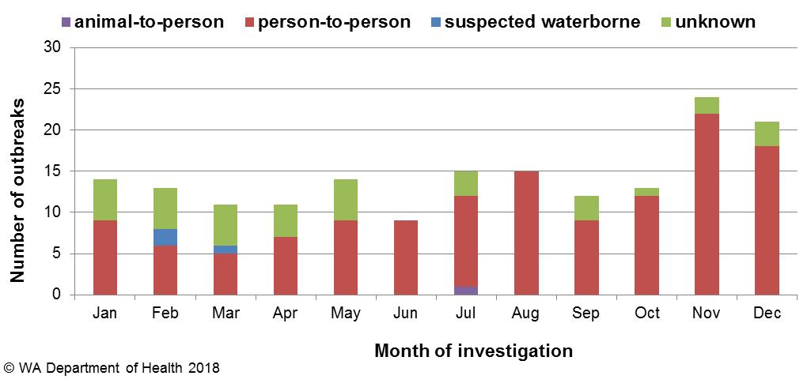

**Figure 21 Number of gastroenteritis outbreaks designated as non-foodborne transmission (animal-to-person, person-to-person, suspected waterborne, unknown) in 2017**

**Table 4 Outbreaks due to non-foodborne transmission or unknown mode of transmission in WA by setting and agent, 2017**



1 Deaths temporally associated with gastroenteritis, but contribution to death not specified

# Cluster investigations

In 2017, there were 7 *Salmonella* clusters and two *Shigella* clusters investigated (Table 5) which are described in [2017 quarterly reports](http://ww2.health.wa.gov.au/Articles/F_I/Infectious-disease-data/Enteric-infection-reports-and-publications-OzFoodNet).

**Significant clusters  
*Salmonella* Typhimurium PFGE 0001**

There has been an ongoing community-wide increase in notifications of STM PFGE 0001 (Figure 22) in WA since 2014, involving multiple MLVA types. Further increases occurred in 2017 with 220 cases of PFGE 0001 infection notified. In 2017, 39 confirmed cases were part of eight point source outbreaks. In four of the eight outbreaks an implicated food was identified and in each of the four outbreaks the implicated foods were raw or undercooked eggs. The remaining 181 cases, comprising 45% males and 55% females, ranged in age from 0 to 95 years (average 32 years), and most (88%) resided in the Perth metropolitan area. In 2016, samples from eggs and egg laying chickens from one egg producer were positive for PFGE 0001, and a second producer had samples from egg laying chickens and the shed environment positive for PFGE 0001 in 2017. Egg dishes made from eggs from these two producers have also been implicated in point source outbreaks. From February 2015 to March 2016, non-point source outbreak cases (community cases) were investigated as part of a case-control study of STM PFGE 0001 illness6. This study supported the hypothesis that the cause of illness was consumption of free range eggs and/or chicken meat at home. Final analysis of the case control data showed that eating raw eggs was statistically associated with illness. These findings should be interpreted with caution as denominator information regarding market share, and occurrence or frequency of animal and environmental testing by egg producers, is unavailable, and multiple factors associated with the handling of eggs and egg-based products can contribute to whether an egg dish causes an infection.

This evidence strongly suggests eating raw/runny eggs is the cause of STM PFGE 0001 point source outbreaks in WA and it is very likely the cause of many of the community cases.

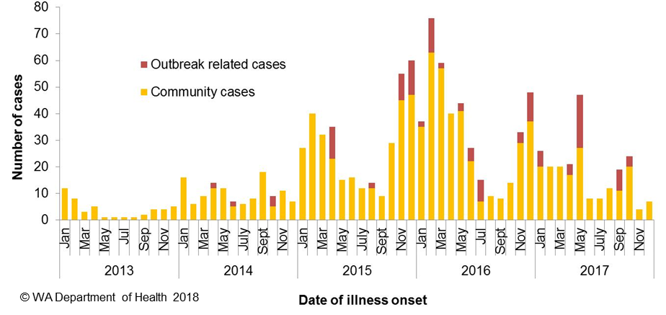

Figure 22 Notifications of *Salmonella* Typhimurium PFGE 0001 in WA

***Salmonella* Typhimurium MLVA 03-17-09-12-523**

STM MLVA 03-17-09-12-523 is one of several MLVA types synonymous with PFGE 0043. Up until September 2016, STM MLVA 03-17-09-12-523 had not been notified in WA since MLVA typing began in WA in January 2015. There were 78 cases of this MLVA type in 2016, starting with a single case in September, then 610 cases in 2017 (Figure 23). In 2017, 110 cases were part of 16 point source outbreaks. These 16 outbreaks are detailed in Table 2. Six further cases from 2017 were part of two outbreaks reported in 2018. The remaining 494 cases, comprising 49% males and 51% females, ranged in age from 0 to 92 years (median 25 years), and most (84%) resided in the Perth metropolitan area. Hospitalisation data was known for 481 community cases; 27% were hospitalised.

Eggs or egg-containing dishes were implicated in eight point source outbreaks of STM MLVA 03-17-09-12-523 in 2017. One WA egg producer was common to four of these outbreaks. For the remaining four outbreaks, eggs were sourced from a variety of producers in one outbreak, and eggs were sourced from three different WA egg producers in the other three outbreaks.

Of the 494 community cases, 291 were interviewed regarding exposures including the type of eggs consumed in the home. Of 230 cases who reported no egg consumption outside the home during their incubation period, 208 could recall whether they had eaten eggs at home. A total of 147 (71%) of these cases reported eating eggs at home, 71 of which had free-range eggs, 20 had cage eggs, 10 had eggs from backyard chickens, three had barn laid eggs, three had organic eggs and 47 could not recall the type of eggs. This distribution should be interpreted with caution as denominator information regarding market share is unavailable.

A representative sample of 26 isolates related to this investigation were further analysed by whole genome sequencing at ICPMR, NSW (See [OzFoodNet 2017 first quarter report](http://ww2.health.wa.gov.au/Articles/F_I/Infectious-disease-data/Enteric-infection-reports-and-publications-OzFoodNet)). Despite being from multiple point source outbreaks, and including isolates from community cases reporting different egg brand consumption, all isolates were within 7 single nucleotide polymorphisms difference of each other. This supported the hypothesis that community cases and point source cases are related and that illness is likely due to a common exposure or exposure to products with a common source of contamination.

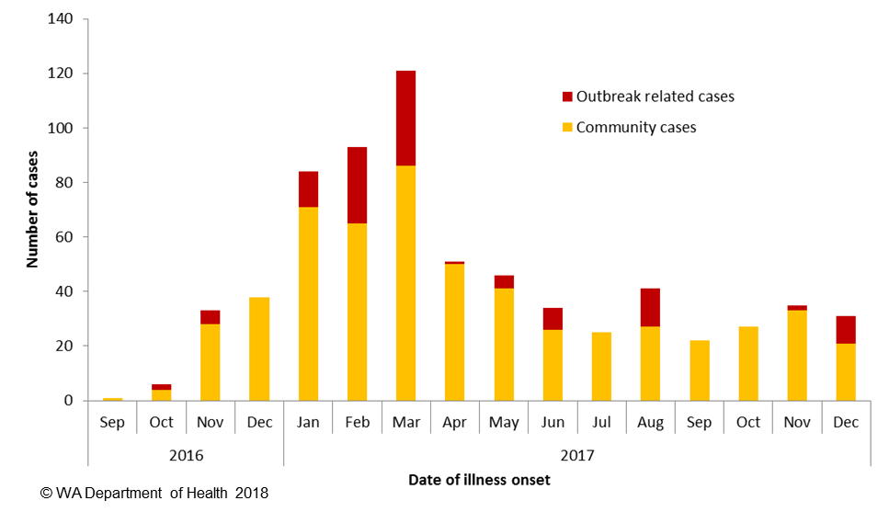

Figure 23 Notifications of *Salmonella* Typhimurium MLVA 03-17-09-12-523 in WA

Table 5 Cluster investigations in WA by month investigation started, setting and agent, 2017

|  |  |  |  |  |  |
| --- | --- | --- | --- | --- | --- |
| **Month of outbreak** | **Setting exposed** | **Agent responsible** | **Number ill** | **Number hospitalised** | **Epidemiological study** |
| Jul | Community | *Shigella flexneri* 2B | 31 | 13 | Case series |
| Feb | Community | *Shigella sonnei* biotype A | 10 | 5 | Case series |
| All year | Community | *Salmonella* Typhimurium PFGE 1, PT 9 | 181 | unk* | Case series |
| All year | Community | *Salmonella* Typhimurium MLVA 03-17-09-12-523 | 494 | 128 | Case series |
| Nov | Community | *Salmonella* Stanley | 11 | 3 | Case series |
| All year | Community | *Salmonella* Singapore | 61 | 10 | Case series |
| All year | Community | *Salmonella* Typhimurium MLVA 03-12/13-11-10-523 | 62 | 8 | Case series |
| Sep-Oct | Community | *Salmonella* Typhimurium MLVA 03-18-09-12-523 | 5 | 0 | Case series |
| Nov | Community | *Salmonella* Typhimurium MLVA 03-17-10-12-523 | 16 | 2 | Case series |

*PT = phage type, PFGE=pulsed field gel electrophoresis, MLVA=multi-locus variable number tandem repeat analysis

# References

1. Hall G, Kirk MD, Becker N, Gregory JE, Unicomb L, Millard G, et al. Estimating foodborne gastroenteritis, Australia. Emerg Infect Dis 2005;11(8):1257-1264.
2. OzFoodNet Working Group. A health network to enhance the surveillance of foodborne diseases in Australia. Department of Health and Ageing 2013. <http://www.ozfoodnet.gov.au/>.
3. Western Australian Department of Health. A-Z list of case definitions. Western Australian Department of Health 2013. <http://ww2.health.wa.gov.au/Articles/N_R/Notification-of-infectious-diseases-and-related-conditions>.
4. National notifiable disease surveillance system. National case definitions. Department of Health and Ageing 2013. <http://www.health.gov.au/internet/main/publishing.nsf/Content/cda-surveil-nndss-nndssintro.htm>.
5. Western Australian Department of Health. Contact details for regional population / public health units. Western Australian Department of Health 2013. <http://healthywa.wa.gov.au/Articles/A_E/Contact-details-for-population-public-health-units>.
6. Dups JNB 2017, ‘Epidemiology and control of communicable diseases in Western Australia, 2015-2016’, Thesis (MPhil), Australian National University, viewed 6 December 2018, <https://openresearch-repository.anu.edu.au/handle/1885/133598>.

# Appendix 1: Number of notifications, notification rate2 and ratio of current to historical mean by pathogen/condition, 2012 to 2017, WA

# 

# 1Abbreviations: STEC: Shiga toxin-producing *E. coli*; HUS: Haemolytic Uraemic Syndrome; NA: not applicable. 2Rate is cases per 100 000 population.

© Department of Health 2018

This document can be made available in

alternative formats on request for a person

with a disability