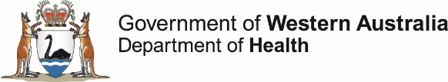

This report describes enteric disease surveillance and investigations carried out during the third quarter of 2020 (3Q20) by OzFoodNet WA in conjunction with other Western Australian Department of Health agencies and local governments.

Some of the increase in notifications is likely to be due to the introduction of polymerase chain reaction (PCR) testing of faecal specimens which has greater sensitivity than culture techniques while some of the decrease in notifications in 3Q20 is due to the ongoing travel restrictions due to COVID-19.

**OzFoodNet Enteric Disease Surveillance Report 3rd Quarter 2020**

**Enhancing foodborne disease surveillance across Australia**

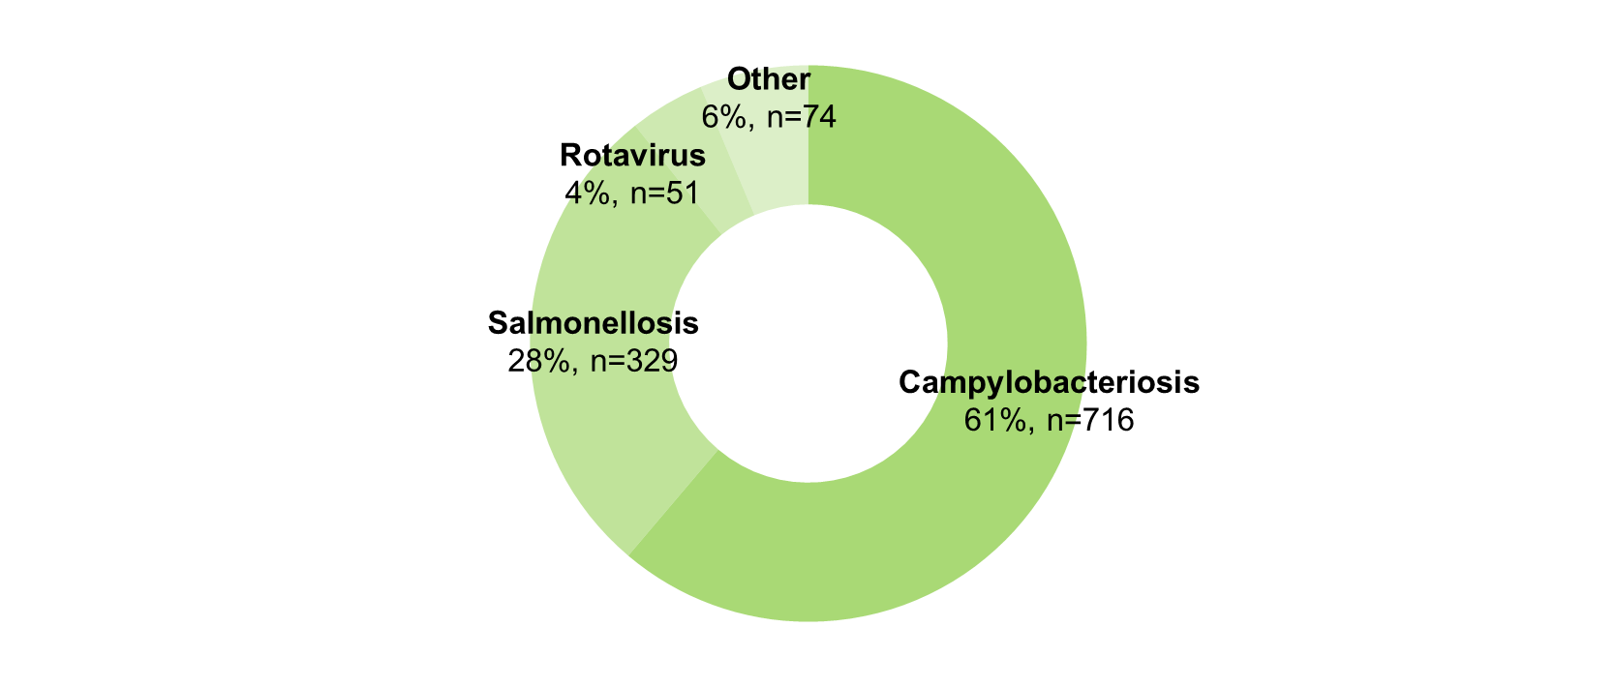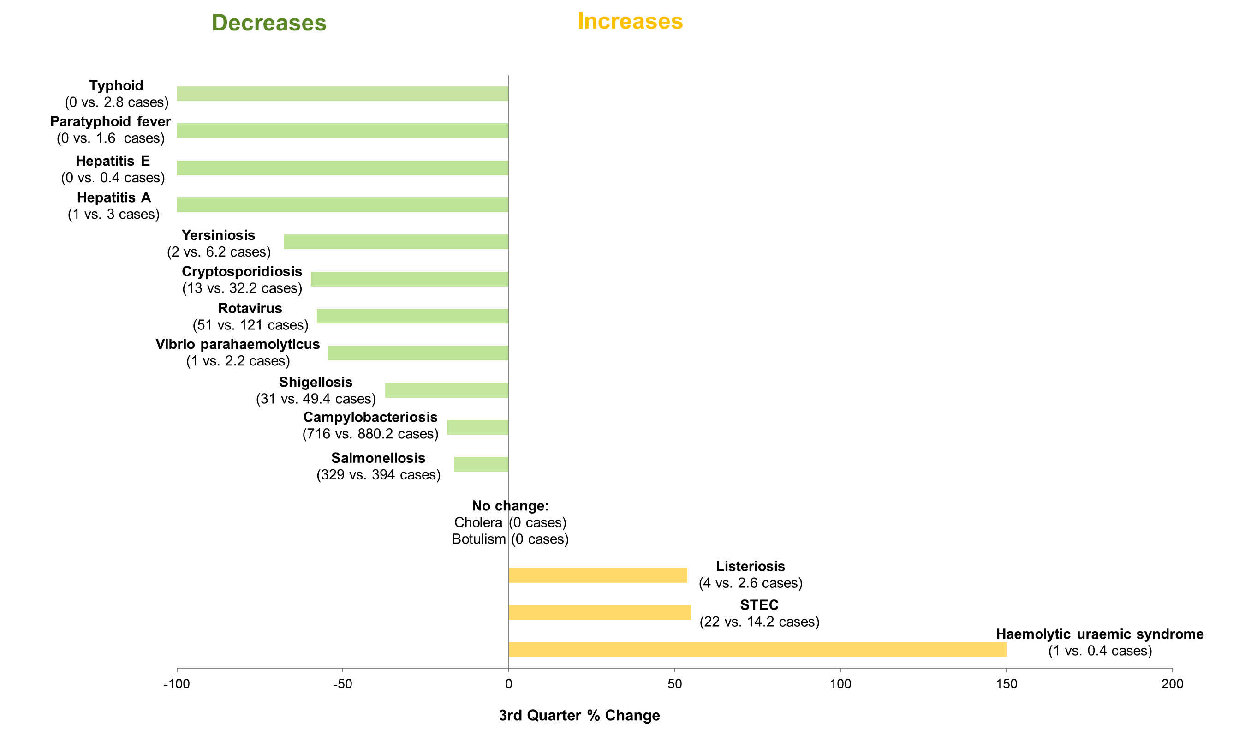

**Most common enteric disease notifications in Quarter 3 2020**

**Change in enteric disease notifications (%)\***

**Appendix 1** Enteric diseases by public health region:

<https://ww2.health.wa.gov.au/-/media/Corp/Documents/Health-for/Infectious-disease/OZfoodnet/Word/WA-OzFoodnet-appendix1-2020-Q3.docx>

*Percentage change in the number of notifications in the current quarter compared to the historical 5-year mean for the same quarter. Positive values indicate an increase when compared to the historical 5-year mean of the same quarter. Negative values indicate a decrease when compared to the historical 5-year mean of the same quarter. Percentage change should be interpreted with caution when the number of cases is small.

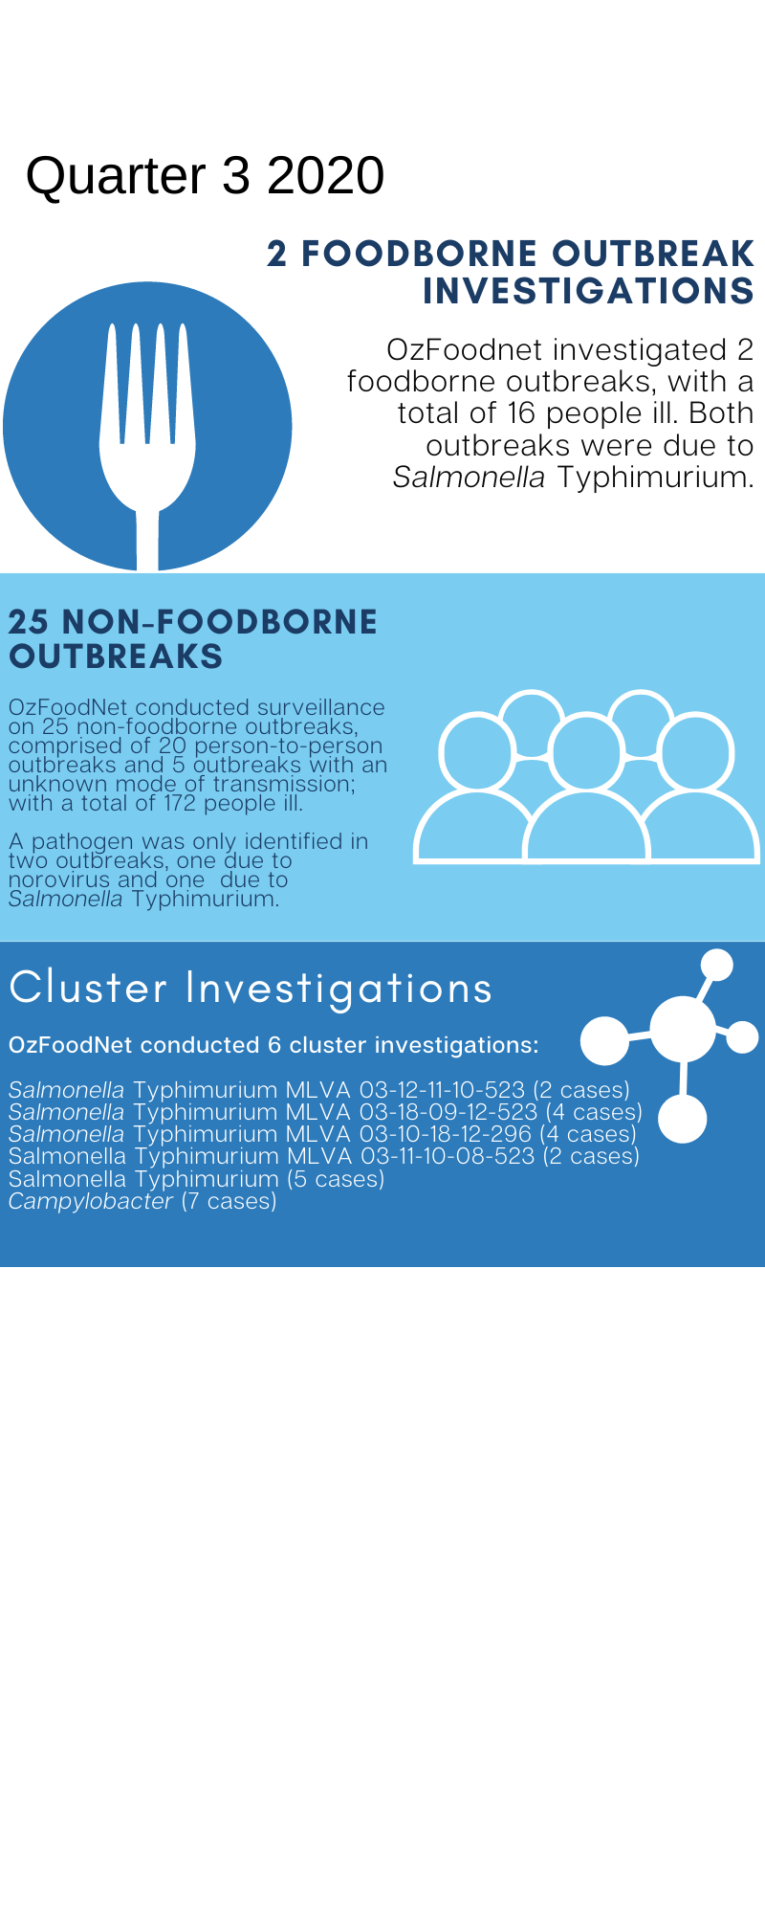**Outbreaks in Quarter 3 2020**

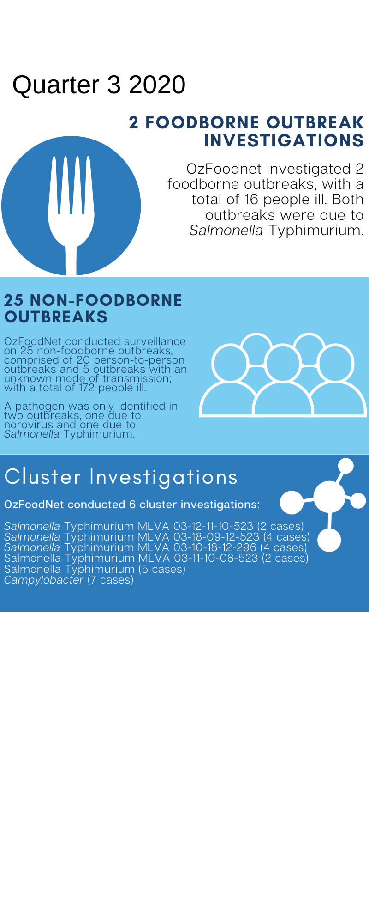



**Appendix 2** Details of foodborne outbreaks investigated in Quarter 3, 2020:

<https://ww2.health.wa.gov.au/-/media/Corp/Documents/Health-for/Infectious-disease/OZfoodnet/Word/WA-OzFoodnet-appendix2-2020-Q3.docx>

**Key trends from Quarter 3 2020**

***Salmonella* Typhimurium (STM) MLVA 03-17-09-12-523**

STM MLVA 03-17-09-12-523 has been under investigation since the type emerged in September 2016. From September 2016 to September 2020 there were 1797 cases notified, including 109 cases in 3Q20. This MLVA type was the single most common MLVA type notified in 3Q20, constituting 45% of STM notifications for the quarter. Of the 109 cases, 13 (12%) were part of two point source outbreaks identified. Tiramisu containing raw eggs was implicated in both outbreaks. Of the remaining 96 cases, most (90%) resided in the Perth metropolitan area. Hospitalisation data were confirmed for 91 community cases; 31% were hospitalised.



Figure: Notifications of *Salmonella* Typhimurium MLVA 03-17-09-12-523 in WA, 2016 to September 2020

**Listeria**

Four listeria cases were notified in 3Q20, including one perinatal pair. The infant, born prematurely, survived. The two non-perinatal cases were an 85-year-old female and 62-year-old male who were both on chemotherapy for terminal cancer. Both cases passed away. All cases had eaten multiple high-risk foods during their incubation. Environmental investigation did not identify any implicated food products and typing for cases were unique.

**Shiga toxin producing *E. coli* (STEC)**

Fourteen of the 22 notifications were culture positive, the most common serotypes were O157:H7 (n=6) and O128:H2 (n=3). No point-source outbreaks were identified in 3Q20. Some of the increase is likely due to PCR testing of all faecal specimens by one private laboratory since the fourth quarter of 2018.

**Haemolytic uraemic syndrome (HUS)**

One HUS case was notified in 3Q20. This case was culture positive for STEC (serotype O26:H11).

**Multi-drug resistant Shigella**

Of eight notifications of *Shigella sonnei* Biotype G in 3Q20, seven were alerted as multi-drug resistant. Five able to be followed up had onsets between 20/08/2020 – 21/09/2020 and all were men in the Perth metro area thought to have acquired infection through male to male sexual contact.