Enteric disease surveillance and outbreak investigations in Western Australia 2020 annual report



**Enhancing foodborne disease surveillance across Australia**



OzFoodNet, Communicable Disease Control Directorate

**Acknowledgments**

Acknowledgement is given to the following people for their assistance with the activities described in this report: the staff from PathWest Laboratory Medicine WA; Mr John Coles and other staff from the Environmental Health Directorate of the Department of Health, Western Australia; Public Health Nurses from the metropolitan and regional Population Health Units; and Local Government Environmental Health Officers.

**Contributors/Editors**

Benjamin Witham, Nevada Pingault, Stephania Tomlin, Barry Combs

Communicable Disease Control Directorate

Department of Health, Western Australia

PO Box 8172

Perth Business Centre

Western Australia 6849

Email: [OzfoodnetWA@health.wa.gov.au](mailto:OzfoodnetWA@health.wa.gov.au)

Telephone: (08) 9222 2152

Web:

OzFoodNet Department of Health, WA

<https://ww2.health.wa.gov.au/Articles/F_I/Infectious-disease-data/Enteric-infection-reports-and-publications-OzFoodNet>

OzFoodNet Department of Health and Ageing

<https://www1.health.gov.au/internet/main/publishing.nsf/Content/cdna-ozfoodnet.htm>

**Disclaimer**:

Every endeavour has been made to ensure that the information provided in this document was accurate at the time of writing. However, infectious disease notification data are continuously updated and subject to change.

PUBLISHED BY

This publication has been produced by the **Department of Health, Western Australia**.

# Executive summary

This report is a summary of enteric disease surveillance activities and outbreak investigations in Western Australia (WA) in 2020. Enteric disease causes a large burden of illness in the WA community. In WA, there are 15 enteric infections and one enteric disease-related condition that are notifiable to the Department of Health. The Department of Health through OzFoodNet (OFN) and other agencies conducts surveillance and investigates outbreaks so that targeted interventions can be used to help prevent further transmission.

In 2020, there were 5737 notifications of enteric disease in WA, which was a rate of 218 per 100 000 population. The 2020 rate was 12% lower than the mean rate for the previous five years. The age group with the highest enteric disease rate was 0-4 years with 604 cases per 100 000 population. The rate of enteric disease for Aboriginal people was 40% higher than for non-Aboriginal people. Of the notified enteric infections with a known place of acquisition, 92% reported acquiring their infection in WA, 8% reported overseas travel and less than 1% reported interstate travel. Of enteric notifications reporting overseas travel, 57% had travelled to Indonesia.

As with previous years, Campylobacteriosiswas the most commonly notified enteric disease in 2020 (n=2890; 50%) followed by salmonellosis (n=1759; 31%); notification rates are 15% and 18% lower than the previous five-year average, respectively. Most notifiable enteric diseases in 2020 had lower or comparable rates to the previous five-year average. Notable increases were observed for cryptosporidiosis (n=495, 196% increase) and shiga toxin-producing *E. coli* infection (n=105, 153% increase). Some of the decrease in 2020 may be due to overseas and interstate travel restrictions and social distancing measures as a result of the COVID-19 pandemic.

**Foodborne and probable foodborne outbreaks**

In 2020, there were 20 outbreaks of foodborne or probable foodborne disease investigated in WA that caused at least 490 cases of illness. Of these 20 outbreaks, 16 were caused by *Salmonella* Typhimurium, one outbreak each was due to norovirus and *Clostridium perfringens* and for two outbreaks the aetiology was unknown (Table B).

Of these 20 outbreaks, a food vehicle was identified in 70% (n=14). Raw or undercooked egg and egg-containing dishes were the most commonly implicated food (n=11, 79%).

**Table A: Foodborne outbreaks investigated in WA by aetiology, 2020**

|  |  |  |  |  |  |  |
| --- | --- | --- | --- | --- | --- | --- |
| Aetiological agent |  |  | Number of Outbreaks | | |  |
| **2015** | **2016** | **2017** | **2018** | **2019** | **2020** |
| *Salmonella* | 7 | 17 | 37 | 33 | 24 | 16 |
| Norovirus | 1 |  | 3 |  | 2 | 1 |
| *Clostridium perfringens* |  | 2 |  |  |  | 1 |
| *Campylobacter* |  | 1 |  |  |  |  |
| Hepatitis A | 1 |  |  |  |  |  |
| *Vibrio parahaemolyticus* |  | 1 |  |  |  |  |
| Unknown | 1 |  | 2 | 4 |  | 2 |
| Total | 10 | 21 | 42 | 37 | 26 | 20 |
| © WA Department of Health 2021 | | | | | | |

**Non-foodborne enteric disease outbreaks**

Non-foodborne enteric disease outbreaks and outbreaks with an unknown mode of transmission are a major cause of illness, especially in institutions such as residential care facilities (RCFs) and child care centres (CCCs). There were 280 non-foodborne outbreaks reported in 2020 which resulted in 3671 ill people, 69 hospitalisations and 6 associated deaths. Most of these outbreaks were in RCFs and CCCs and due to person-to-person transmission. There was a large increase in outbreaks at CCCs in 2020, most reported in the fourth quarter and in the Perth metropolitan region.

# Table of contents

Executive summary 3

Table of contents 5

Introduction 7

Data sources and methods 9

Data sources 9

Data collection by Aboriginality 10

Regional boundaries 10

Calculation of rates 10

Definitions 11

Site activities during the year 11

Surveillance and investigation 11

Activities on enhancing laboratory and epidemiological surveillance 12

Activities to assist enteric disease policy development 12

Strengthening skills and capacity for enteric disease surveillance and investigation 12

Conference meetings and presentations 13

Incidence of specific enteric diseases 13

Botulism 13

Campylobacteriosis 13

Cholera 15

Cryptosporidiosis 15

Haemolytic Uraemic Syndrome (HUS) 18

Hepatitis A infection 18

Hepatitis E infection 19

Listeriosis 19

Rotavirus infection 19

Salmonellosis 21

Shiga toxin-producing *E. coli* (STEC) infection 25

Shigellosis 27

Typhoid and paratyphoid fever 29

Vibrio parahaemolyticus infection 30

Yersinia infection 30

Gastrointestinal disease outbreaks and investigations 31

Foodborne and probable foodborne outbreaks 31

Outbreaks due to non-foodborne transmission or with an unknown mode of transmission 34

Cluster investigations 37

References 40

Appendix 1: Number of notifications, notification rate2 and ratio of current to historical mean by pathogen/condition, 2015 to 2020, WA 41

List of tables

Table 1 Number and proportion of the top 10 *Salmonella* serotypes notified in WA, 2020, with comparison to the 5-year average 24

Table 2 The 10 most common *S*. Typhimurium MLVA types reported in 2020 25

Table 3 Foodborne and probable foodborne outbreaks, 2020 33

Table 4 Outbreaks due to non-foodborne transmission or unknown mode of transmission in WA by setting and agent, 2020 36

Table 5 Cluster investigations in WA by month investigation started, setting and agent, 2020 37

List of figures

Figure 1 Campylobacteriosis notifications by year and month, WA, 2015 to 2020 14

Figure 2 Campylobacteriosis notification rate by age group and sex, WA, 2020 14

Figure 3 Campylobacteriosis notification rates by region and Aboriginality, WA, 2020 15

Figure 4 Cryptosporidiosis notifications by year and month, WA, 2015 to 2020 16

Figure 5 Cryptosporidiosis notification rate by age group and sex, WA, 2020 17

Figure 6 Cryptosporidiosis notification rates by region and Aboriginality, WA, 2020 17

Figure 7 Place of acquisition for hepatitis A notifications, 2015 to 2020 18

Figure 8 Notifications of listeriosis showing non-pregnancy related infections and deaths, and materno-foetal infections and deaths, WA, 2015 to 2020 19

Figure 9 Rotavirus notifications by year and month, WA, 2015 to 2020 20

Figure 10 Rotavirus notification rates by age group and sex, WA, 2020 20

Figure 11 Rotavirus notification rates by region and Aboriginality, WA, 2020 21

Figure 12 Salmonellosis notifications by year and month, WA, 2015 to 2020 22

Figure 13 Salmonellosis notification rate by age group and sex, WA, 2020 22

Figure 14 Salmonellosis notification rates by region and Aboriginality, WA, 2020 23

Figure 15 Salmonellosis notifications by place of acquisition and year, 2015 to 2020 23

Figure 16 STEC notifications by year and month, WA, 2015 to 2020 26

Figure 17 STEC notification rates by age group and sex, WA, 2020 26

Figure 18 Shigellosis notifications by year and month, WA, 2015 to 2020 27

Figure 19 Shigellosis notification rates by age group and sex, WA, 2020 28

Figure 20 Shigellosis notification rates by region and Aboriginality, WA, 2020 28

Figure 21 The most common *Shigella* types notified in 2020 29

Figure 22 Number of non-foodborne gastroenteritis outbreaks by mode of transmission and month, 2020 36

Figure 23 Notifications of *Salmonella* Typhimurium MLVA 03-17-09-12-523 in WA 39

# Introduction

It has been estimated that there are 5.4 million cases of foodborne illness in Australia each year and that the cost of this illness is $1.2 billion per year1. This is likely to be an underestimate of the true cost of enteric illness in Australia as not all enteric infections are caused by foodborne transmission. Other modes of transmission such as person-to-person, animal-to-person and waterborne transmission are also very important in enteric infection. Most enteric infections are preventable through interventions at the level of primary production, institution infection control, and food handling and hand hygiene at food businesses and in households.

This report describes Western Australian enteric disease surveillance and investigations carried out in 2020 by OzFoodNet WA (OFN) and other Western Australian government agencies. Most of the data presented in this report is derived from enteric disease notifications from doctors and laboratories received by the Department of Health, WA and are likely to underestimate the true incidence of disease. This data nevertheless remains the most important information on incidence of these infections for surveillance purposes in Western Australia (WA). In addition, norovirus, which is not notifiable, is the cause of a large burden of illness in RCFs and in the general community.

OFN is part of the Communicable Disease Control Directorate (CDCD) of the WA Department of Health. OFN in WA is also part of a National OzFoodNet network funded by the Commonwealth Department of Health2. The mission of OzFoodNet is to enhance surveillance of foodborne illness in Australia and to conduct applied research into associated risk factors. The OFN site based in Perth is responsible for the whole of WA, which has a total population of approximately 2.6 million. Collaboration between States and Territories is facilitated by circulation of fortnightly jurisdictional enteric surveillance reports, monthly teleconferences, tri-annual face-to-face meetings and through the informal network. This network also includes communication and consultation with Food Standards Australia New Zealand, the Commonwealth Department of Health, the National Centre for Epidemiology and Population Health, the Communicable Diseases Network of Australia and the Public Health Laboratory Network.

The primary objectives of OzFoodNet nationally are to:

* estimate the incidence and cost of foodborne illness in Australia,
* investigate the epidemiology of foodborne diseases, by enhancing surveillance and conducting studies on foodborne pathogens,
* collaborate nationally to coordinate investigations into foodborne disease outbreaks, particularly those that cross State, Territory and country borders,
* train people to investigate foodborne illness.

At a local level, OFN conducts surveillance of enteric infections to identify clusters and outbreaks of specific diseases and conducts epidemiological investigations to help determine the cause of outbreaks. OFN also conducts research into the risk factors for sporadic cases of enteric diseases and develops policies and guidelines related to enteric disease surveillance, investigation and control. OFN regularly liaises with staff from the Population Health Units (PHUs), the Environmental Health Directorate of Department of Health, WA (EHD); and the Environmental, Diagnostic and Surveillance laboratories at PathWest Laboratory Medicine WA (PathWest).

CDCD maintains and coordinates the WA notifiable disease surveillance system and provides specialist clinical, public health and epidemiological training and advice to PHUs. The WA notifiable diseases surveillance system relies on the mandatory reporting by doctors and laboratories of notifiable diseases and disease-related conditions, 16 of which are enteric.

PHUs are responsible for public health activities, which includes communicable disease control, in their WA administrative health regions. There are eight PHUs in WA that are involved with communicable disease surveillance: Goldfields, Great Southern, Kimberley, Metropolitan, Midwest, Pilbara, South West and Wheatbelt. The PHUs monitor facility gastroenteritis outbreaks and provide infection control advice. The PHUs also conduct follow up of single cases of important enteric diseases including typhoid, paratyphoid, hepatitis A and E, cholera and *Shigella dysenteriae*. OFN will also assist with the investigation of these enteric diseases if there is a cluster and/or they are locally acquired, and will investigate facility outbreaks if the outbreak is due to probable foodborne transmission.

The EHD liaises with Local Government (LG) Environmental Health Officers (EHOs) during the investigation of food businesses, and coordinates food business investigations when multiple LGs are involved.

The Environmental, Diagnostic and Surveillance laboratories at PathWest provide public health laboratory services for the surveillance and investigation of enteric disease.

# Data sources and methods

### **Data sources**

Data on WA cases of notifiable enteric diseases were obtained from the WA notifiable infectious disease database (WANIDD). The notifications contained in WANIDD are received from medical practitioners and pathology laboratories under the provisions of the Public Health Act 2016 and subsequent amendments, and are retained in WANIDD if WA (for diseases not nationally notifiable)3 or national case definitions are met4.

Notifiable enteric diseases included in this report are botulism, campylobacteriosis, cholera, cryptosporidiosis, haemolytic uraemic syndrome (HUS), hepatitis A infection, hepatitis E infection, listeriosis, rotavirus infection, salmonellosis, shiga toxin-producing *E. coli* (STEC) infection, shigellosis, typhoid and paratyphoid fever, *Vibrio parahaemolyticus* infection and yersiniosis. In March 2020, data for these diseases were extracted from WANIDD by optimal date of onset (ODOO) for the time period 01/01/2015 to 31/12/2020, and exported to Microsoft® Excel 365. The ODOO is a composite of the ‘true’ date of onset provided by the notifying doctor or obtained during case follow-up, the date of specimen collection for laboratory notified cases, and when neither of these dates is available, the date of notification by the doctor or laboratory, or the date of receipt of notification, whichever is earliest.

Notification data extracted for this report may have been revised since the time of extraction. Subsequent minor changes to the data would not substantially affect the overall trends and patterns.

Information on *Salmonella* serotypes, *Shigella* species, Multi-locus variable number tandem repeat analysis (MLVA) and Whole Genome Sequencing of certain pathogens was obtained from PathWest, the reference laboratory for WA. Other specialised diagnostic data were obtained from the Microbiological Diagnostic Unit, University of Melbourne and the Australian *Salmonella* Reference Laboratory, Institute of Medical and Veterinary Science (Adelaide).

Information on RCF and other facility outbreaks was collected by PHU staff who forward collated epidemiological and laboratory data to OFN.

### **Data collection by Aboriginality**

For the purposes of this report, the term ‘Aboriginal’ is used in preference to ‘Aboriginal and Torres Strait Islander’ to recognise that Aboriginal people are the original inhabitants of WA.

In WA, there is considerable mobility of Aboriginal people, both within WA and across the Northern Territory and South Australia borders, which means that some Aboriginal people will be patients of more than one health service. Due to the small size of the Aboriginal population in WA (4% of the total population in 2020) and the large number of cases reported in Aboriginal people, inaccuracies in the population estimates of Aboriginal people can have a disproportionate impact on calculated rates. In the preparation of this report, these factors are acknowledged as limitations. Information on Aboriginality is also missing for 5% of enteric notifications in 2020.

### **Regional boundaries**

Notification data is divided into ten WA Health administrative regions based on PHU boundaries. Three of the regions are in the Perth metropolitan area (East, North and South) and seven in the regional areas are Goldfields (GOLD), Great Southern (GSTH), Kimberley (KIMB), Midwest (MIDW), Pilbara (PILB), South West (STHW) and Wheatbelt (CENT). For the purposes of this report, the three metropolitan PHUs have been combined into one ‘metropolitan’ (METRO) region.

### **Calculation of rates**

Notification rates were calculated by dividing the number of notifications of infections within the relevant population by the total number of people within that population and were expressed per 100,000 population. WA’s estimated population denominators used for calculation of rates were obtained from Rates Calculator version 9.5.5.1 (Epidemiology Branch, WA Department of Health). The Rates Calculator provides population estimates by age, sex, Aboriginality, year and area of residence, and is based on population figures based upon 2016 Australian Bureau of Statistics Census data. Rates calculated for this report have not been adjusted for age. It should be noted that small numbers of notifications give unstable and imprecise notification rates.

### **Definitions**

**Foodborne outbreak** is an incident where two or more persons experience a similar illness after consuming a common food or meal and epidemiological analyses and/or microbiological evidence (including food and/or environmental) implicates the meal or food as the source of illness.

**Probable foodborne outbreak** is an incident where two or more persons experience a similar illness after consuming a common food or meal and a specific meal or food is suspected, but another mode of transmission cannot be ruled out.

**Person-to-person outbreak** is an incident where two or more persons experience a similar illness after exposure to an infected person.

**Unknown outbreak transmission** is an incident where two or more persons experience a similar illness but the mode of transmission is unable to be determined.

An implicated dish in a *Salmonella* outbreak is described as an **egg dish** if

* *Salmonella* is isolated from eggs (from the implicated premises) or the implicated dish containing eggs (microbiological evidence) OR
* There is analytical evidence that a dish containing eggs was associated with illness OR
* In the absence of microbiological or analytical evidence, an implicated dish is described as an egg dish if it contains raw or undercooked eggs and most cases report eating the dish in the absence of other high risk foods eaten in common.

# Site activities during the year

During 2020 the following activities and prevention measures were conducted by OFN.

### **Surveillance and investigation**

* Ongoing surveillance of infectious enteric disease in WA.
* Investigation of 20 local foodborne or probable foodborne outbreaks and 22 clusters.
* Investigation of seven *Listeria* *monocytogenes* cases.
* Surveillance of seven typhoid cases.
* Investigation of *S.* Enteritidis cases with unknown travel history and interviews of seven locally acquired cases with a hypothesis generating questionnaire to identify risk factors for the cause of illness.
* Surveillance of 249 person-to-person gastroenteritis outbreaks, including 61 that occurred in RCFs and 174 in child care centres.
* Investigation of 22 gastroenteritis outbreaks with unknown mode of transmission, 17 of which occurred at RCFs.
* Investigation of nine probable waterborne outbreaks due to cryptosporidoisis.
* Investigation of 105 cases of STEC and interview of acute cases to identify risk factors for the cause of illness.
* Participation in multi-jurisdictional outbreak investigations.

### **Activities on enhancing laboratory and epidemiological surveillance**

* Participation in fortnightly meetings with EHD staff.
* Provision of enteric disease data, interpretation and advice upon request to LG EHOs, laboratory and PHU staff.
* Participation in monthly national OzFoodNet teleconferences.
* Monitoring of culture-independent nucleic acid amplification diagnostic testing in private laboratories and impact on notification rates.
* Addition of illness and exposure data for WA *Listeria monocytogenes* and hepatitis A cases to national enhanced data sets.
* Participation in the WA *Salmonella* Outbreak Response Taskforce activities which included survey of eggs and egg producers as well as whole genome sequencing and analysis of human and non-human isolates.
* Participation in cryptosporidiosis project with Murdoch University on the molecular typing of *Cryptosporidium* isolates from public swimming pools and human cases.
* Participation in a rotavirus project with the Murdoch Children’s Research Institute on the molecular typing of rotavirus samples.
* Set up an online SMS system for follow up of sporadic *Salmonella* notifications to assist in detection of possible outbreaks.

### **Activities to assist enteric disease policy development**

* OFN epidemiologists were members of OzFoodNet and other national working groups on a national outbreak register and National Policy for reporting and managing communicable disease events on cruise ships.
* Participation in the WA Foodborne Illness Reduction Strategy Across-Government Advisory Group and Primary Production and Processing Project Group.
* Progress of reviewing and transitioning operational directives related to sporadic enteric disease follow up, enteric disease exclusions and the management and reporting of gastroenteritis outbreaks in facilities.

### **Strengthening skills and capacity for enteric disease surveillance and investigation**

* Presented an enteric disease update at the Public Health Nurses seminar in November.
* Attended Australian eggs virtual *Salmonella* workshop for regulators.

### **Conference meetings and presentations**

* Attended the national OFN virtual face-to-face (F2F) meeting in October.
* Prepared slides on the emergent MDR *Shigella* issue in WA that were presented by the metropolitan PHU staff at the WA AIDS Council meeting in October.
* Presented the emergent MDR *Shigella* at the WAMRO (Western Australia Multi-resistant Organism) expert advisory meeting in December.

# Incidence of specific enteric diseases

In 2020, a total 5737 notifications of enteric disease were reported in WA, which was a rate of 218 per 100 000 population. This rate was 12% lower than the mean rate for the previous five years of 248 per 100 000 population. The overall rate was heavily influenced by notifications of campylobacteriosis and salmonellosis which comprised 50% and 31% of reports, respectively. The age group with the highest enteric disease rate was 0-4 years with 604 cases per 100 000 population, which is 2.8 times the overall rate for WA. In 2020, Aboriginal people had a rate of 276 cases per 100 000 population which was 40% higher than non-Aboriginal people (204 cases per 100 000 population). The age group with the highest rate among Aboriginal people was 0-4 years with a rate of 1046 cases per 100 000 population, compared to a 0-4 year age group rate for non-Aboriginal people of 540 cases per 100 000 population. The region with the highest rate was the Kimberley region with 467 cases per 100 000 population. Of the people notified with enteric infections with a known place of acquisition, 92% reported acquiring their infection in WA, 8% reported overseas travel and less than 1% reported interstate travel. Most (57%) people with enteric notifications who reported overseas travel had travelled to Indonesia. Some of the decrease in enteric notifications in 2020 is likely a result of the decline in overseas acquired infections following travel restrictions from March onwards as a result of the COVID-19 pandemic. In the 2015-2019 period, an average of 25% of enteric notification with a place of known acquisition were acquired overseas.

### Botulism

Botulism is rare in WA, with the last case reported in 2015.

### Campylobacteriosis

Campylobacteriosis was the most commonly notified enteric infection in 2020 with 2890 notifications and a rate of 109.8 per 100 000 population. This notification rate was 15% lower than the previous five-year average (Appendix 1). Campylobacteriosis notifications are historically highest in the spring and summer months, in 2020 notifications were lowest in April following a large decrease starting in March (Figure 1). In 2020, as with previous years, the campylobacteriosis notification rate for males was higher than for females (120.3 and 99.4 per 100 000 population, respectively). The highest rates were in young children 0-4 years (152.8 per 100 000 population) followed by older adults 85+ years (150.9 per 100 000 population) (Figure 2). The lowest rates were in the age groups 10-14 years (70.4 per 100 000 population) and 5-9 years (85.4 per 100 000 population).

Figure 1 Campylobacteriosis notifications by year and month, WA, 2015 to 2020

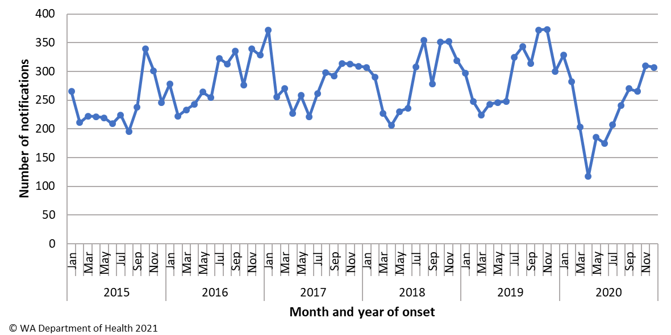

Figure 2 Campylobacteriosis notification rate by age group and sex, WA, 2020

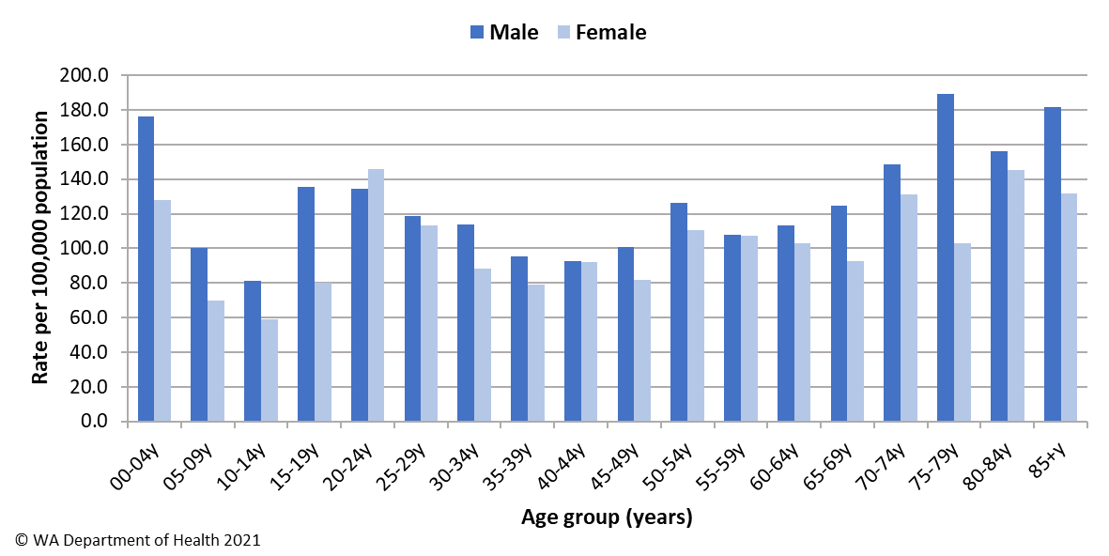

For the last six years the notification rate for non-Aboriginal people has been consistently higher than for Aboriginal people and for 2020, the rate for non-Aboriginal people was 2.1 times higher (112.2 and 52.6 per 100 000 population, respectively). The 2020 notification rate for campylobacteriosis was highest in the South West region (140.3 cases per 100 000 population). The region with the lowest rate was Pilbara (73.3 per 100 000 population) (Figure 3). Of those campylobacteriosis cases with known place of acquisition, most (92%) people acquired their illness in WA with 8% of people acquiring their illness overseas. Indonesia was the most common country of acquisition (67%).

As with most enteric infections in 2020 some of the decrease in campylobacteriosis notifications is due to the impacts of the COVID-19 pandemic. There were no overseas or interstate notifications of campylobacteriosis since March.

Figure 3 Campylobacteriosis notification rates by region and Aboriginality, WA, 2020

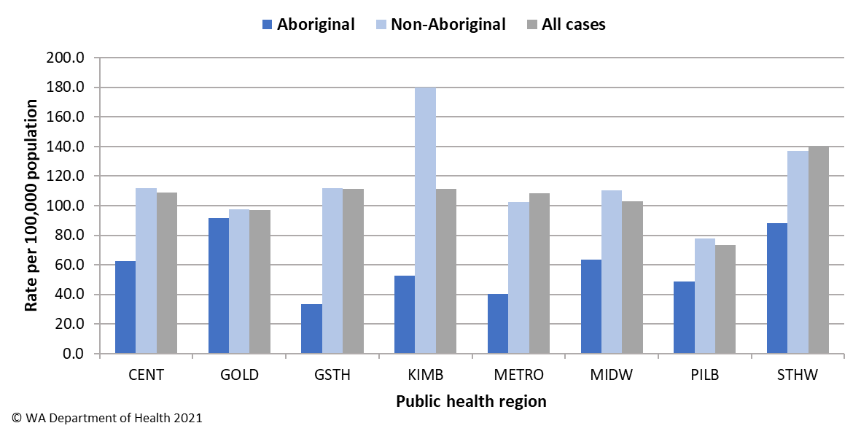

### Cholera

Cholera is mainly seen in people who have travelled overseas. The last case in WA was in 2017.

### Cryptosporidiosis

There were 495 cryptosporidiosis cases notified in 2020, making it the third most common notifiable enteric disease. The notification rate (18.8 cases per 100 000 population) was almost two times higher than the mean of the previous five years (9.6 cases per 100 000 population) (Appendix 1). In each of the years from 2015 to 2020, the number of cryptosporidiosis notifications was higher in the late summer through to autumn (Figure 4). In 2020, there was a large increase in the Perth metropolitan region between January and March with a total 358 cases. Of the 358 cases, 158 were interviewed and 58 were linked to nine suspected waterborne outbreaks at individual aquatic facilities. There was also an increase in cases in the Pilbara region over the same period with a cluster investigated in March, however the cause of illness was unknown.

Figure 4 Cryptosporidiosis notifications by year and month, WA, 2015 to 2020

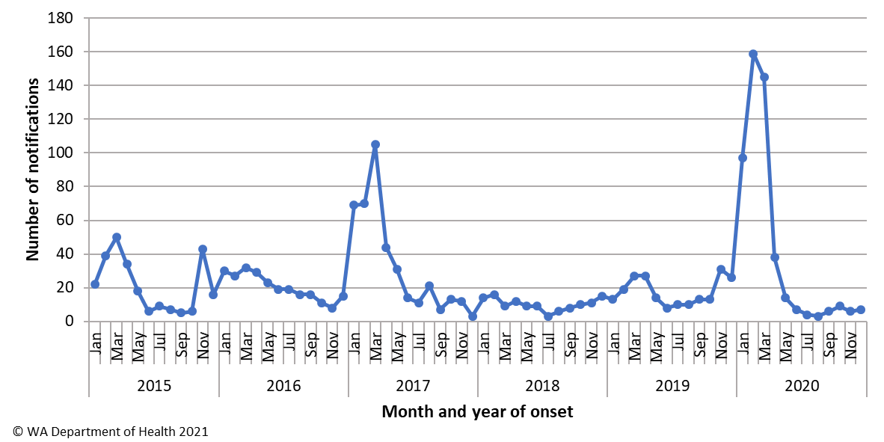

The cryptosporidiosis notification rate in females was similar to males in 2020 (20.1 and 17.5 per 100 000 population, respectively). The 0-4 years age group had the highest notification rate (87.5 per 100 000 population), and accounted for 31% of all cryptosporidiosis notifications (Figure 5).

Figure 5 Cryptosporidiosis notification rate by age group and sex, WA, 2020

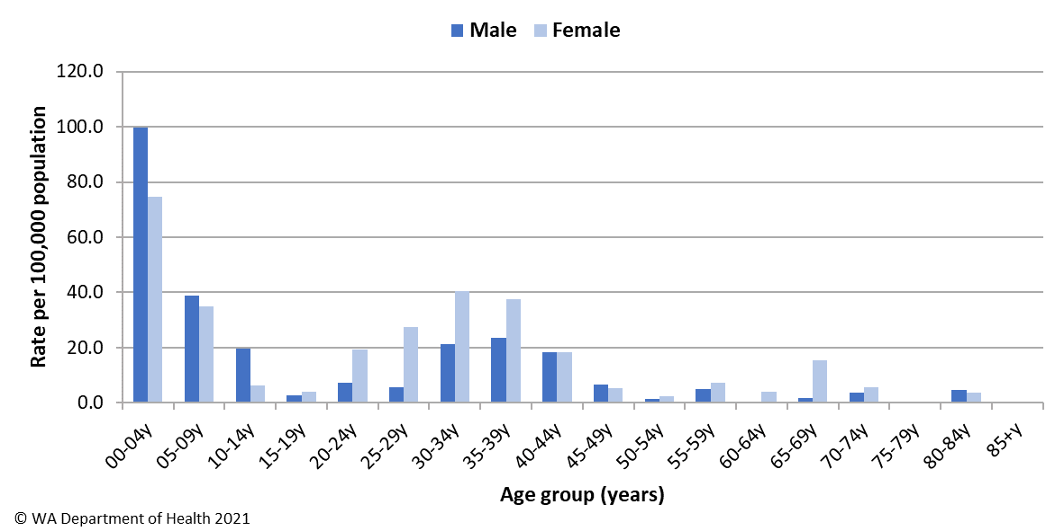

The overall notification rate for the non-Aboriginal population was 19% higher than the rate for the Aboriginal population (18.9 and 16 cases per 100 000 population, respectively). The Pilbara region had the highest notification rate (33.3 cases per 100 000 population), followed by the Perth metropolitan region (20.2 cases per 100 000 population) (Figure 6). Of those cryptosporidiosis cases with known place of acquisition, 93% of people acquired their illness in WA, with 6% of people acquiring their illness overseas and 1% of people acquiring their illness interstate.

Figure 6 Cryptosporidiosis notification rates by region and Aboriginality, WA, 2020

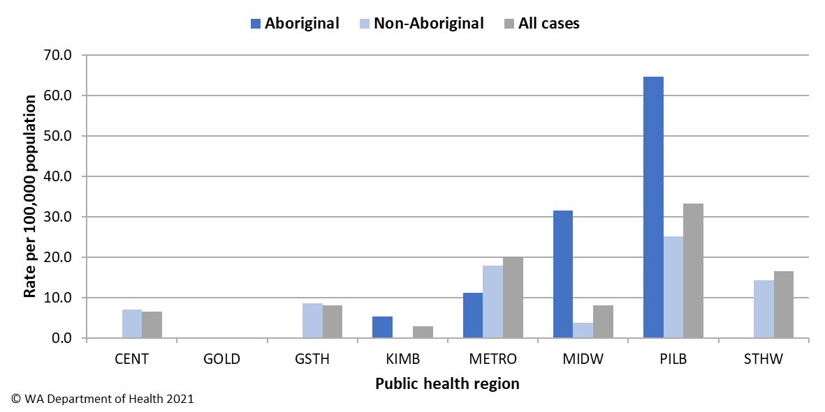

### Haemolytic Uraemic Syndrome (HUS)

Four cases of HUS were notified in 2020. Cases were three males and one female, aged 0 to 63 years. Three cases had acute gastroenteritis and were also diagnosed with STEC. All three cases were from country regions with possible environmental exposures. One of these cases resided on a sheep station in contact with farm animals which was identified as their main risk factor. The serotypes identified were O26, O157 and O165. The forth case from the Kimberley region had acute gastroenteritis and was also diagnosed as a probable *Shigella* case epi-linked to his sibling who was positive for *Shigella flexneri* 2B. All HUS cases recovered.

### Hepatitis A infection

There were six cases of hepatitis A notified in 2020 with a rate of 0.2 cases per 100 000 population, which was a 67% decrease from the average rate of the previous five years (Appendix 1). The age range for the 2020 cases was 8 to 74 years, with five male and one female notification. All notifications in 2020 were overseas acquired with one each reported acquired in India, South Africa, Cambodia, Malaysia, Pakistan and a cruise ship that had traveled through South East Asia (Figure 7). The decrease in 2020 was likely partially due to overseas travel restrictions.

Figure 7 Place of acquisition for hepatitis A notifications, 2015 to 2020

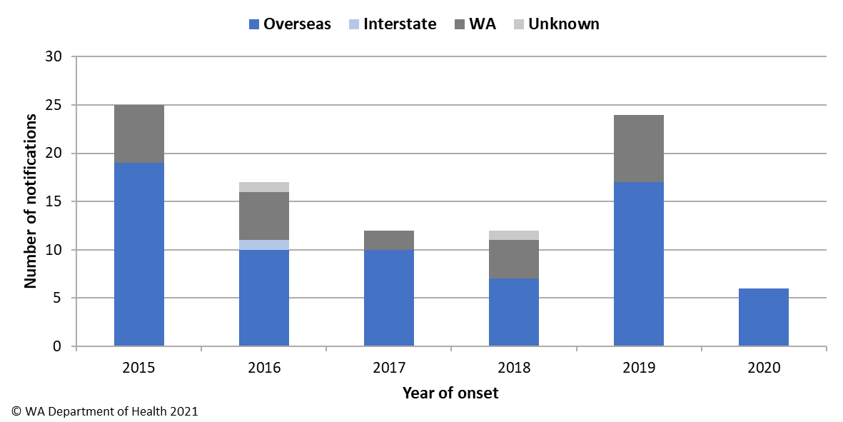

### Hepatitis E infection

There were three cases of hepatitis E notified in 2020. All cases were male, aged 23 to 29 years. Cases had travelled overseas to India (n=2) and Pakistan (n=1).

### Listeriosis

There were seven cases of *Listeria monocytogenes* infection notified in 2020 with a rate of 0.3 cases per 100 000 population, which was similar to the average rate of the previous five years (Appendix 1). There was one materno-foetal pair in 2020 (Figure 8). The remaining five had immunocompromising illnesses, ages ranged from 67 to 85 years with four male and one female case. Three deaths were temporally reported in non-pregnancy related cases.

Figure 8 Notifications of listeriosis showing non-pregnancy related infections and deaths, and materno-foetal infections and deaths, WA, 2015 to 2020

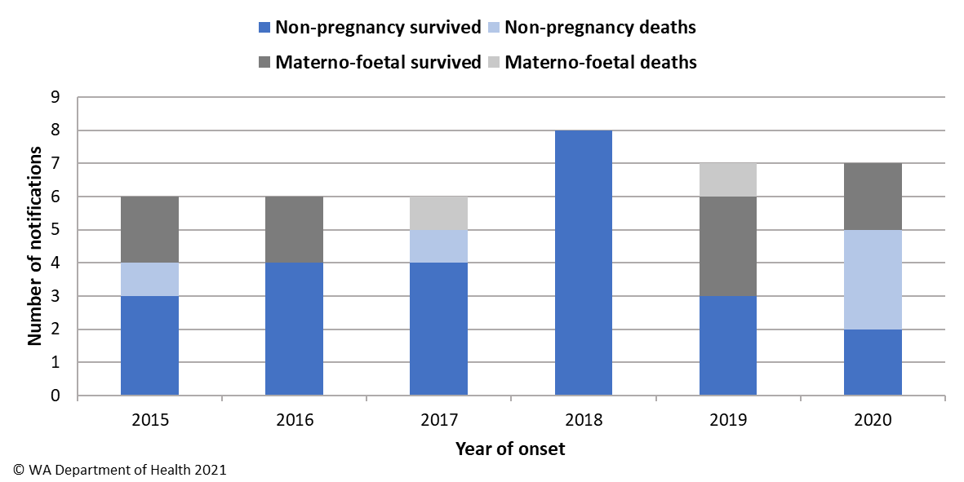

### Rotavirus infection

There were 215 cases of rotavirus infection in WA in 2020 (8.2 per 100 000 population). The notification rate in 2020 was 51% lower than the previous five-year average of 16.6 cases per 100 000 population (Appendix 1). Historically, rotavirus notifications typically peak in the winter months, however cases in 2020 did not follow this trend with low notifications across the year (Figure 9).

Figure 9 Rotavirus notifications by year and month, WA, 2015 to 2020

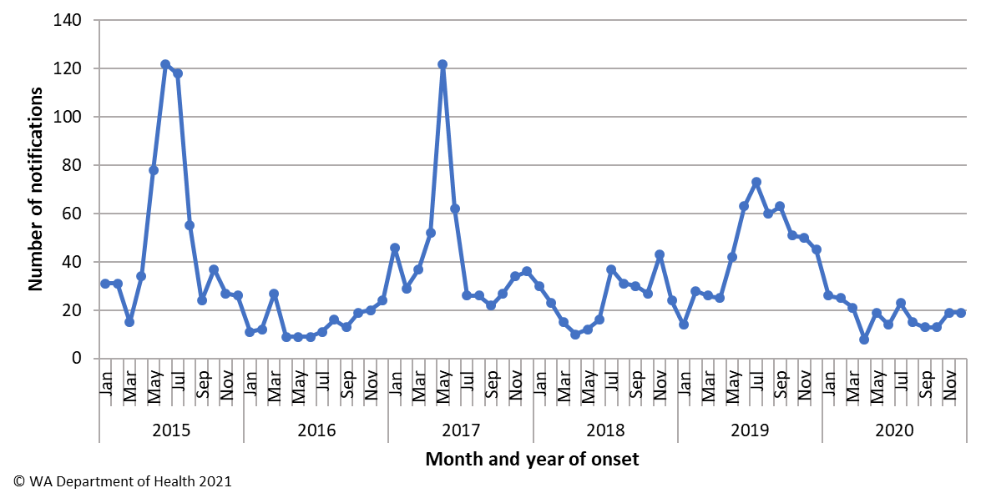

As in previous years, the age group with the highest rotavirus notification rate in 2020 was the 0-4 years group (103.6 cases per 100 000 population) (Figure 10). The overall notification rate was similar for females and males (8.3 and 8.1 per 100 000 population, respectively).

Figure 10 Rotavirus notification rates by age group and sex, WA, 2020

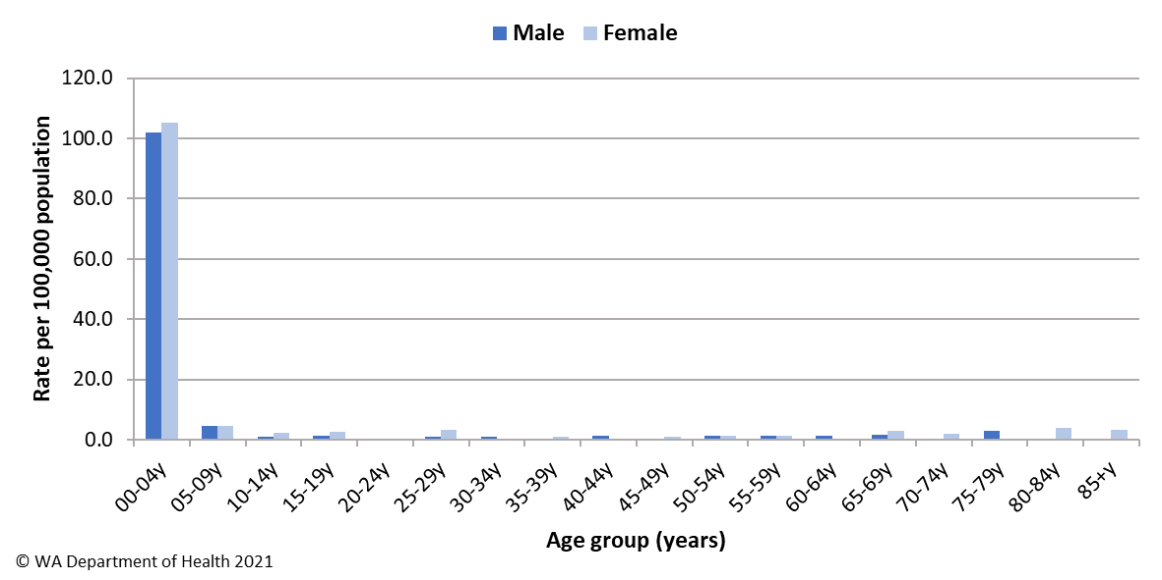

The regions with the highest rotavirus notification rates in 2020 were the Great Southern and Pilbara regions (11.5 and 10 cases per 100 000 population, respectively) (Figure 11). Overall, notification rates were 1.5 times higher for Aboriginal than for non-Aboriginal people (12.2 and 8 per 100 000 population, respectively). Of those rotavirus cases with known place of acquisition, 95% of people acquired their illness in WA with the remaining 5% of people acquiring their illness overseas. There was one person-to-person outbreak due to rotavirus in 2020 at a hospital (Table 4).

Figure 11 Rotavirus notification rates by region and Aboriginality, WA, 2020

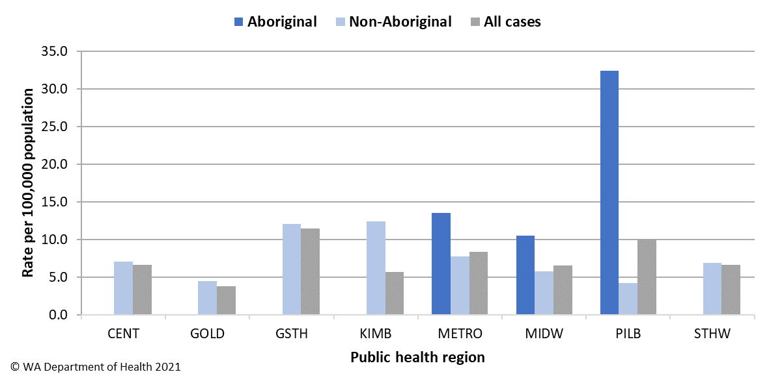

### Salmonellosis

Salmonellosis was the second most commonly notified enteric infection in WA in 2020 with 1759 cases and rate of 66.8 cases per 100 000 population (Appendix 1). The WA rate for 2020 was 18% lower than the previous five-year average (81.1 cases per 100 000 population) but higher than the national average of 48 cases per 100 000 population ([NNDSS data](http://www9.health.gov.au/cda/source/rpt_4_sel.cfm)). Historically, salmonellosis notifications are highest in the summer and autumn months, the peak for salmonellosis in 2020 was February (Figure 12).

Figure 12 Salmonellosis notifications by year and month, WA, 2015 to 2020

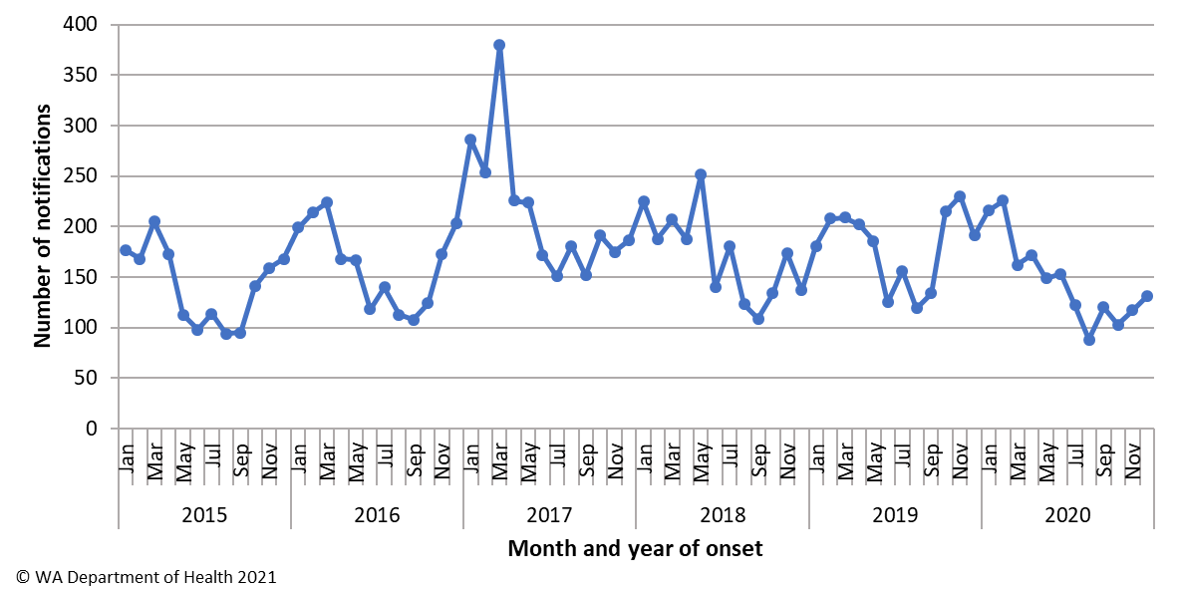

The notification rates for females was marginally higher than for males (69.9 and 63.7 per 100 000 population, respectively). As in previous years, the 0-4 year age group had the highest notification rate (227.2 per 100 000 population) (Figure 13). The age group 85+ years had the next highest notification rate (104 per 100 000 population).

Figure 13 Salmonellosis notification rate by age group and sex, WA, 2020

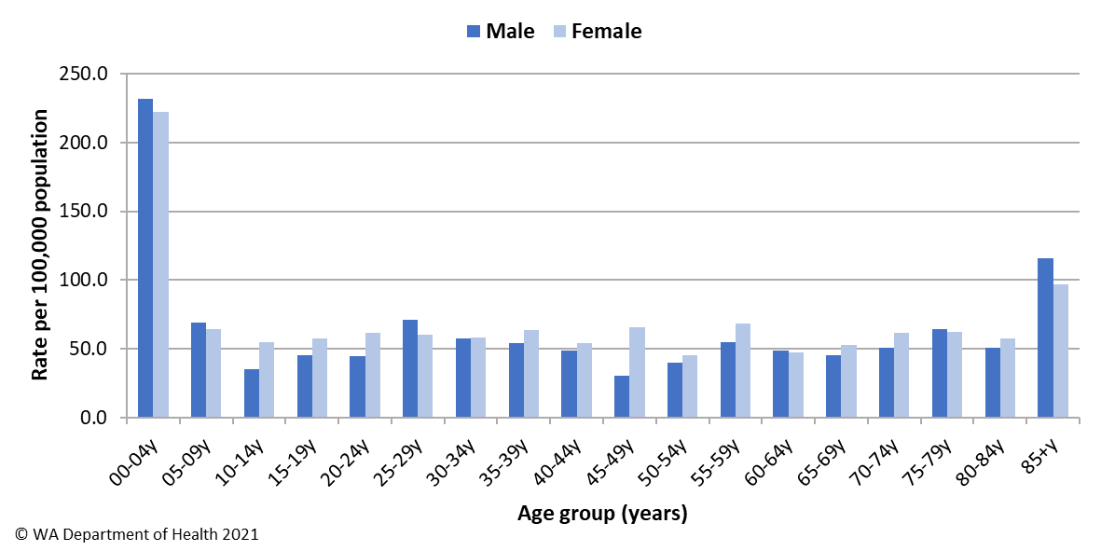

The overall salmonellosis notification rate for Aboriginal people was 81.7 cases per 100 000 population, which was 20% higher than the notification rate for non-Aboriginal people (66.2 cases per 100 000 population).

The Kimberley region had the highest notification rate in 2020 (185.2 per 100 000 population) which was 5.1 times the rate for the Great Southern region, which had the lowest notification rate, of 36 cases per 100 000 population (Figure 14). The notifications in the Kimberley region include a variety of serotypes and did not cluster in time or location. Of those salmonellosis cases with known place of acquisition (80%), most (93%) people acquired their illness in WA with 6% of people acquiring their illness overseas (Figure 15). The most common country of acquisition was Indonesia reported for 65% of overseas acquired cases.

Figure 14 Salmonellosis notification rates by region and Aboriginality, WA, 2020

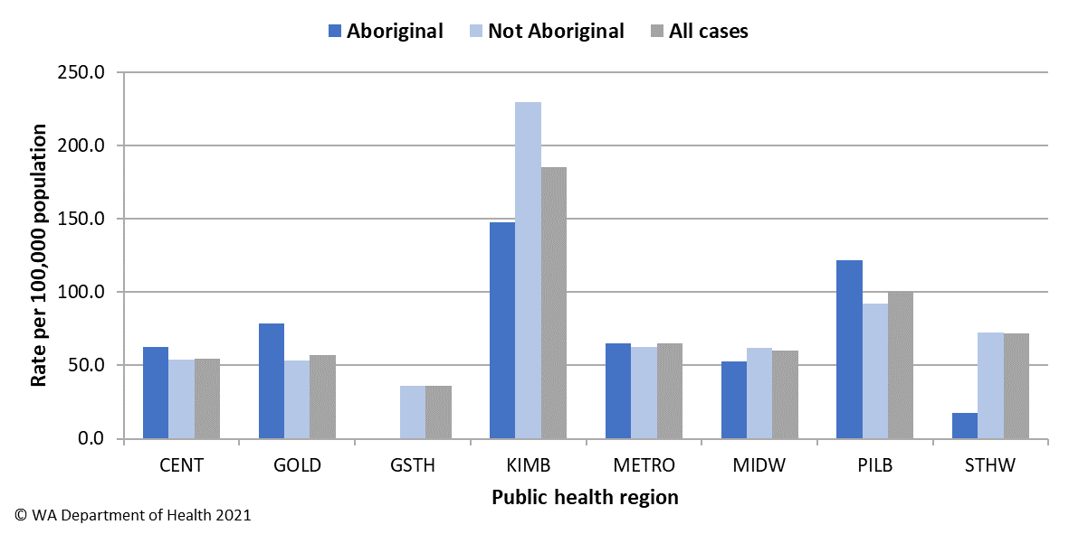

Figure 15 Salmonellosis notifications by place of acquisition and year, 2015 to 2020

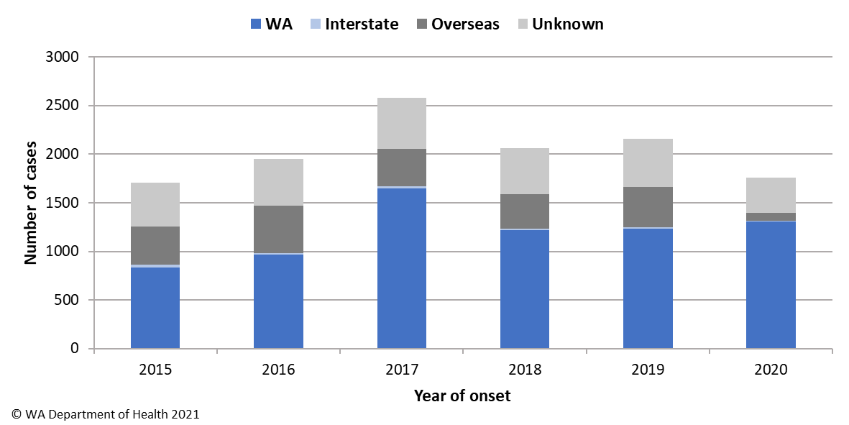

The most commonly notified *Salmonella* serotype in WA in 2020 was *S.* Typhimurium (STM), with 1165 notifications (Table 1), which was 66% of all *Salmonella* and 15% higher than the mean of the previous five years. STM is further typed using MLVA and there were 185 MLVA types identified in 2020. Of these, the top 10 types contributed 63% (n=735) of the total STM notifications and the most common MLVA type (03-17-09-12-523) contributed 34% of all STM notifications (Table 2). MLVA type 03-17-09-12-523 was also the *Salmonella* type that caused eight of the 18 *Salmonella* outbreaks investigated in 2020. The next most common MLVA types were 03-18-08-12-523 (n=76), and 03-18-09-12-523 (n=69), both are closely related to the most common MLVA pattern. These MLVA types caused one outbreaks each including a large outbreak in April that affected over 100 people (Table 3).

The second most commonly notified serotype was *S*. Enteritidis with 47 notifications, which was 77% below the mean of the previous five years (Table 1). In 2020, 83% of cases travelled overseas during their incubation period. There were 8 (17%) cases of *S*. Enteritidis that appeared to be locally acquired, but interviews of cases did not identify a common source. Other non-*S*. Typhimurium serotypes, particularly those historically associated with travel including *S*. paratyphi B bv Java and *S*. Newport, also decreased in 2020 with only one overseas acquired salmonellosis case notified since March. There were also 70 *Salmonella* species in 2020 where a serotype was not identified.

Table 1 Number and proportion of the top 10 *Salmonella* serotypes notified in WA, 2020, with comparison to the 5-year average

|  |  |  |  |  |
| --- | --- | --- | --- | --- |
| Salmonella serotype | 2020 | %a | Mean 2015 to 2019 | Ratiob |
| *Salmonella* Typhimurium | 1165 | 66.2 | 1010 | 1.15 |
| *Salmonella* Enteritidis | 47 | 2.7 | 206 | 0.23 |
| *Salmonella* Saintpaul | 39 | 2.2 | 54 | 0.73 |
| *Salmonella* Infantis | 28 | 1.6 | 31 | 0.90 |
| *Salmonella* Muenchen | 27 | 1.5 | 28 | 1.00 |
| *Salmonella* Chester | 26 | 1.5 | 28 | 0.92 |
| *Salmonella* Paratyphi B bv Java | 24 | 1.4 | 81 | 0.30 |
| *Salmonella* Choleraesuis bv Australia | 20 | 1.1 | 10 | 2.00 |
| *Salmonella* Virchow | 20 | 1.1 | 40 | 0.50 |
| *Salmonella* Newport | 16 | 0.9 | 29 | 0.55 |
| © WA Department of Health 2021 |  |  |  |  |

aPercentage of total *Salmonella* cases notified in 2020.

bRatio of the number of reported cases in 2020 compared to the five-year average of 2015-2019.

Table 2 The 10 most common *S*. Typhimurium MLVA types reported in 2020

|  |  |  |  |  |  |
| --- | --- | --- | --- | --- | --- |
| MLVA type | Number of cases | %a | Number of outbreaks | Number of outbreak cases | % outbreak cases |
| 03-17-09-12-523 | 394 | 33.8 | 7 | 45 | 11 |
| 03-18-08-12-523 | 76 | 6.5 | 1 | 52 | 68 |
| 03-18-09-12-523 | 69 | 5.9 | 1 | 3 | 4 |
| 03-10-17-11-496 | 50 | 4.3 | 0 | 0 | 0 |
| 03-10-15-11-496 | 28 | 2.4 | 0 | 0 | 0 |
| 03-11-15-10-523 | 28 | 2.4 | 1 | 24 | 86 |
| 03-13-11-10-523 | 27 | 2.3 | 1 | 8 | 30 |
| 03-10-16-11-496 | 24 | 2.1 | 0 | 0 | 0 |
| 03-17-10-12-523 | 20 | 1.7 | 0 | 1b | 5 |
| 04-13-09-00-490 | 19 | 1.6 | 1 | 18 | 95 |
| © WA Department of Health 2021 | | |  |  |  |

aPercentage of total *S*.Typhimurium cases notified in 2020.

bOne outbreak included nine notified cases of 03-17-09-12-523 and one notified case of 03-17-10-12-523

### Shiga toxin-producing *E. coli* (STEC) infection

There were 105 cases of STEC reported in 2020 with a rate of 4 cases per 100 000 population, which was 53% higher than the five-year average (Appendix 1). Some of the increase in 2020 is likely to be due to the introduction of PCR tests for STEC by two pathology laboratories, which also notified 94% of STEC cases in WA for 2020. One of these laboratories uses a PCR test on faecal specimens with bloody diarrhoea, by request or signs of HUS and began using this method in January 2016. Another laboratory also introduced a PCR test for STEC on request in July 2016, this changed in December 2018 to include PCR testing on all stool specimens. These changes in testing procedures is reflected in the increase in STEC notifications from 2016, that increases again from late 2018. This higher level of notifications is maintained until February 2020 and then notifications decrease, which coincides with the introduction of COVID-19 restrictions (Figure 16).

Figure 16 STEC notifications by year and month, WA, 2015 to 2020

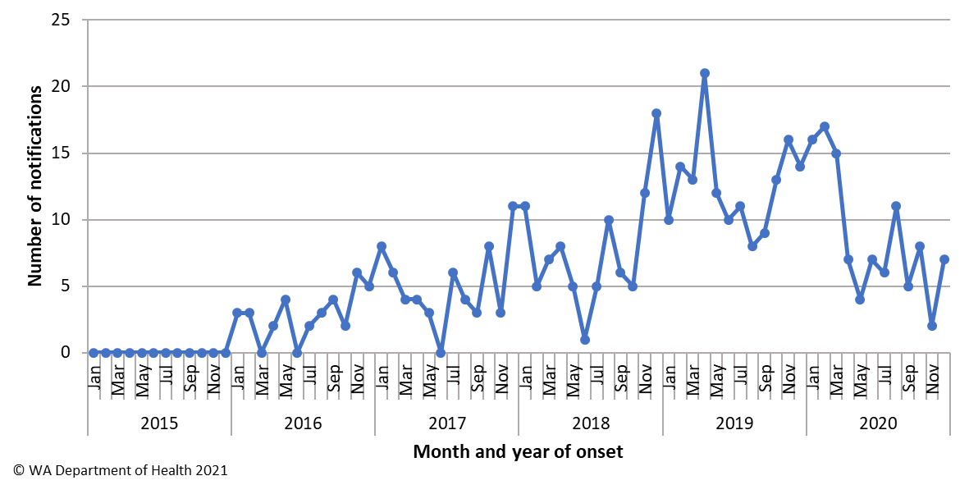

STEC notification rates in 2020 were higher in older adults. The notification rate for females were 30% higher than males (4.5 and 3.5 per 100 000 population, respectively). Notification rates for females were higher in the older age groups but not in the younger age groups (Figure 17). The region with the highest notification rate was the Midwest with 16.3 cases per 100 000 population. Notification rates were higher for non-Aboriginal people accounting for 97% (n=102) of cases in 2020.

Figure 17 STEC notification rates by age group and sex, WA, 2020

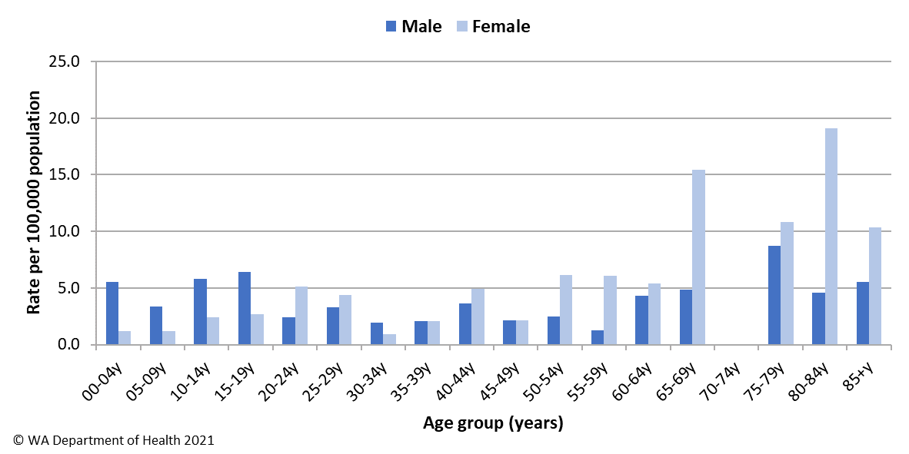

Of the 105 cases in 2020, 92% (n=97) were followed up and 53% (n=51) had an acute illness prior to testing. The remaining cases had chronic gastroenteritis symptoms or no gastroenteritis symptoms. Culture was performed on 83% (n=87) specimens, of which 59% (n=51) were culture-positive. The main serotypes in 2020 were O128:H2 (n=11) and O157:H7 (n=9). Of those cases with an acute illness, 90% had acquired their infection in WA and 10% had acquired their infection overseas. Of locally acquired cases interviewed, no point source outbreaks or clusters were identified.

### Shigellosis

There were 227 cases of shigellosis notified in 2020, with a notification rate of 8.6 per 100,000 population. The notification rate was 7% higher than the previous five-year average (Appendix 1). Similar to previous years, the number of notifications in 2020 was highest in January (Figure 18).

As of 1 July 2018 the national *Shigella* case definition changed to include notifications that are PCR positive as probable cases and culture positive notifications as confirmed cases. In 2020, there were 58 probable and 169 confirmed shigellosis cases. Of the probable cases, 93% were for Metropolitan residents, and of those with known place of acquisition, 64% were acquired overseas. In comparison for the confirmed cases, only 29% were for Metropolitan residents, and of those with known place of acquisition, 8% were acquired overseas.

Figure 18 Shigellosis notifications by year and month, WA, 2015 to 2020

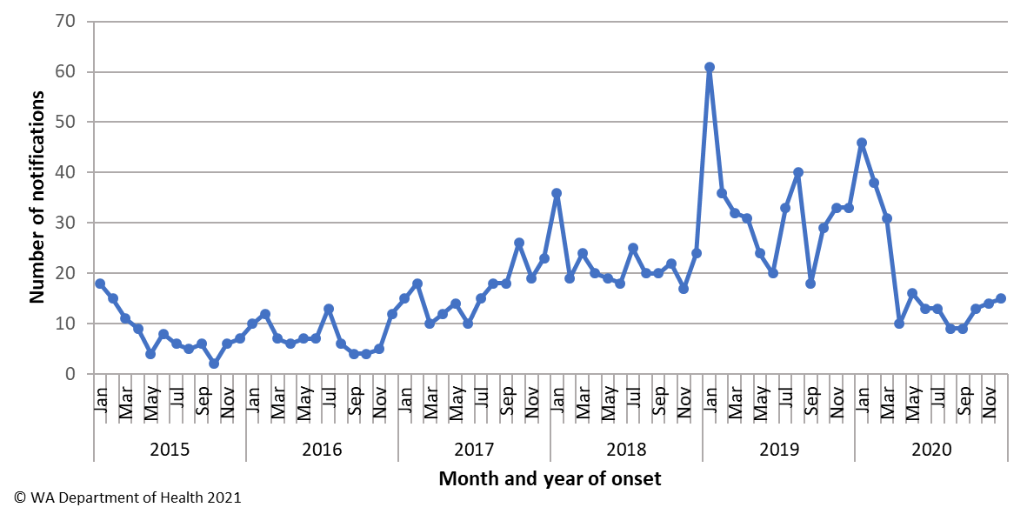

The shigellosis notification rate was 36% higher in males compared to females in 2020 (9.9 and 7.3 per 100 000 population, respectively). The 0-4 years age group had the highest rate of notification with 25.7 cases per 100 000 population (Figure 19).

Figure 19 Shigellosis notification rates by age group and sex, WA, 2020

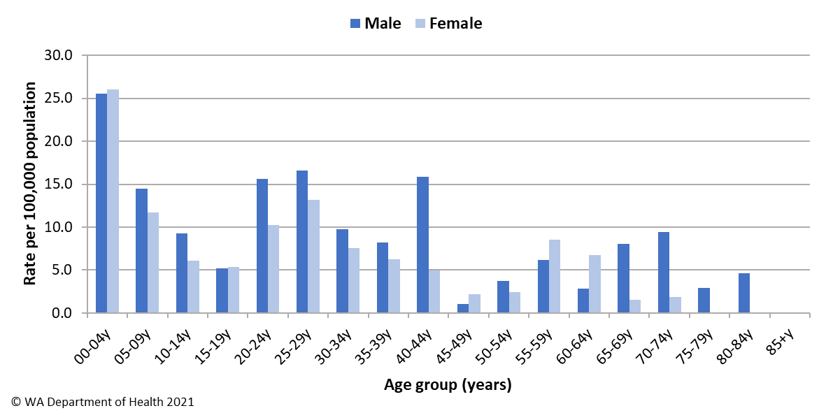

In 2020, the notification rate was 25 times higher for the Aboriginal population as compared to the non-Aboriginal population (109.9 and 4.4 per 100 000 population, respectively). The region with the highest shigellosis notification rate was Kimberley (156.7 cases per 100 000 population) followed by the Midwest and Pilbara regions (57.1 and 31.7 cases per 100 000 population, respectively) (Figure 20).

Figure 20 Shigellosis notification rates by region and Aboriginality, WA, 2020

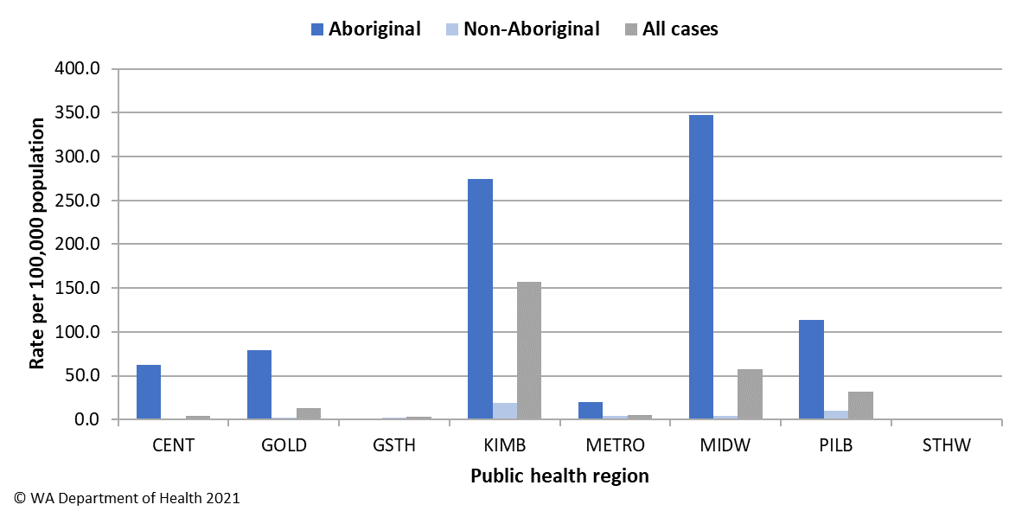

The predominant subtypes of *Shigella* notified in 2020 were *S. flexneri* 2b (n=70) which peaked in March, *S. sonnei* biotype A (n=39) which peaked in November, and then *S. sonnei* biotype G (n=30) which had notifications reported throughout the year (Figure 21). Of the notifications with known travel history, 100% of *S. flexneri* 2b and *S. sonnei* biotype A were locally acquired. Both *S. flexneri* 2b and *S. sonnei* biotype A were mostly regional cases (91% and 87% respectively) and in Aboriginal people (93% and 82% respectively). For *S. sonnei* biotype G with known place of acquisition, 24% cases were acquired overseas, 83% were Perth metropolitan cases and 93% were in non-Aboriginal people.

Twenty-two multi-drug resistance (MDR) *Shigella* notifications were reported in 2020. This increased from eight in 2019, three in 2018 and a single case in 2017, most in previous years were associated with overseas travel. In 2020, 19/22 MDR *Shigella* were *S. sonnei* biotype G and of these only one was female and acquired overseas, the remaining 18 cases were all male and acquired locally where known. Most (n=16, 89%) of these locally acquired MDR *S. sonnei* biotype G cases were notified between August and December and all were men who have sex with men where known (n=14).

Figure 21 The most common *Shigella* types notified in 2020

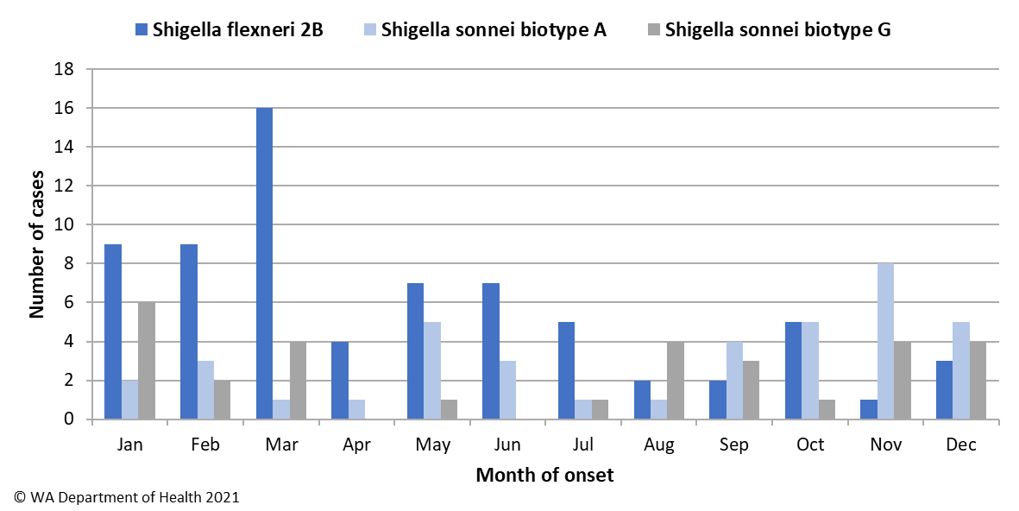

### Typhoid and paratyphoid fever

In 2020, there were 7 cases of typhoid fever (caused by *Salmonella* Typhi) notified with a rate of 0.3 cases per 100 000 population, which was lower than the average rate of the previous five years (Appendix 1). Three cases had recently travelled overseas prior to illness onset and the country for all cases was India. There were four locally acquired cases notified in November 2020 from two separate family groups, both involved a symptomatic case that were later linked to a household member identified as an asymptomatic carrier through screening. The two asymptomatic travellers had both travelled to India in 2019 and one of the families also had relatives from India staying in the household earlier in the year who were the suspected source though they also had no reported illness. There were no cases of paratyphoid fever notified in WA in 2020. The decrease in typhoid and paratyphoid fever in 2020 is likely due to the overseas travel restrictions.

### Vibrio parahaemolyticus infection

There were three cases of *Vibrio parahaemolyticus* infection notified in 2020 with a rate of 0.1 cases per 100 000 population which was substantially lower than the mean rate of the previous five years (Appendix 1). This decrease was likely in part due to the overseas travel restrictions which historically make up the majority of cases. The 2020 cases were all male, ranging in age from 25 to 63 years. Of these cases, one reported travel overseas during their incubation period (Indonesia). The two cases who acquired their illness in WA included one case with a positive wound swab who had swam in a river. The second case had a positive stool sample and their source of illness unknown, although they did report eating cooked shellfish.

### Yersinia infection

There were 16 cases of culture-positive *Yersinia* *enterocolitica* infection notified in 2020, with a rate of 0.6 cases per 100 000 population, which is similar compared to the mean rate of the previous five years (Appendix 1). There were eight female and eight male cases with ages ranging between 2 and 85 years. Eight cases had acquired their illness in WA, two cases acquired their illness overseas in Indonesia (n=1) and South America (n=1), and the place of acquisition was unknown for six cases. The majority (n=13) of cases were notified by one private pathology laboratory, which uses a faecal PCR test followed by reflex culture.

# Gastrointestinal disease outbreaks and investigations

### Foodborne and probable foodborne outbreaks

There were 20 foodborne or probable foodborne gastroenteritis outbreaks investigated in WA in 2020 (Table 3). The number of foodborne and probable foodborne outbreaks was below the five-year average (n=27.6) with a decrease reported each year since 2017 where the number of outbreaks investigated peaked at 42. The 20 foodborne outbreaks caused at least 490 cases of gastroenteritis and 49 hospitalisations. Short descriptions of these outbreaks are provided in [2020 quarterly reports](http://ww2.health.wa.gov.au/Articles/F_I/Infectious-disease-data/Enteric-infection-reports-and-publications-OzFoodNet).

**Aetiology**

Of the 20 outbreaks, 16 were due to STM, with seven outbreaks of MLVA type 03-17-09-12-523 and nine outbreaks of unique MLVA types. This was an 11% decrease in STM outbreaks compared to the five-year average (n=22.4). A decrease in STM outbreaks has been the trend observed for the sustained decline in foodborne and probable foodborne outbreaks in WA since 2017. For the remaining four outbreaks in 2020, one outbreak each was due to norovirus and *Clostridium perfringens* and for two outbreaks the aetiology was unknown (suspected viral agent).

**Food vehicles**

The investigations of the 20 outbreaks identified food vehicles for 14 outbreaks. Similar to previous years eating egg containing dishes was the most common vehicle identified in 79% (n=11) outbreaks. This was similar compared to the five-year average of outbreaks associated with eggs (n=11.8). The egg containing dishes included raw egg sauces such as mayonnaise and aioli, breakfast egg dishes, tiramisu and beef lasagne, which contained undercooked pasta sheets made with raw eggs. All 11 egg-related outbreaks were caused by STM, including MLVA types 03-17-09-12-523 (n=5), and one each of 03-13-12-10-523, 03-10-15-10-496, 03-13-11-10-523, 03-18-08-12-523, 03-11-15-10-523 and 03-10-16-11-496. The egg producer and production system were able to be determined in all 11 of these egg-related outbreaks and included multiple egg producers, and free-range, pastured and cage production systems. This information was gathered from environmental investigations. The cause of STM outbreaks due to egg-dishes is likely due to multiple contributing factors including levels of egg contamination, egg storage, handling and dish preparation. The remaining *Salmonella* Typhimurium outbreaks with food vehicles identified were due to chicken nuggets and roast pork/beef and the norovirus outbreak was associated with chicken sliders.

**Epidemiological investigation and evidence**

The evidence that supported the classification of 20 enteric outbreaks as foodborne or probable foodborne transmission was obtained using analytical studies for four outbreaks, microbiology for four outbreaks, and descriptive case studies (DCSs) for 13 outbreaks. The analytical studies involved interviewing those people who were at the implicated meal using a questionnaire on all foods/drinks available. These studies can be used to find a statistical association between a food eaten and illness. Microbiological evidence refers to the implicated food being positive for the same pathogen as the cases. For the outbreaks investigated as a DCS, there was strong circumstantial evidence to support probable foodborne transmission, such as ill people independently visiting a common food business, or the venue being the only source of food for cases.

**Food preparation settings**

The setting where food was prepared for the 20 foodborne outbreaks in 2020 included nine restaurants (caused by STM n=8, unknown n=1), three aged care facilities (caused by STM n=2, *Clostridium perfringens* n=1), two takeaway (both caused by STM), two commercial caterers (caused by STM n=1, unknown n=1), and one outbreak each in a prison (STM), private residence (STM), mobile food service (norovirus), bakery (STM) and primary produce (STM).

Table 3 Foodborne and probable foodborne outbreaks, 2020

|  |  |  |  |  |  |  |  |  |  |  |
| --- | --- | --- | --- | --- | --- | --- | --- | --- | --- | --- |
| Mode of transmission | Outbreak code | Month of outbreak | Where food prepared | Where food eaten | Agent responsible | Number ill | Hospitalised | Died | Evidence | Responsible vehicles |
| probable foodborne | 01/20/VRC | Jan | aged care | aged care | Clostridium perfringens | 7 | 0 | 0 | D | Unknown |
| probable foodborne | 02/20/HAM | Feb | festival/mobile service | school | Norovirus | 74 | 0 | 0 | A | Chicken sliders |
| probable foodborne | 042-2020-001 | Jan | aged care | aged care | Salmonella Typhimurium MLVA 03-17-09-12-523 | 7 | 1 | 2 | D | Unknown |
| probable foodborne | 042-2020-002 | Feb | bakery | other | Salmonella Typhimurium MLVA 03-18-09-12-523 | 3 | 2 | 0 | D | Unknown |
| foodborne | 042-2020-003 | Feb | primary produce | private residence | Salmonella Typhimurium MLVA 03-13-12-10-523 | 8 | 0 | 0 | M | Eggs |
| probable foodborne | 042-2020-004 | Feb | restaurant | restaurant | Salmonella Typhimurium MLVA 03-10-15-10-496 | 5 | 1 | 0 | D | Egg dish: hollandaise sauce and poached eggs |
| probable foodborne | 042-2020-005 | Feb | aged care | aged care | Salmonella Typhimurium MLVA 03-17-09-12-523 x11, MLVA 03-19-09-12-523 x1, MLVA 03-17-09-13-523 x1 | 18 | 3 | 2 | D | Unknown |
| foodborne | 042-2020-006 | Mar | restaurant | restaurant | Salmonella Typhimurium MLVA 03-13-11-10-523 | 10 | 1 | 0 | M | Egg dish; breakfast egg dishes |
| probable foodborne | 042-2020-007 | Mar | take-away | private residence | Salmonella Typhimurium MLVA 03-17-09-12-523 | 12 | 8 | 0 | D | Beef lasagne |
| foodborne | 042-2020-009 | Apr | Takeaway | Private Residence | Salmonella Typhimurium MLVA 03-18-08-12-523 | 107 | 12 | 0 | M | Egg dish: banh mi with raw egg butter |
| probable foodborne | 042-2020-010 | May | Restaurant | Private Residence | Salmonella Typhimurium MLVA 03-17-09-12-523 | 9 | 3 | 0 | D | Tiramisu |
| foodborne | 042-2020-011 | Jun | Prison | Prison | Salmonella Typhimurium MLVA 03-11-15-10-523 | 57 | 4 | 0 | A,M | Egg dish: raw egg mayonnaise |
| foodborne | 042-2020-012 | Jul | Restaurant | Private Residence | Salmonella Typhimurium MLVA 03-12-12-10-523 | 7 | 3 | 0 | A | Chicken nuggets |
| probable foodborne | 042-2020-015 | Sept | Restaurant | Private Residence | Salmonella Typhimurium MLVA 03-17-09-12-523 | 9 | 2 | 0 | D | Tiramisu |
| probable foodborne | 042-2020-016 | Oct | Restaurant | Restaurant | Salmonella Typhimurium MLVA 03-10-16-12-523 | 4 | 2 | 0 | D | Egg dish: raw egg sauces |
| probable foodborne | 042-2020-017 | Oct | Restaurant | Restaurant | Salmonella Typhimurium MLVA 03-17-09-12-523 | 17 | 2 | 0 | D | Tiramisu |
| probable foodborne | 11/20/TCB | Nov | Restaurant | Restaurant | Unknown | 41 | 0 | 0 | D | Unknown |
| probable foodborne | 042-2020-018 | Dec | Restaurant | Restaurant | Salmonella Typhimurium MLVA 03-17-09-12-523 | 4 | 0 | 0 | D | Tiramisu |
| probable foodborne | 12/20/NCC | Dec | Commercial catering | Workplace | Unknown | 37 | 1 | 0 | D | Unknown |
| foodborne | 042-2020-019 | Dec | Commercial catering | Functions | Salmonella Typhimurium MLVA 04-13-09-00-490 | 54 | 4 | 0 | A | Pork & beef; roasted |

**1**Month of outbreak is the month the outbreak was first reported or investigated, whichever is earliest

2MLVA=multi-locus variable number tandem repeat analysis

3D=descriptive, M=microbiological, A=Analytical

### Outbreaks due to non-foodborne transmission or with an unknown mode of transmission

In 2020, there were 280 outbreaks of gastroenteritis investigated that were not classified as foodborne disease outbreaks (Table 4). These outbreaks included 249 outbreaks associated with person-to-person transmission, 22 outbreaks where the mode of transmission was unclear or unknown and nine outbreaks due to probable waterborne transmission (Figure 22).

**Probable person-to-person outbreaks**

Of the 249 probable person-to-person (PTP) transmission outbreaks, 174 (70%) occurred in child care centres, 61 (24%) in RCFs, seven (3%) in schools, six (2%) in hospitals, and one in the community (Table 4). The causative agent for 33 (13%) of the outbreaks was confirmed as norovirus and for one outbreak each it was adenovirus, rotavirus and *Shigella* (1% total). In the remaining 213 (86%) outbreaks the causative agent was unknown, either because specimens were not collected, a pathogen was not identified during testing, viral testing was not requested, or it was not clear from the results what the causative pathogen was. A total of 3485 people were affected by these outbreaks, with 56 hospitalisations and 4 associated deaths.

The number of PTP outbreaks in 2020 was almost two times the average of the previous five years (n=126). The increase was a result of the number of outbreaks in child care centres that where over five times higher than the previous five years (n=34), most (86%) were in the fourth quarter and peaked in November (Figure 20).

**Outbreaks with unknown mode of transmission**

In the 22 outbreaks where the likely mode of transmission was unclear or unknown, 17 (77%) occurred in aged care facilities, two each were reported in private residences and child care and one in a hospital (Table 4).

In 19 of these outbreaks the causative agent was unknown and symptoms were not typical of viral gastroenteritis, particularly norovirus, outbreaks and therefore the outbreaks were described as unknown rather than person-to-person. In 15 of these outbreaks all cases had diarrhoea only, two outbreaks cases had vomiting only with onsets over only a few days, one outbreak had vomiting and diarrhoea but all onsets on the same day, and one outbreak all but one case had diarrhoea only. Twelve out of these 19 outbreaks had specimens tested which were negative for common bacterial and viral pathogens (including norovirus). One outbreak had only one specimen tested that was positive for Aeromonas species, it was unclear if this was the causative pathogen of the outbreak. No specimens were tested for six outbreaks.

Three outbreaks had positive results from specimens collected but the mode of transmission remained unclear. One outbreak among a sports team had one specimen positive for norovirus but it could not be determined if transmission was foodborne or person-to-person. A second outbreak following a party at a private residence involved three cases positive for STM MLVA 03-25-18-11-523 however the organiser was unable be contacted to determine possible exposures. The third outbreak at an aged care identified seven residents positive for STM MLVA 03-17-09-16-523. In this outbreak it was suspected that initial illness was foodborne with subsequent person-to person transmission, but the source remained unknown. Months later, three residents and two staff at the facility including one food handler were also positive for the same MLVA type with onsets over two months. The food handler was identified to be an asymptomatic carrier and most likely the source of infection for the residents and other staff member diagnosed later in the year, but it could not be determined if the food handler was the cause of the initial outbreak or was also infected during the outbreak.

**Probable waterborne outbreaks**

There were nine *Cryptosporidium* outbreaks in 2020 likely caused by exposure to local recreational aquatic facilities. These were all identified during investigation of a large increase of cryptosporidiosis in Perth metropolitan region in the first quarter of 2020.

Figure 22 Number of non-foodborne gastroenteritis outbreaks by mode of transmission and month, 2020

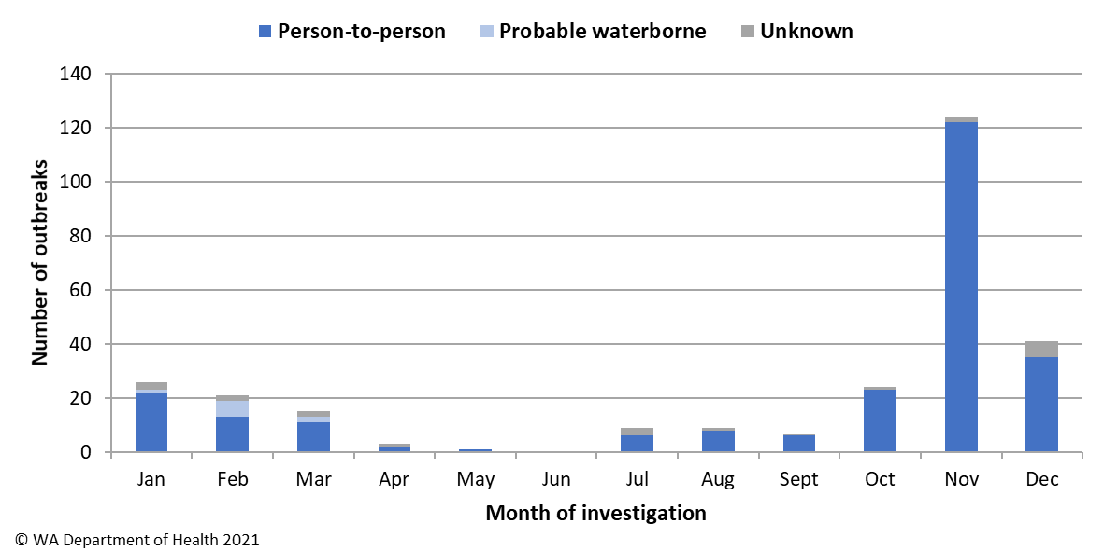

**Table 4 Outbreaks due to non-foodborne or unknown mode of transmission in WA by setting and agent, 2020**

|  |  |  |  |  |  |  |
| --- | --- | --- | --- | --- | --- | --- |
| Outbreaks with non-foodborne transmission | | | | | | |
| Mode of transmission | **Setting exposed** | **Agent responsible** | **Number of outbreaks** | **Number of cases** | **Number hospitalised** | **1 Number died** |
| Person-to-person | **Child care facility** | Adenovirus | 1 | 49 | 1 | 0 |
|  |  | Norovirus | 4 | 130 | 3 | 0 |
|  |  | Unknown | 169 | 2232 | 20 | 0 |
|  | **Child care total** |  | **174** | **2411** | **24** | **0** |
|  | **Residential care facility** | Norovirus | 23 | 644 | 19 | 4 |
|  |  | Unknown | 38 | 264 | 10 | 0 |
|  | **Residential care total** |  | **61** | **908** | **29** | **4** |
|  | **School** | Norovirus | 2 | 38 | 1 | 0 |
|  |  | Unknown | 5 | 40 | 0 | 0 |
|  | **School total** |  | **7** | **78** | **1** | **0** |
|  | **Hospital** | Norovirus | 4 | 75 | 0 | 0 |
|  |  | Rotavirus | 1 | 2 | 0 | 0 |
|  |  | Unknown | 1 | 5 | 0 | 0 |
|  | **Hospital total** |  | **6** | **82** | **0** | **0** |
|  | **Community** | Shigella | 1 | 6 | 2 | 0 |
| Person-to-person total |  |  | **249** | **3485** | **56** | **4** |
| Unknown | **Residential care facility** | Salmonella Typhimurium | 1 | 11 | 3 | 1 |
|  |  | Unknown | 16 | 79 | 2 | 1 |
|  | **Residential care total** |  | **17** | **90** | **5** | **2** |
|  | **Private residence** | Salmonella Typhimurium | 1 | 4 | 0 | 0 |
|  |  | Norovirus | 1 | 19 | 0 | 0 |
|  | **Private residence total** |  | **2** | **23** | **0** | **0** |
|  | **Child care** |  | **2** | **12** | **0** | **0** |
|  | **Hospital** |  | **1** | **3** | **0** | **0** |
| Unknown total |  |  | **22** | **128** | **5** | **2** |
| Probable waterborne | **Other** | Cryptosporidium | 9 | 58 | 8 | 0 |
| Grand total |  |  | **280** | **3671** | **69** | **6** |
| © WA Department of Health 2021 | | | | | | |

1Deaths temporally associated with gastroenteritis, but contribution to death not specified

### Cluster investigations

In 2020, there was one ongoing *Salmonella* cluster and 22 new clusters. The aetiology for the 22 new clusters in 2020 were 18 *Salmonella* clusters, two *Campylobacter* clusters and one cluster each of *Shigella* and *Cryptosporidium* (Table 5).

**Table 5 New cluster investigations in WA by month investigation started, setting and agent, 2020**

|  |  |  |  |  |  |  |
| --- | --- | --- | --- | --- | --- | --- |
| Month of outbreak | Setting exposed | Agent responsible* | Number ill | Number hospitalised | Epidemiological study | |
| Jan | Community | *Salmonella* Muenchen | 10 | 1 | Case series | |
| Jan | Community | *Salmonella* Choleraesuis bv Decatur | 7 | 2 | Case series | |
| Jan | Community | *Salmonella* Choleraesuis bv Australia | 5 | 0 | Case series | |
| Jan | Community | *Salmonella* Anatum | 3 | 0 | Case series | |
| Jan | Community | *Cryptosporidium* | 4 | 0 | Case series | |
| Feb | Community | *Salmonella* Bovismorbificans | 3 | 1 | Case series | |
| Feb | Community | *S*.Typhimurium MLVA 04-16-00-00-462 | 3 | 0 | Case series | |
| Feb | Community | *S*. Typhimurium MLVA 03-25-11-14-523 | 4 | 0 | Case series | |
| Apr | Community | *S*. Typhimurium MLVA 03-10-15-11-496 | 4 | 2 | Case series | |
| Jun | Community | *S*. Typhimurium MLVA 03-20-11-10-523 | 4 | 0 | Case series | |
| Jun | Community | *S*. Typhimurium MLVA 03-17-09-13-523 | 4 | 1 | Case series | |
| Jul | Community | *S*. Typhimurium MLVA 03-12-11-10-523 | 2 | 1 | Case series | |
| Jul | Community | *S*. Typhimurium MLVA 03-18-09-12-523 | 4 | 0 | Case series | |
| Jul | Community | *S*. Typhimurium MLVA 03-10-18-12-496 | 4 | 3 | Case series | |
| Aug | Community | *Salmonella* Typhimurium | 5 | 3 | Case series | |
| Aug | Community | *S*. Typhimurium MLVA 03-11-10-08-523 | 2 | 0 | Case series | |
| Sept | Community | Campylobacter | 7 | 1 | Case series | |
| Oct | Community | *Shigella sonnei* biotype G | 19 | 2 | Case series | |
| Oct | Community | *S*. Typhimurium MLVA 03-16/17-09-12-523 | 4 | 1 | Case series | |
| Nov | Community | *S*. Typhimurium MLVA 04-13-09-00-490 | 9 | 1 | Case series | |
| Dec | Community | Campylobacter | 4 | 0 | Case series | |
| Dec | Community | *S*. Typhimurium MLVA 03-17-09-12-523 | 7 | 2 | Case series | |
| © WA Department of Health 2021 | | | | | |

*MLVA=multi-locus variable number tandem repeat analysis

**Ongoing investigation - *Salmonella* Typhimurium MLVA 03-17-09-12-523**

Up until September 2016, STM MLVA 03-17-09-12-523 had not been notified in WA since MLVA typing began in WA in January 2015. Since the emergence of this strain in September 2016 to end of 2020, there have been a total 1868 cases, 486 hospitalisations and nine deaths temporally associated with this infection in WA (Figure 23). A total of 50 point source outbreaks with this strain have been investigated since 2016. In 25 outbreaks a food vehicle was identified, 24 were due to consumption of raw or undercooked egg or egg containing dishes. The remaining 1527 community cases comprised 48% males and 52% females, with median age of 28 years (range 0 to 99 years), and most (87%) resided in the Perth metropolitan region.

In response to this ongoing investigation a *Salmonella* Outbreak Response Taskforce was established in July 2019 which included representatives from WA Department of Health, PathWest laboratory, Department of Primary Industry and Regional Development, and select Local Governments. The primary outcomes of the taskforce were to collaborate with egg producers which would include on-farm investigations of epidemiologically linked farms, undertake a retail egg study to determine the level of *Salmonella* contamination on eggs in WA and to further analyse a selection of isolates related to this ongoing investigation by whole genome sequencing (WGS) at PathWest.

The department collected and tested a total 412 (dozen) samples of retail eggs between October 2019 and May 2020. Two samples were positive for *Salmonella*, both were STM. Results indicate a low prevalence of *Salmonella* in retail eggs in WA but there is a high consumption of eggs in WA (5).

Over 300 isolates, including human, food, animal and environmental samples, of STM MLVA 03-17-09-12-523 and closely related types were sequenced and analysed. The isolates were found to mostly belong to a single clade, which supported the hypothesis that illness is likely due to a common exposure or exposure to products with a common source of contamination.

The department conducted on-site visits and sampling at epidemiologically linked farms between February and April 2020. STM MLVA 03-17-09-12-523 was detected on all farms with varying level of contamination found between different sheds and farms. Several recommendations were made to the egg producers in response. These improvements included general farm management in biosecurity, pest control and cleaning as well as vaccination of flocks against STM. Vaccination programs for new flocks had commenced or were planned to commence in 2021 on investigated farms.

Figure 23 Notifications of *Salmonella* Typhimurium MLVA 03-17-09-12-523 in WA

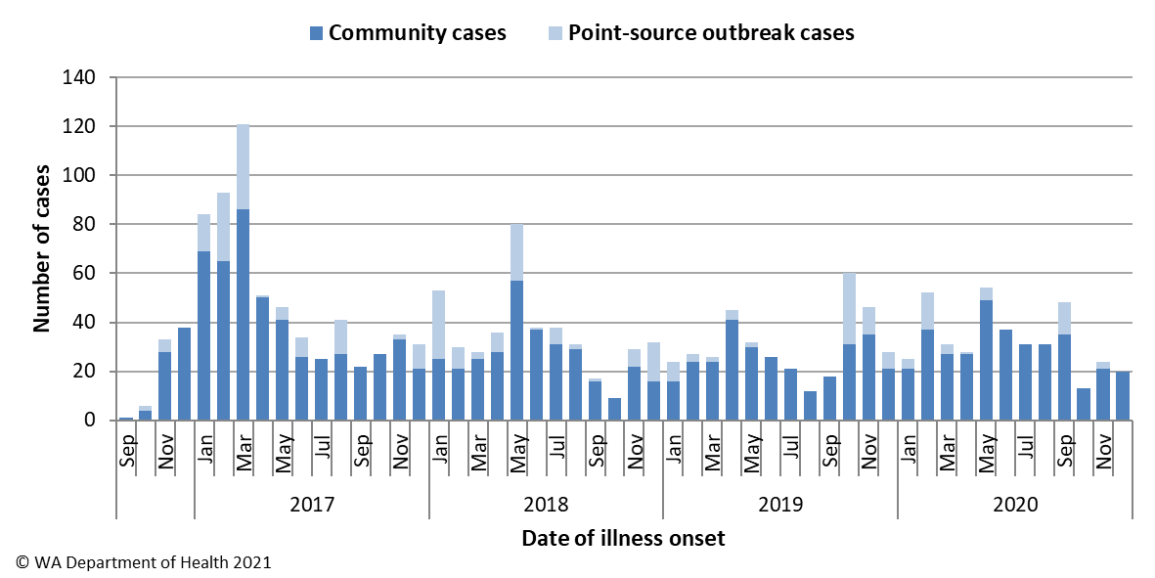

# References

1. Hall, G., Kirk, MD., Becker, N., Gregory, JE., Unicomb, L., Millard, G., et al. Estimating foodborne gastroenteritis, Australia. Emerg Infect Dis 2005;11(8):1257-1264.
2. OzFoodNet Working Group. A health network to enhance the surveillance of foodborne diseases in Australia. Australian Government Department of Health 2020. <https://www1.health.gov.au/internet/main/publishing.nsf/Content/cdna-ozfoodnet.htm>
3. Western Australian Department of Health. A-Z list of case definitions. Western Australian Department of Health 2020. <http://ww2.health.wa.gov.au/Articles/N_R/Notification-of-infectious-diseases-and-related-conditions>.
4. Communicable Diseases Network Australia. Australian national notifiable diseases and case definitions. Australian Government Department of Health 2020

<http://www.health.gov.au/casedefinitions>

1. Hendrie, G., Baird, D., & Noakes, M. (2016, October). Australians’ usual egg consumption. CSIRO Publications.

# Appendix 1: Number of notifications, notification rate2 and ratio of current to historical mean by pathogen/condition, 2015 to 2020, WA

|  |  |  |  |  |  |  |  |  |  |  |  |  |  |  |  |  |  |  |  |  |  |  |  |  |  |  |  |
| --- | --- | --- | --- | --- | --- | --- | --- | --- | --- | --- | --- | --- | --- | --- | --- | --- | --- | --- | --- | --- | --- | --- | --- | --- | --- | --- | --- |
| Pathogen/ Syndrome | 2015 | | | 2016 | | | | 2017 | | | | 2018 | | | | 2019 | | | | 2020 | | | | 2015-2019 Mean Rate | | Rate Ratio | |
| **No.** | **Rate** | | **No.** | | **Rate** | | **No.** | | **Rate** | | **No.** | | **Rate** | | **No** | | **Rate** | | **No** | | **Rate** | |
| *Campylobacter* | 2890 | 113.7 | | 3408 | | 133.3 | | 3390 | | 131.6 | | 3458 | | 133.2 | | 3533 | | 135.1 | | 2890 | | 109.8 | | 129.4 | | 0.85 | |
| *Salmonella* | 1705 | 67.1 | | 1951 | | 76.3 | | 2579 | | 100.1 | | 2058 | | 79.3 | | 2156 | | 82.5 | | 1759 | | 66.8 | | 81.1 | | 0.82 | |
| *Cryptosporidium* | 255 | 10.0 | | 245 | | 9.6 | | 400 | | 15.5 | | 122 | | 4.7 | | 211 | | 8.1 | | 495 | | 18.8 | | 9.6 | | 1.96 | |
| *Shigella* | 97 | 3.8 | | 93 | | 3.6 | | 198 | | 7.7 | | 264 | | 10.2 | | 390 | | 14.9 | | 227 | | 8.6 | | 8.0 | | 1.07 | |
| Rotavirus | 598 | 23.5 | | 180 | | 7.0 | | 519 | | 20.2 | | 298 | | 11.5 | | 540 | | 20.7 | | 215 | | 8.2 | | 16.6 | | 0.49 | |
| STEC1 | 0 | 0.0 | | 34 | | 1.3 | | 60 | | 2.3 | | 93 | | 3.6 | | 151 | | 5.8 | | 105 | | 4.0 | | 2.6 | | 1.53 | |
| *Yersinia* | 31 | 1.2 | | 15 | | 0.6 | | 15 | | 0.6 | | 11 | | 0.4 | | 24 | | 0.9 | | 16 | | 0.6 | | 0.7 | | 0.81 | |
| *Listeria* | 6 | 0.2 | | 6 | | 0.2 | | 6 | | 0.2 | | 8 | | 0.3 | | 7 | | 0.3 | | 7 | | 0.3 | | 0.3 | | 1.04 | |
| Typhoid fever | 8 | 0.3 | | 12 | | 0.5 | | 21 | | 0.8 | | 13 | | 0.5 | | 20 | | 0.8 | | 7 | | 0.3 | | 0.6 | | 0.46 | |
| Hepatitis A | 25 | 1.0 | | 17 | | 0.7 | | 12 | | 0.5 | | 12 | | 0.5 | | 24 | | 0.9 | | 6 | | 0.2 | | 0.7 | | 0.33 | |
| HUS1 | 1 | 0.0 | | 3 | | 0.1 | | 3 | | 0.1 | | 1 | | 0.0 | | 1 | | 0.0 | | 4 | | 0.2 | | 0.1 | | 2.17 | |
| Hepatitis E | 2 | 0.1 | | 3 | | 0.1 | | 4 | | 0.2 | | 2 | | 0.1 | | 4 | | 0.2 | | 3 | | 0.1 | | 0.1 | | 0.98 | |
| *Vibrio parahaemolyticus* | 7 | 0.3 | | 24 | | 0.9 | | 21 | | 0.8 | | 14 | | 0.5 | | 16 | | 0.6 | | 3 | | 0.1 | | 0.6 | | 0.18 | |
| Cholera | 0 | 0.0 | | 0 | | 0.0 | | 1 | | 0.0 | | 0 | | 0.0 | | 0 | | 0.0 | | 0 | | 0.0 | | 0.0 | | NA | |
| Botulism | 1 | 0.0 | | 0 | | 0.0 | | 0 | | 0.0 | | 0 | | 0.0 | | 0 | | 0.0 | | 0 | | 0.0 | | 0.0 | | NA | |
| Paratyphoid fever | 11 | 0.4 | | 12 | | 0.5 | | 4 | | 0.16 | | 9 | | 0.3 | | 9 | | 0.3 | | 0 | | 0.0 | | 0.3 | | NA | |
| Total | **5637** | **221.9** | | **5652** | | **221.1** | | **7233** | | **280.8** | | **6363** | | **245.2** | | **7086** | | **271.1** | | **5737** | | **218.0** | | **248.0** | | **0.88** | |
| ©WA Department of Health 2021 | | |  | |  | |  | |  | |  | |  | |  | |  | |  | |  | |  | |  | |

1Abbreviations: STEC: Shiga toxin-producing *E. coli*; HUS: Haemolytic Uraemic Syndrome; NA: not applicable. 2Rate is cases per 100 000 population. 3Shigella includes probable and confirmed notifications as of 1st July 2018; the 5-year mean should be interpreted with caution.

**This document can be made available in alternative formats on request for a person with a disability.**

© Department of Health 2021

Copyright to this material is vested in the State of Western Australia unless otherwise indicated. Apart from any fair dealing for the purposes of private study, research, criticism or review, as permitted under the provisions of the *Copyright Act 1968*, no part may be reproduced or re-used for any purposes whatsoever without written permission of the State of Western Australia.